CyberSourceCartridge

Version 15.1.0



04/15/2015

Contents

Summary 5

Component Overview 8

Functional Overview 8

Credit Card Authorization Service 8

Taxes 9

Address Verification Service (AVS) 10

Delivery Address Verification Service (DAV) 10

Bill Me Later (BML) 10

Decision Manager 11

Payment Tokenization 13

Payer Authentication 13

Full Authorization Reversal 14

Retail Point-of-Sale (POS) 14

Alipay Authorization 15

Alipay Batch Job 16

PayPal Express Authorization [From Cart Page and Mini Cart] 16

PayPal Authorization [From Billing Page] 17

Use Cases Scenarios 18

Credit Card Authorization 18

Taxes 21

Address Validation Service (AVS) 21

Delivery Address Verification Service (DAV) 22

BML 22

Decision Manager 23

Payment Tokenization 23

Payer Authorization 24

Retail Point-of-Sale (POS) 24

Alipay Authorization 25

PayPal Express Checkout and Authorization 26

Alipay PayPal Order Status Mapping with Demandware Order 31

Demandware – Cybersource Service Response Field Mapping for Alipay and Paypal Services 32

Limitations, Constraints 36

Compatibility 38

Implementation Guide 38

➢ Before Integration 38

Custom Code 40

Credit Card Auth 40

Bill Me Later 46

Tax Service 47

Address Verification Service 52

Delivery Address Validation Service 52

Full Authorization Reversal 53

Payer Authentication Service 53

Payment Tokenization Service 55

Alipay Authorization 75

Alipay Batch Job 80

PayPal Express Checkout [From Cart Page and Mini Cart] 81

PayPal Checkout [From Billing Page] 97

Remove Duplicate Payment Methods while Checkout 100

Retail POS 102

Site Configuration 117

Import Meta Data 117

Configure Payment Processor for Alipay 118

Configure Site Preferences 119

Configure Site Preferences for Alipay 123

Business Manager changes for Alipay Batch Job 124

Configure Site Preferences for PayPal and PayPal Express Checkout 124

Applying CyberSource Cartridge to the Site 126

Configure Custom Objects for Retail POS 126

Testing 128

Authorize Credit Card 128

Tax Service 128

Address Verification Service (AVS) 129

Delivery Address Verification Service (DAV) 129

Payment Tokenization 129

Full Authorization reversal 129

Device Fingerprint 129

Payer Authentication 130

Retail POS Authorization Request 130

Alipay Initiate Request 130

Alipay Check Status Request 130

Paypal Capture Request 131

Cartridges Structure and Reference 131

Pipelines 131

Scripts 132

Templates 134

Configuration Files 134

Retail POS Cartridge Components 134

Typical Project Plan 135

Roles, Responsibilities 135

Typical Efforts and Timelines 135

Pre-Production Steps 138

CyberSource Site Preferences 140

Cybersource_paypal Site Preferences 142

Device Fingerprint 144

How does it work? 144

Setup: 144

Hints for the CsDeviceFingerprintRedirectionType: 145

Modified Scripts and pipelines for the device fingerprint 146

Known Issues 147

CyberSource document links 148

Release History 149

# Summary

This document provides technical overview and implementation details for each CyberSource service integrated within Demandware platform. The CyberSource cartridge extends the functionality of Demandware Storefront, enabling real time access to CyberSource eCommerce transaction services listed below.

Credit Card Authorization – The CyberSource Credit Card Authorization service provides merchant with a mechanism to get authorization for the order amount. The authorization service validates the card based and authorize card for the order amount. For additional spam/fraud detection by Cybersource, a ‘device fingerprint’ could be submitted additionally, if configured.

CyberSource Address Verification (AVS) – The CyberSource AVS service provides merchants with a mechanism to reduce merchant banking fees, by verifying billing information before authorizing payment for customer purchases. Although the AVS service is automatically called during the authorization process, the behavior resulting from specific AVS responses and its interaction with the payment process is customizable through storefront configuration.

Tax Service – The CyberSource tax calculation service provides merchants with a complete tax calculation service according to and pursuant to domestic and international tax regulations, including but not limited to, district, city, county and state levels of governing tax authority.

Delivery Address Verification (DAV) Service – The CyberSource DAV service provides merchants with an optional mechanism to prevent, limit or correct faulty shipping information, related to improperly entered or formatted information from the customer. This service helps reduce the potential additional costs resulting from undeliverable or returned merchandise.

Bill Me Later Service – The Bill Me Later service from Bill Me Later, Inc., and available via your single connection to CyberSource, allows your customers to make purchases using an instant line of credit.

Decision Manager – CyberSource Decision Manager Service provides set of tools that merchant to evaluate rules and chose tool and return a decision of “Accept”, “Reject”, or “Review”. Merchant can also setup process to ignore certain rules when necessary.

Payment Tokenization – CyberSource Payment Tokenization Service provides set of tools to store customer and payment related sensitive data on secured cybersource hosted servers.

Payer Authentication – CyberSource Payer Authentication services enable you to add support to your web store for card authentication services, including Visa Verified by VisaSM, MasterCard® andMaestro® SecureCode™ (UK Domestic and international), American Express SafeKeySM.

Alipay Authorization – The CyberSource Alipay authorization service provide merchant with a mechanism to get authorization for order amount. The Initiate service of CyberSource Alipay initiates and authorizes the ordered amount and check status service returns the payment status of raised request from Alipay and return user to merchant site. There is a slight difference of currency associated with the amount in the request for Alipay Domestic and International simulators. CNY would be the currency associated for Domestic Alipay requests and Site specific currency would be associated with International Alipay requests.

**Note:** Please refer to the section Alipay PayPal Order Status Mapping with Demandware Order on page 37.

Alipay Batch Job – The CyberSource Alipay Batch Job provide merchant an additional functionality to change the Demandware order and payment status after getting response from check status service call. This batch job processes all the order placed with Alipay as payment methods and orders with status New, Open and Created. For each order it passes Request Id to Alipay Check Status service and accordingly updates the Demandware Order and Payment Status.

**Note:** Please refer to the section Alipay PayPal Order Status Mapping with Demandware Order on page 37.

PayPal Express Authorization [From Cart Page and Mini Cart] – The CyberSource PayPal Express authorization service provide merchant with a mechanism to authorize and capture order amount by using billing and shipping address of user’s PayPal account. User directly routed to PayPal site on choosing express checkout and return back to merchant site after validating its credentials. On placing the order, authorization and capture service of CyberSource PayPal authorize the amount and change the status of Demandware order to Paid. On configuring system to authorization service only, amount would be authorized but order payment status would be Not Paid.

**Note:** Please refer to the section Alipay PayPal Order Status Mapping with Demandware Order on page 37.

PayPal Authorization [From Billing Page] – The CyberSource PayPal authorization service provide merchant with a mechanism to authorize and capture order amount using normal checkout flow with PayPal as payment option. On placing an order user will be redirected to PayPal account to authenticate its credentials and after authentication user will be redirected back to merchant site to complete the checkout flow. Order payment status would be same mentioned above for PayPal express authorization.

**Note:** Please refer to the section Alipay Paypal Order Status Mapping with Demandware Order on page 37.

# Component Overview

## Functional Overview

### Credit Card Authorization Service

The credit card authorization service pipeline allows storefront application to request for credit authorization for the total order amount. The pipeline makes the credit card authorization web service call to CyberSource authorization service and receive confirmation about the availability of the funds.

The Demandware Cybersource–AuthorizeCreditCard pipeline populates the authorization request with ship-to, bill-to, credit card data, and purchase total data from the basket and invokes the authorization web service call using CyberSource web service API.

Credit Card Authorization sequence flow:

1. Creates CyberSource authorization request using ship-to, bill-to, credit card data, and purchase total data from the current basket.
2. If authorize Payer is configured, then make the authorize payer request, if not ignore and continue with the authorization request.
3. Create credit card authorization request.
4. If DAV is enabled, then set up DAV business rules, as needed.
5. Set up AVS Ignore Result business rule for request with AVS Ignore Flags specification, as needed.
6. Make actual service call to CyberSource Simple Order API.
7. If Delivery Address Verification is enabled, then:
   1. Capture pertinent DAV result information & DAV Reason Code
   2. If DAV fails and DAV On Failure is set to ‘REJECT’, then exit immediately with rejection response
8. If DAV On Failure is set to ‘APPROVE’ and the DAV Reason Code is a fail code (not 100), then:
   1. Exit immediately with declined or review response, as merchant defines
9. Capture pertinent AVS information
10. Validate authorization reason code and set corresponding end node, based on Auth response code.

The list of activities depicted in the following diagram takes place when API request is made for an online credit card authorization: [**Source, CyberSource Credit Card Service, and October 2009**]

**Figure 1** Processing an Online Authorization [**Source, CyberSource Credit Card Service, October 2009**]



1. The customer places an order and provides the credit card number, the card expiration date, and other information about the card.

2   You send a request for authorization over a secure Internet connection. If the customer buys a digitally delivered product or service, you can request both the authorization and the capture at the same time. If the customer buys a physically fulfilled product, do not request the capture until you ship the product.

3   CyberSource validates the order information, then contacts your payment processor and requests authorization.

4   The processor sends the transaction to the card association, which routes it to the issuing bank for the customer’s credit card. Some card companies, including Discover and American Express, act as their own issuing banks.

5   The issuing bank approves or declines the request. Depending on the card type, the bank could also use the Address Verification Service (AVS) to determine whether the customer provided the correct billing address. For more information about AVS, refer to AVS service documents via the CyberSource Services Documentation at <http://www.cybersource.com/support_center/support_documentation/services_documentation/payment.php> or as described in this integration guide.

6   CyberSource runs its own tests, and then tells you if the authorization succeeded.

7   Response is sent back to the client.

### Taxes

Online Customer adds Product(s) to Cart and proceeds to Checkout.

As soon as shipping information is entered and validated, taxes are updated to reflect current tax rates based on six basic criteria:

1. Customer ship to address
2. Merchant ship from address
3. Merchant point of order origin (POO)
4. Merchant point of order acceptance (POA)
5. Product code
6. Merchant nexus

Product information is provided on an individual line item basis and all merchant/request IDs are captured for future reference. When the customer enters in shipping information, the Tax Service is called to calculate taxes.

### Address Verification Service (AVS)

AVS does not exist as a stand-alone callable service. Please refer to the Credit Card Authorization Service walkthrough for high level walkthrough.

### Delivery Address Verification Service (DAV)

DAV service may be run as a stand-alone callable service, as well as be performed as a part of other services. Please refer to Credit Card Authorization Service for more information regarding the DAV service, as an integral part of payment auth.

As a stand-alone service, the process is defined as:

* Customer enters shipping information
* Shipping information passes client-side validation (required elements filled in)
* Shipping information passes basic server-side validation (syntactically correct)
* Request is made to CyberSource DAV Service
* Response returns DAVReasonCode (100=Success)
* End node returns either: authorized, declined or error (authorized==success, declined==failure)
* Captured validation information is extracted from pipeline dictionary to present user with choices to correct problems, confirm “standardized” formatting or try again
* If service is successful, allow Shipping Address save operation to continue

### Bill Me Later (BML)

A customer selects Bill Me Later during the checkout process at your site, similar to selecting the option to pay via Visa or MasterCard.

To request a Bill Me Later authorization, Demandware pipeline sends a request for a credit card authorization but instead of including a credit card number in the request, send the customer’s Bill Me Later account number set in the custom preferences.

To bill the customer, send a request for a credit card capture. No additional capture request fields are required for a Bill Me Later capture, unless you are processing multiple captures.

The Bill Me Later authorization service pipeline allows storefront application to request for credit authorization for the total order amount through the Bill Me Later.

The Demandware Cybersource–AuthorizeBML pipeline populates the authorization request with ship-to, bill-to, credit card data, and purchase total data from the basket and invokes the authorization web service call using CyberSource web service API.

Bill Me Later authorization sequence process:

* If it is the first time a customer has used Bill Me Later, they are presented with terms and conditions and asked for date of birth and last 4 digits of social security number.
* Once terms are agreed to, checkout continues as usual.
* A real-time credit decision is made and the consumer is notified within 3-5 seconds.
* On subsequent purchases, the customer simply chooses Bill Me later, a real-time credit decision is made and the customer is notified within 3-5 seconds.
* In rare circumstances, additional verification steps are applied.
* After completion of the first purchase a welcome email is sent by Bill Me Later. This email contains a secure link for login to the self-service website, as well as a user ID for the customer.
* Your customer typically receives a bill (sent by Bill Me Later, Inc.) in their mailbox within fifteen days of the settlement posting to the customer’s account. The due date for this bill is 25 days from the date the bill is rendered.
* You submit the transaction for settlement upon shipment of goods or rendering the service—just as you do with a credit card purchase. Funding is received within the same timeframe as that of a purchase made with a credit card.

### Decision Manager

The CyberSource Decision Manager provides Merchant and ability to set business rules, provide case management, and Reporting.

The CyberSource Decision Manager Business rule engine allows Merchant to analyze the order data based on predefined or custom rules. The business rules can be set by orders, by category, or by SKU.

The Demandware CyberSource Cartridge pipeline processes incoming Decision Manager Request and set contained orders to the new decision made through the decision manager.

NOTE: Make the pipeline Cybersource-NewDecision as public before using in production environment.

Entry point into Demandware pipeline:

http://<sandboxname>/on/demandware.store/Sites-<store>-Site/default/Cybersource-NewDecision?content=<xml content>

Sample incoming reviewed order status update xml file

<?xml%20version=”1.0”%20encoding=”utf-8”?>

<!DOCTYPECaseManagementOrderStatus SYSTEM “https://ebctest.cybersource.com/ebctest/reports/dtd/cmorderstatus_1_1.dtd”>

<CaseManagementOrderStatus

MerchantID=”sample_merchant”

Name=”Case Management Order Status”

Date=”2008-12-18 12:22:09 GMT”

Version=”1.1”

nxmlns=”http://reports.cybersource.com/reports/cmos/1.0”>

<Update MerchantReferenceNumber=”10679256010963322294714”RequestID=”1744185012770167904567”>

<OriginalDecision>REVIEW</OriginalDecision>

<NewDecision>ACCEPT</NewDecision>

<Reviewer>sample_reviewer</Reviewer>

<ReviewerComments>sample_comment</ReviewerComments>

<Queue>sample_queue</Queue>

<Profile>test</Profile>

<FollowonResult>

<Status>Success</Status>

<Application>Credit%20Card%20Settlement</Application>

<RequestID>1744185012770167904567</RequestID>

<Decision>Accept</Decision>

<ReasonCode>100</ReasonCode>

<Rcode>1</Rcode>

<Rflag>SOK</Rflag>

<RMsg>Request%20was%20processed%20successfully.</RMsg>

</FollowonResult>

</Update>

</CaseManagementOrderStatus>

### Payment Tokenization

Tokenization is the replacement of sensitive data with a unique identifier that cannot be mathematically reversed. In your environment, tokens take the place of sensitive credit card data. Typically, the token will retain the last four digits of the card as a means of accurately matching the token to the payment card owner. The remaining numbers are generated using proprietary tokenization algorithms.

How It Works

* To make a purchase on your website, the customer will enter their payment card information into the designated payment fields on the order page. These payment fields will be hosted by CyberSource using [Hosted Payment Acceptance](http://www.cybersource.com/products_and_services/payment_security/hosted_payment_acceptance/). When the customer hits the ‘submit’ button, the data is immediately encrypted and transmitted directly to CyberSource for storing, processing, and token generation. The payment data never enters your environment.
* The encrypted primary account number (PAN) is decrypted when it enters CyberSource’s Level 1, PCI-compliant data vault, where it is securely stored. The payment data is then passed on to the processing channel (bank) and returned to CyberSource with an accepted or denied result.
* CyberSource returns the result to you but substitutes the PAN data with a uniquely generated token. You store the token in your database of record system (such as ERP system) for future transactions or chargeback resolution on that account. Customer service representatives can easily verify customers as the custom token will retain the last four digits of the original PAN.

### Payer Authentication

CyberSource Payer Authentication services enable you to add support to your web store for card authentication services, including Visa Verified by VisaSM, MasterCard® and Maestro® SecureCode™ (UK Domestic and international), American Express SafeKeySM, and JCB J/Secure™.

These card authentication services deter unauthorized card use and protect you from fraudulent chargeback activity referred to as *liability shift*.

How It Works

Payer Authentication provides the following services:

* + **Check Enrollment**: Determines whether the customer is enrolled in one of the card authentication programs.
  + **Validate Authentication**: Ensures that the authentication that you receive from the issuing bank is valid.



The Check Enrollment service determines whether the customer is enrolled in one of the

Card authentication services:

* **No**: If the card is not enrolled, you can process the authorization immediately.
* **Yes**: If the card is enrolled, the customer’s browser displays a window where the customer can enter the password associated with the card. This is how the customer authenticates their card with the issuing bank.
* If the password matches the password stored by the bank, you need to verify that the information is valid with the Validate Authentication service. If the identity of the sender is verified, you can process the payment with the Card Authorization service.
* If the password does not match the password stored by the bank, the customer may be fraudulent. You must refuse the card and can request another form of payment.

### Full Authorization Reversal

A full authorization reversal is a follow-on transaction that uses the request ID returned from a previous authorization. The request ID links the full authorization reversal to the authorization. CyberSource uses the request ID to look up the customer’s billing and account information from the original authorization, which means merchant is not required to include those fields in full authorization reversal request.

### Retail Point-of-Sale (POS)

This service of CyberSource enables a merchant to process a credit card for retail point-of-sale transaction at their stores. The integration takes inputs for the API service and provides CyberSource API response for later use. This integration takes care for terminal which has manual entry for credit card details and terminal with a magnetic stripe where a credit card can be swiped and enter amount for the transaction.

### Alipay Authorization

The Alipay authorization service pipeline allows storefront application to request for authorization for total ordered amount along with the currency. The pipeline make the web service call to CyberSource Alipay initiate service to initiate payment request and authorize the amount and after successful initiation pipeline make the web service call to check the payment status of initiated request.

The Demandware CyberSource- AuthorizeAlipay pipeline populates the payment initiate request with purchase total data, product name, product description and Alipay Payment type such as APD (Domestic payment for China based merchant to trade in China) and APY (International payment for International merchant to trade from outside China) and invoke the initiate web service call using CyberSource web service API.

**Alipay Authorization Sequence Flow:**

1. Create CyberSource Alipay Initiate request using purchase total data, product name, and product description (optional) from the current order object
2. Set Alipay payment type to domestic or international in site preference
3. After configuration make actual service call to Alipay Initiate request
4. Validate Reason code and Decision of Initiate request and accordingly set the corresponding end node.
5. If initiation is successful, then assign the required values in Demandware Payment Transaction object and add a node to create CyberSource Alipay Check Status Request using Request ID of Initiate service response
6. Make service call to Alipay Check Status request to return the payment status of initiated request
7. Validate Reason Code and Payment status of check status service response and set the corresponding end node
8. If ReasonCode = 100 then check the payment status. If payment status is COMPLETED for service call then complete the checkout flow and place the order with “New” as order status and “Paid” as order payment status.
9. If ReasonCode = 100 and PaymentStatus = PENDING, complete the checkout flow with order status as “Created” and order payment status as “Not Paid”.
10. If ReasonCode = 100 and PaymentStatus = ABANDONED or PaymentStatus = TRADE_NOT_EXIST, fail the order and show message on the screen.
11. If Decision = REJECT and ReasonCode = 102 or ReasonCode = 233, fail the order and show message on the screen.
12. If Decision = ERROR and ReasonCode = 150, fail the order and show message on the screen.

**Note:** As Alipay live environment is not available, so for Alipay Domestic and International scenarios, Site Preference configuration for Reconciliation ID needs to configure to test various scenarios of Alipay Initiate and Check Status service. Also, If shopper does not return from the AliPay then Demandware order status shall remain the same as “Created” and shall be updated once Batch Job for Check Payment Status service runs from scheduler

### Alipay Batch Job

Alipay batch job process Demandware orders placed by Alipay as payment method by making web service call to Alipay Check Status Service.

The Demandware Cybersource-AlipayCheckPaymentStatusWorkflow pipeline node is called from batch job that populates the check status request with Request ID generated and stored in Demandware Payment Transaction custom attribute after Alipay Initiate request service call for every order placed by Alipay as payment method and invoke the Check Status web service call using CyberSource web service API.

**Alipay Batch Job Sequence Flow:**

1. Query on all the Demandware orders placed through Alipay with New, Open and Created as order status and get the Request Id stored in Order Payment Transaction custom object attribute after Alipay Initiate web service call.
2. Pass the Request Id and Payment Type to Alipay Check Status Service and make the actual service call.
3. Validate Reason Code and Payment status of check status service response and set the corresponding end node
4. If ReasonCode = 100 then check the payment status. If payment status is COMPLETED for service call then update the order status to “New”, Order Payment Status to “Paid”, Alipay Payment Status to “COMPLETED” in Order Payment Transaction custom object attribute and set the export status to “Ready For Export”
5. If ReasonCode = 100 and PaymentStatus = PENDING, no need to update any Demandware status in case of PENDING Alipay Payment Status.
6. If ReasonCode = 100 and PaymentStatus = ABANDONED or PaymentStatus = TRADE_NOT_EXIST, fail the order.
7. If Decision = REJECT and ReasonCode = 102 or ReasonCode = 233, fail the order.
8. If Decision = ERROR and ReasonCode = 150, fail the order.

**Note:** Please refer to the order status mapping mentioned in section Alipay Paypal Order Status Mapping with Demandware Order on page 37.

### PayPal Express Authorization [From Cart Page and Mini Cart]

PayPal Express Authorization service pipeline allow storefront application to request for authorization of ordered amount by validating credential of the user without using billing and shipping information from Demandware storefront. The pipeline makes the PayPal authorization web service call to CyberSource authorization service to get confirmation about availability of funds and authorize the amount.

The Demandware Cybersource - AuthorizePaypal pipeline populates the authorization request with item and purchase total data from order object and invokes the authorization web service call using CyberSource web service API.

PayPal Express Authorization Sequence Flow:

1. Create CyberSource Authorization request using item object, purchase total data object and required values as a result of set service, get service and order setup service call.
2. Site preference “PayPal Payment Option” has been provided for either Authorization or Authorization and Capture service calls. If user has selected Authorization from the site preference then only amount will be authorized but order payment status would be “Not Paid” and in case of Authorize and Capture service calls, payment status would become “Paid”.
3. After adding the product into cart, user can either choose express checkout from mini cart or from cart. On clicking express checkout user will be redirected to PayPal to authenticate its credentials. A call to CyberSource PayPal set and get service would be made and user will redirect back to merchant site and shopper basket billing/shipping information shall be updated with PayPal Get Service response and shopper redirected to Review page to complete the order.
4. On placing the order, actual service call to CyberSource Order setup, Authorize and Capture service would be made to authorize the amount.
5. If Decision Manager is enabled from Site Preference and CyberSource console, create CyberSource Authorization request using bill-to, ship-to, item object and purchase data object to make CyberSource PayPal Authorization service call.
6. Validate Reason Code and set corresponding end node, based on Auth response code.

### PayPal Authorization [From Billing Page]

PayPal Authorization service pipeline allow storefront application to request for authorization of ordered amount by validating credential of the user by using billing and shipping information from Demandware storefront. The pipeline makes the PayPal authorization web service call to CyberSource authorization service to get confirmation about availability of funds and authorize the amount.

The Demandware Cybersource - AuthorizePaypal pipeline populates the authorization request with item and purchase total data from order object and invokes the authorization web service call using CyberSource web service API.

PayPal Express Authorization Sequence Flow:

1. Create CyberSource Authorization request using item object, purchase total data object, bill-to, ship-to objects from the order object.
2. Site preference “PayPal Payment Option” has been provided for either Authorization or Authorization and Capture service calls. If user has selected Authorization from the site preference then only amount will be authorized but order payment status would be “Not Paid” and in case of Authorize and Capture service calls, payment status would become “Paid”.
3. After adding the product into cart, user chooses normal checkout flow by choosing PayPal as payment method to authorize amount. On placing an order, a sequential call will be made to all the services. Set CyberSource PayPal service will return PayPal token which in turn will be passed to get service to get the address details, address verification detail, payer details etc. and update the shopper basket object. CyberSource Order setup service will setup an order and Authorize and Capture CyberSource PayPal service will authorize the payment and send back the user to merchant site from PayPal site to complete the order.
4. If Decision Manager is enabled from Site Preference and CyberSource console, create CyberSource Authorization request using bill-to, ship-to, item object and purchase data object to make CyberSource PayPal Authorization service call.
5. Validate Reason Code and set corresponding end node, based on Auth response code.

## Use Cases Scenarios

### Credit Card Authorization

The following table outlines the possible Demandware actions based on the response of the CyberSource gateway. Each client may choose to handle the response code differently. As of release 2.10, all errors logged as “fatal”, can activate an email alert to recipients identified in business manager.

|  |  |  |  |
| --- | --- | --- | --- |
| **Response** | **DW Storefront Action** | **Cyber-**  **Source Code** | **CyberSource suggested response** |
|  |  |  |  |
| Successful transaction. | Continue Checkout | 100 |  |
|  |  |  |  |
| **Validation Errors** | | | |
| Request is missing one or more fields | Should not occur as validation should catch this Show user “denied” error message Log fatal error (email alert) | 101 | See the reply fields missingField_0...N for which fields are missing. Resend the request with the complete information. |
|  |  |  |  |
|  |  |  |  |
| One or more fields in the request contains invalid data. | Should not occur as validation should catch this Show user “denied” error message Log fatal error (email alert) | 102 | See the reply fields invalidField_0...N for which fields are invalid. Resend the request with the correct information. |
|  |  |  |  |
| **System Errors** | | | |
| General system failure. | Show user “Unable to process – Call Cust Service” error message Log fatal error (email alert) | 150 | Wait a few minutes and resend the request. |
|  |  |  |  |
|  |  |  |  |
| The request was received but there was a server time-out. | Show user “Unable to process – Call Cust Service” error message Log fatal error (email alert) | 151 | Wait a few minutes and resend the request. |
|  |  |  |  |
|  |  |  |  |
| The request was received but there was a service time-out. | Show user “Unable to process – Call Cust Service” error message Log fatal error (email alert) | 152 | Wait a few minutes and resend the request. |
|  |  |  |  |
| The request just wait and then timeout, ends up as exception on the Demandware script | This could be one of the unique scenario where CyberSource waits for the Merchant’s bank to authorize the order and exceeds timeout sets at the Demandware. This ends up into SOAP exception. Client code can handle this scenario differently. | Script sets Rason Code to 999 | Handle at client’s end depending on business rules associated with this scenario. |
|  |  |  |  |
| **Authorization denied errors** | | | |
| Declined the request because the card has expired. | Show user “Auth denied” error message | 202 | Request a different card or another form of payment. |
|  |  |  |  |
|  |  |  |  |
|  |  |  |  |
| The account number is invalid. | Show user “Auth denied” error message | 231 | Request a different card or other form of payment. |
|  |  |  |  |
| **Gateway Account problem** | | | |
| There is a problem with your merchant configuration. | Show user “Unable to process – Call Cust Service” error message Log fatal error (email alert) | 234 | Do not resend the request. Contact Customer Support to correct the configuration problem. |
|  |  |  |  |
| **Fraud Management** | | | |
| The fraud score exceeds your threshold. | Show user “Unable to process – Call Cust Service” error message Log fatal error (email alert) | 400 |  |
|  |  |  |  |
| The order is marked for review by Decision Manager. | Proceed with checkout Leave DW order “unconfirmed” | 480 |  |
|  |  |  |  |
| The order is rejected by Decision Manager. | Show user “Unable to process – Call Cust Service” error message Log fatal error (email alert) | 481 |  |

### Taxes

List of use cases and appropriate action taken listed below:

|  |  |
| --- | --- |
| **Use case scenarios** | **Result** |
| If shipping information is specified, then arequest is made to the Tax Service | If successful, the contents of the Basket are taxed and price totals are adjusted.  If failed, because of service outage or failed address verification then don’t update anything. Other services must handle AVS/DAV/Service outages before successful checkout and final sales tax calculation. Failure is logged for email notification. |
| Since cybersource charges per request to the tax service, the cartridge has been modified to reduce the number of tax requests. Subsequent tax requests in the current session are only made to cybersource if the line item’s products id, quantity or price has changed or if the basket merchandise price total (including order level and product level), adjusted shipping price totals or adjusted basket total price has changed. | If the basket state that would affect tax has changed then a tax call will be made to cybersource and the basket will be updated with the new tax prices.  If the basket state that would affect tax has not change, the request to cybersource is skipped. |

### Address Validation Service (AVS)

Note that AVS does not run as an independent process, but is instead an optional, integrated aspect of payment authorization. List of use cases and appropriate action taken listed below:

|  |  |
| --- | --- |
| **Use case scenarios** | **Result** |
| AVS Ignore Result set to true | AVS Information is captured, but does not affect authorization response. |
| AVS Ignore Result set to false | AVS information is captured and if result from AVS is error or declined, then propagates that result up to the calling service. |
| AVS Ignore Result is set to false & AVS Decline Flags is defined | Seed request with additional result codes which should also result in a declined response. |

### Delivery Address Verification Service (DAV)

List of use cases and appropriate action taken listed below:

|  |  |
| --- | --- |
| **Use case scenarios** | **Result** |
| DAV Enable is set to false | No DAV information will be requested. No correction/validation information will be collected from the response. |
| DAV Enable is set to true, DAV On Failure set to REJECT | DAV information will be requested from the calling service. DAV related corrections and validation information is captured, and a DAV-related failure will be propagated to the calling service. |
| DAV Enable is set to true, DAV On Failure set to APPROVE | DAV information will be requested from the calling service. DAV related corrections and validation information is captured, but the result does not affect Authorization result. |

### BML

List of use cases and appropriate action taken listed below:

|  |  |
| --- | --- |
| **Use case scenarios** | **Result** |
| BML Authorization failed with response.decision = ERROR | Client application to display appropriate user friendly message to the end user. |
| BML Authorization failed with response.decision = ACCEPT | Pipeline sets the Authorization code to BMLPaymentInstrument.paymentTransaction.transactionID and ends with Authorized status  Order object is populated with cybersource transaction ID |
| BML Authorization failed with script error, or exception | Pipeline ends with error status, client code to display appropriate error message to the end user. |

### Decision Manager

Updates order status with the new decision set through the Decision Manager. The order status is updated in Demandware through the incoming xml. There are following possible options:

The new order status can be set to either accepted or rejected. TheCybersource-NewDecision pipeline retrieves the order for the incoming XML content, read order number from the XML, and updates corresponding storefront order with the status passed in the XML for the order.

List of use cases and appropriate action taken listed below:

|  |  |
| --- | --- |
| **Use case scenarios** | **Result** |
| Incoming order status is set to “ACCEPT” | Read order from the order table; Update the status and set that add it to the accepted orders collection.  The accepted order collection can then be used to log and alert.  Sets the HTTP response code “200”. |
| Incoming order status is set to “REJECT” | Read order from the order table; update the status and set that add it to the declined orders collection.  The declined order collection can then be used to log and alert.  Sets the HTTP response code “200”. |

### Payment Tokenization

Payment Tokenization service stores the customer and card related sensitive data for future reuse. Updates order object with the subscription id received from Cybersource.

List of use cases and appropriate action taken listed below:

|  |  |
| --- | --- |
| **Use case scenarios** | **Result** |
| Create subscription response is set to “ACCEPT” | Place the order and update the order object with subscription id. |
| Create subscription response is set to “REJECT” | Place the order but leave the subscription field empty. Make entry in log files to record the event. |

### Payer Authorization

List of use cases and appropriate action taken listed below:

|  |  |
| --- | --- |
| Use case scenarios | Result |
| Enrolment Check Error | Merchant proceeds to authorization (optional) |
| Cardholder Not Participating | Merchant proceeds to authorization |
| Unable To Verify Enrolment | Merchant proceeds to authorization (optional) |
| Successful Authentication | Merchant proceeds to authorization |
| Authentication Failure | Merchant asks for another form of payment |
| Attempted Authentication | Merchant proceeds to authorization |
| Authentication Unavailable | Merchant proceeds to authorization (optional) |
| Invalid Authentication Response | Merchant asks for another form of payment |
| PARes Signature Error | Merchant asks for another form of payment |
| Whitespace in PARes | Merchant proceeds to authorization |

### Retail Point-of-Sale (POS)

The use case for POS can be achieved by two scenarios:

1. Hardware - swipe credit card – (A Bluetooth scanning device must be paired to the iPad device.)

On Payments page, we listen for credit card swipes only after the user has entered the amount for Credit Card and tapped enter.

**Expected Result**: The swiped credit card is read and payment is made to the order

1. **Hardware - manually enter credit card with keypad**: (A Bluetooth scanning device must be paired to the iPad device.)

From Payments page, enter amount to be applied to credit card.

**Expected Result:** Manually enter credit card number on device and payment is accepted.

### Alipay Authorization

The following table outlines the possible Demandware actions based on the response of the CyberSource gateway. Each client may choose to handle the response code differently.

|  |  |  |  |
| --- | --- | --- | --- |
| **Response** | **DW Storefront Action** | **Cyber-**  **Source Code** | **CyberSource suggested response** |
| Successful transaction. | Continue Checkout | 100 |  |
| **Validation Errors** | | | |
| Request is missing one or more fields | Should not occur as validation should catch this Show user “denied” error message Log error message into Demandware logs | 101 | See the reply field’s missingField_0...N for which fields are missing. Resend the request with the complete information. |
| One or more fields in the request contain invalid data. | Should not occur as validation should catch this Show user “denied” error message Log error message into Demandware logs | 102 | See the reply field’s invalidField_0...N for which fields are invalid. Resend the request with the correct information. |
| General decline by the processor | Should not occur as validation should catch this Show user “denied” error message Log error message into Demandware logs | 233 | Request that the customer select a different form of payment. |
| **System Errors** | | | |
| General system failure. | Show user “Unable to process – Call Customer Service” error message Log fatal error | 150 | Wait a few minutes and resend the request. |
| The request just wait and then timeout, ends up as exception on the Demandware script | This could be one of the unique scenarios where CyberSource waits for the Merchant’s bank to authorize the order and exceeds timeout sets at the Demandware. This ends up into SOAP exception. Client code can handle this scenario differently. | Script sets Reason Code to 999 | Handle at client’s end depending on business rules associated with this scenario. |

### PayPal Express Checkout and Authorization

The following table outlines the possible Demandware actions based on the response of the CyberSource gateway. Each client may choose to handle the response code differently.

|  |  |  |  |
| --- | --- | --- | --- |
| **Response** | **DW Storefront Action** | **Cyber-**  **Source Code** | **CyberSource suggested response** |
|  |  |  |  |
| Successful transaction. | Continue Checkout | 100 |  |
|  |  |  |  |
| **Validation Errors** | | | |
| Request is missing one or more fields | Should not occur as validation should catch this Show user “denied” error message Log error message into Demandware logs | 101 | See the reply field’s missingField_0...N for which fields are missing. Resend the request with the complete information. |
|  |  |  |  |
|  |  |  |  |
| One or more fields in the request contain invalid data. | Should not occur as validation should catch this Show user “denied” error message Log error message into Demandware logs | 102 | See the reply field’s invalidField_0...N for which fields are invalid. Resend the request with the correct information. |
|  |  |  |  |
| **System Errors** | | | |
| General system failure. | Show user “Unable to process – Call Customer Service” error message Log fatal error | 150 | Wait a few minutes and resend the request. |
|  |  |  |  |
|  |  |  |  |
| The request was received but there was a server time-out. | Show user “Unable to process – Call Customer Service” error message Log fatal error | 151 | Wait a few minutes and resend the request. |
|  |  |  |  |
| The request just wait and then timeout, ends up as exception on the Demandware script | This could be one of the unique scenarios where CyberSource waits for the Merchant’s bank to authorize the order and exceeds timeout sets at the Demandware. This ends up into SOAP exception. Client code can handle this scenario differently. | Script sets Reason Code to 999 | Handle at client’s end depending on business rules associated with this scenario. |
|  |  |  |  |
| **Authorization denied errors** | | | |
| PayPal rejected the transaction. | Show user “Unable to process – Call Customer Service” error message Log error message into Demandware logs | 223 |  |
|  |  |  |  |
|  |  |  |  |
|  |  |  |  |
| General decline by PayPal. | Show user “Unable to process – Call Customer Service” error message Log error message into Demandware logs | 233 | Request a different form of payment option at PayPal Website. |
|  |  |  |  |
| **Gateway Account problem** | | | |
| There is a problem with your CyberSource merchant configuration. | Show user “Unable to process – Call Customer Service” error message Log error message into Demandware logs | 234 | Do not resend the request. Contact Customer Support to correct the configuration problem. |
| PayPal rejected the transaction. A successful transaction was already completed for this PayPal Token value. | Show user “Unable to process – Call Customer Service” error message Log error message into Demandware logs | 238 |  |
|  |  |  |  |
| **Fraud Management** | | | |
| The order is marked for review by Decision Manager. | Proceed with checkout Leave DW order “unconfirmed” | 480 |  |
|  |  |  |  |
| The order is rejected by Decision Manager. | Show user “Unable to process – Call Customer Service” error message Log error message into Demandware logs | 481 |  |

**CyberSource PayPal Transactional Flow**:

**Step 1:** Set Service request and reply— accept item object, bill to, ship to objects, purchase data to generate the PayPal token.

**Step 2:** Get Service request and reply — accept request id, request token and PayPal token generated by set service and return address verification response, payer details and address details.

**Step 3:** Order Setup request and reply— accept payer id and order details to generate order setup response required to authorize the request.

**Step 4:** Authorization service request and reply — accept order related details and authorize the order amount.

**Step 5:** Capture service request and reply — capture the amount authorized by Authorization service.

Use Case 1: Checkout using PayPal Express Checkout on Cart Page

“PayPal Checkout” button has been added on Demandware reference SiteGenesis.

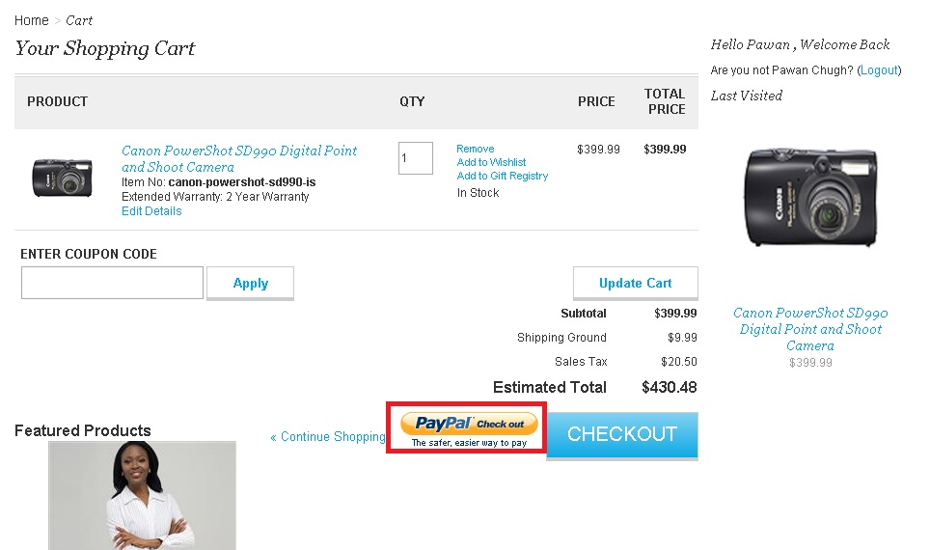

Use Case 2: Checkout using “PayPal Checkout” button on mini cart

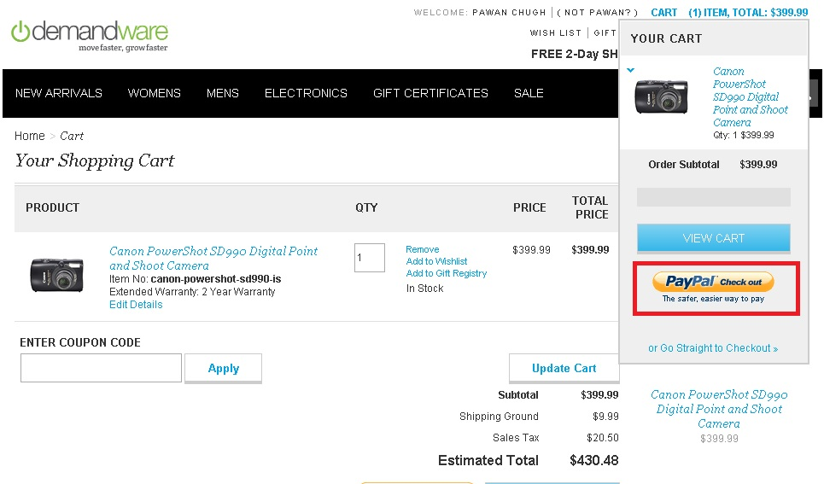

Use case 3: Checkout using Pay Pal as payment method on Payment page.

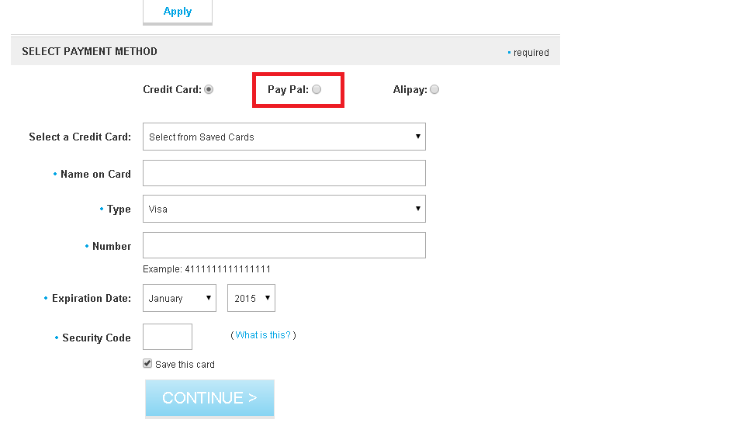

### Alipay PayPal Order Status Mapping with Demandware Order

|  |  |  |  |  |  |
| --- | --- | --- | --- | --- | --- |
| **Payment Method** | **Cybersource Service Call** | **Payment Status or Reason Code** | **DW Order Status Mapping** | **DW Payment Status Mapping** | **DW Export Status Mapping** |
| Alipay | apCheckStatusService | COMPLETED | New | Paid | Ready For Export |
| Alipay | apCheckStatusService | PENDING | Created | Not Paid | Not Exported |
| Alipay | apCheckStatusService | ABANDONED | Failed | Not Paid | Not Exported |
| Alipay | apCheckStatusService | TRADE_NOT_EXIST | Failed | Not Paid | Not Exported |
| Alipay | apCheckStatusService | REJECT | Failed | Not Paid | Not Exported |
| Alipay | apCheckStatusService | ERROR | Failed | Not Paid | Not Exported |
| Paypal | payPalAuthorizationService | ReasonCode=100 | New | Not Paid | Ready For Export |
| Paypal | payPalAuthorizationService | ReasonCode!=100 | Failed | Not Paid | Not Exported |
| Paypal | payPalCaptureService | Completed | New | Paid | Ready For Export |

### Demandware – Cybersource Service Response Field Mapping for Alipay and Paypal Services

|  |  |  |
| --- | --- | --- |
| **Service Name** | **Service Response Field** | **Demandware Field** |
| **apInitiateService** | apInitiateService.returnURL | PaymentInstrument.paymentTransaction.custom.apMerchantURL |
|  | reasonCode | PaymentInstrument.paymentTransaction.custom.approvalStatus |
|  | apInitiateReply.reconciliationID | PaymentInstrument.paymentTransaction.custom.apInitiatePaymentReconciliationID |
|  | requestID | PaymentInstrument.paymentTransaction.custom.apInitiatePaymentRequestID |
|  | requestToken | PaymentInstrument.paymentTransaction.custom.requestToken |
|  | PaymentProcessor | PaymentInstrument.paymentTransaction.paymentProcessor |
| **apCheckStatusService** | apCheckStatusService.paymentStatus | Order.paymentTransaction.custom.apPaymentStatus |
|  | reasonCode | Order.paymentTransaction.custom.apCheckStatusServiceApprovalStatus |
|  | apCheckStatusService.reconciliationID | Order.paymentTransaction.custom.apCheckStatusReconciliationID |
|  | requestID | Order.paymentTransaction.custom.requestId |
|  | requestToken | Order.paymentTransaction.custom.apCheckStatusRequestToken |
|  | apCheckStatusService.processorTransactionID | Order.paymentTransaction.custom.apCheckStatusProcessTransactionID |
| **payPalEcSetService** | payPalEcSetService.correlationID | PaymentInstrument.paymentTransaction.custom.paypalSetRequestCorrelationID |
| **payPalEcGetDetailsService** | requestToken | PaymentInstrument.paymentTransaction.custom.paypalEcSetRequestToken |
|  | requestID | PaymentInstrument.paymentTransaction.custom.paypalEcSetRequestID |
|  | payPalEcGetDetailsService.payerId | PaymentInstrument.paymentTransaction.custom.payPalPayerId |
|  | payPalEcGetDetailsService.paypalToken | PaymentInstrument.paymentTransaction.custom.paypalToken |
|  | payPalEcGetDetailsService.avsCode | PaymentInstrument.paymentTransaction.custom.paypalAvsCode |
|  | payPalEcGetDetailsService.payerStatus | PaymentInstrument.paymentTransaction.custom.paypalGetDetailsPayerStatus |
|  | payPalEcGetDetailsService.addressStatus | PaymentInstrument.paymentTransaction.custom.paypalGetDetailsAddressStatus |
|  | payPalEcGetDetailsService.correlationID | PaymentInstrument.paymentTransaction.custom.paypalGetDetailsCorrelationId |
|  | payPalEcGetDetailsService.paypalTaxAmount | PaymentInstrument.paymentTransaction.custom.paypalGetDetailsTaxAmount |
|  | payPalEcGetDetailsService.payerFirstname | PaymentInstrument.paymentTransaction.custom.paypalPayerFirstName |
|  | payPalEcGetDetailsService.payerLastname | PaymentInstrument.paymentTransaction.custom.paypalPayerLastName |
|  | payPalEcGetDetailsService.payerCountry | PaymentInstrument.paymentTransaction.custom.paypalPayerCountry |
|  | payPalEcGetDetailsService.paypalBillingAgreementAcceptedStatus | PaymentInstrument.paymentTransaction.custom.paypalBillingAgreementAcceptedStatus |
|  | payPalEcGetDetailsService.payer | Basket.customerEmail |
|  | payPalEcGetDetailsService.shipToName | OrderAddress.firstName + OrderAddress.lastName |
|  | payPalEcGetDetailsService.payerPhone | OrderAddress.phone |
|  | payPalEcGetDetailsService.shipToAddress1 | OrderAddress.address1 |
|  | payPalEcGetDetailsService.shipToAddress2 | OrderAddress.address2 |
|  | payPalEcGetDetailsService.shipToCity | OrderAddress.city |
|  | payPalEcGetDetailsService.shipToZip | OrderAddress.postalCode |
|  | payPalEcGetDetailsService.shipToCountry | OrderAddress.countryCode |
|  | payPalEcGetDetailsService.shipToState | OrderAddress.state |
|  | payPalEcGetDetailsService.payerFirstname | OrderAddress.firstName |
|  | payPalEcGetDetailsService.payerMiddlename | OrderAddress.secondName |
|  | payPalEcGetDetailsService.payerLastname | OrderAddress.lastName |
|  | payPalEcGetDetailsService.payerPhone | OrderAddress.phone |
|  | payPalEcGetDetailsService.street1 | OrderAddress.address1 |
|  | payPalEcGetDetailsService.street2 | OrderAddress.address2 |
|  | payPalEcGetDetailsService.city | OrderAddress.city |
|  | payPalEcGetDetailsService.postalCode | OrderAddress.postalCode |
|  | payPalEcGetDetailsService.countryCode | OrderAddress.countryCode |
|  | payPalEcGetDetailsService.state | OrderAddress.state |
| **payPalEcOrderSetupService** | requestID | PaymentInstrument.paymentTransaction.custom.orderSetupRequestId |
|  | requestToken | PaymentInstrument.paymentTransaction.custom.orderSetupRequestToken |
|  | payPalEcOrderSetupService.transactionId | PaymentInstrument.paymentTransaction.custom.orderSetupTransactionId |
|  | payPalEcOrderSetupService.paypalPaymentStatus | PaymentInstrument.paymentTransaction.custom.paypalOrderSetupPaymentStatus |
|  | payPalEcOrderSetupService.paypalTransactiontype | PaymentInstrument.paymentTransaction.custom.paypalOrderSetupTransactionType |
|  | payPalEcOrderSetupService.correlationID | PaymentInstrument.paymentTransaction.custom.paypalOrderSetupCorrelationID |
|  | payPalEcOrderSetupService.paypalPendingReason | PaymentInstrument.paymentTransaction.custom.paypalOrderSetupPendingReason |
| **payPalAuthorizationService** | requestID | PaymentInstrument.paymentTransaction.custom.requestId |
|  | requestToken | PaymentInstrument.paymentTransaction.custom.requestToken |
|  | reasonCode | PaymentInstrument.paymentTransaction.custom.approvalStatus |
|  | payPalAuthorizationService.transactionId | PaymentInstrument.paymentTransaction.custom.paypalAuthTransactionID |
|  | payPalAuthorizationService.amount | PaymentInstrument.paymentTransaction.custom.authAmount |
|  | payPalAuthorizationService.paypalAmount | PaymentInstrument.paymentTransaction.custom.paypalAuthorizedAmount |
|  | payPalAuthorizationService.protectionEligibility | PaymentInstrument.paymentTransaction.custom.paypalProtectionEligibility |
|  | payPalAuthorizationService.protectionEligibilityType | PaymentInstrument.paymentTransaction.custom.paypalProtectionEligibilityType |
|  | payPalAuthorizationService.correlationID | PaymentInstrument.paymentTransaction.custom.paypalCorrelationId |
| **payPalCaptureService** | payPalCaptureService.paypalPaymentStatus | PaymentInstrument.paymentTransaction.custom.paypalPaymentStatus |
|  | payPalCaptureService.parentTransactionId | PaymentInstrument.paymentTransaction.custom.paypalParentTransactionId |
|  | payPalCaptureService.authorizationId | PaymentInstrument.paymentTransaction.custom.paypalAutorizationId |
|  | payPalCaptureService.paypalReceiptId | PaymentInstrument.paymentTransaction.custom.paypalReceiptId |
|  | payPalCaptureService.transactionId | PaymentInstrument.paymentTransaction.custom.paypalCaptureTransactionID |
|  | requestID | PaymentInstrument.paymentTransaction.custom.paypalCaptureRequestId |
|  | requestToken | PaymentInstrument.paymentTransaction.custom.paypalCaptureRequestToken |
|  | payPalCaptureService.paypalFeeAmount | PaymentInstrument.paymentTransaction.custom.paypalCaptureFeeAmount |
|  | payPalCaptureService.correlationID | PaymentInstrument.paymentTransaction.custom.paypalCaptureCorrelationID |

## Limitations, Constraints

Not currently implemented:

* Multiple shipments. Tax rates are only calculated for a single shipment per order. To implement tax service calculation for multiple shipments, a separate web service call must be made for each distinct “ship to” location.
* Custom User Interface components to correct address validation (DAV/AVS) errors and/or omissions or to confirm “standardized” address format corrections. All pertinent data is collected, but because each merchant will have customized specifications how to deal with such information (or use other 3rd party solutions to play the same role), no default user interface is provided.
* Custom user interface for view, update and delete subscription. All functionalities are created and working in stand-alone mode in **Cybersource_Subscription.xml** pipeline. They have to customized and integrated as per the merchant specific needs.
* Custom user interface for Full Authorization Reversal. Full Authorization reversal is created and working in stand-alone mode in **Cybersource_Services.xml** pipeline. It has to customized and integrated as per the merchant specific needs.

Currently implemented with limitations and constraints:

* Testing of Alipay is possible only with Test data provided by CyberSource such as Reconciliation ID that is getting passed to Alipay Initiate Service to get the response back. We don’t have Alipay simulator and access to Alipay live environment.

* CNY is the only hardcoded currency value that has been used for Alipay Domestic requests.
* Incase user has enabled Decision Manager from CyberSource console, its mandatory to enable Decision Manager from Business Manager Site Preference path: Site -> Site Preferences -> Custom Preferences -> Cybersource_paypal -> check/uncheck as per decision manager enabled/disabled in CyberSource console.
* Order should remain in same state if user closes the browser while transaction is in progress. For example: For Alipay, if user closes the browser while coming back from simulator and before coming to order confirmation page, order will remain in created state. Similar is the case with PayPal and rest of the payment methods.
* In case of PayPal Express checkout, site specific default shipment method would be passed while placing an order. For example if Ground is the shipment method default selected in Business Manager for a particular site, then for PayPal express checkout Ground method would be passed by default as Shipment method.
* Since Alipay and PayPal are dealing with different order and payment status, merchant need to take care of different order messaging on order confirmation page after successful completion of order.

## Compatibility

This cartridge is supported under Demandware API release 2.10.0 and onward.

# Implementation Guide

## Before Integration

Before starting with integration process, merchant needs to identify which type of checkout flow is currently being deployed on the storefront. After the release of SiteGenesis 13.1, there are now two different types of Checkout flows possible in Demandware as explained below:

1. **One Step Checkout (Up to SiteGenesis 12.6)**

Up to SiteGenesis 12.6, in the COPlaceOrder-Start pipeline, the order object was created after successfully calling the COPlaceOrder-HandlePayments pipeline. This ensured that an Order object was created only after receiving successful Payment Authentication message from the Payment Processor. Refer to the screenshot below:

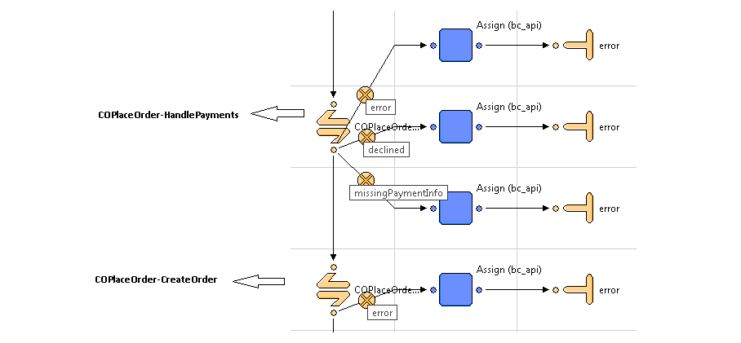

1. **Two Step Checkout (SiteGenesis 13.1 onwards)**

SiteGenesis 13.1 release onwards, in the COPlaceOrder-Start pipeline, the Order object is created before calling the COPlaceOrder-HandlePayments pipeline. This allowed the merchants to create an Order in Business Manager with fail status, even in case of a failed Payment Authorization. Refer to the screenshot below:

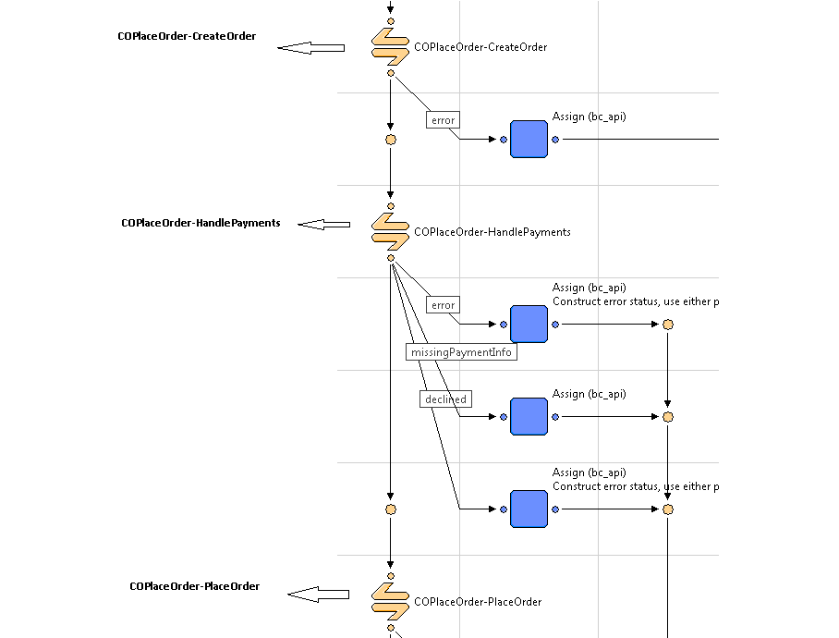

## Custom Code

### Credit Card Auth

Update CYBERSOURCE_CREDIT-Authorize pipeline to call Cybercource-AuthorizeCreditCard pipeline.

NOTE: Refer to the screen below for changes:

The following screen is based on Up to SiteGenesis 12.6

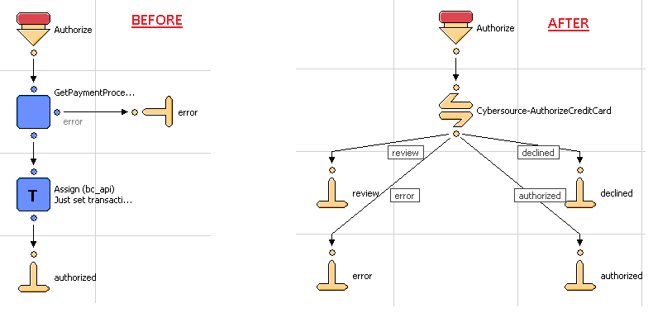

The following screen is based on SiteGenesis 13.1

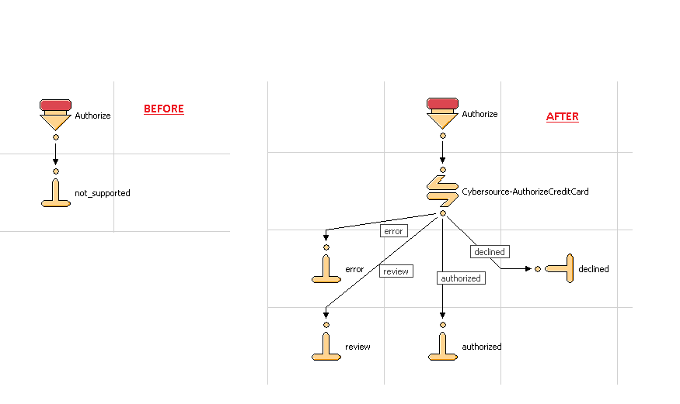

Update COPlaceOrder-CreateOrder Pipeline to include an assign node just after the createorder2 pipelet. Refer to the screenshot below for more details:

**Note:** This change is required only for Merchants using the **Two Step Checkout Flow**.

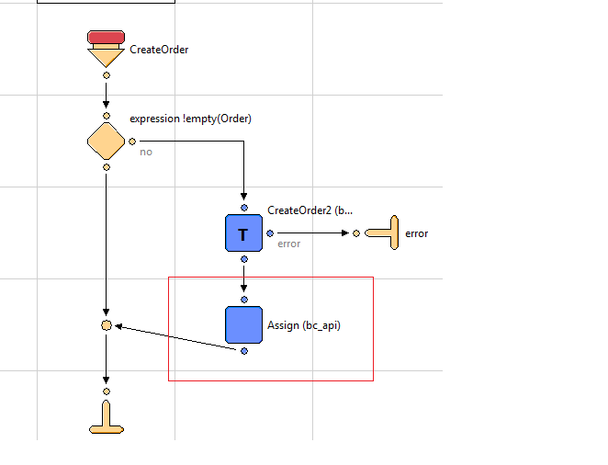

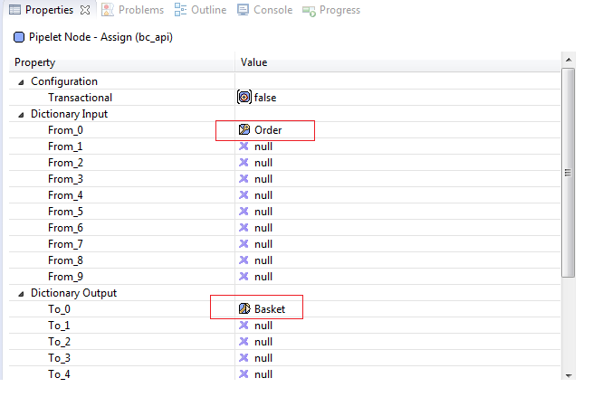

Note: Below mentioned change is required if merchant is using Paypal, Alipay payment methods along with Credit Card and BML Payment methods. COPlaceOrder-CreateOrder node need to update as mentioned below.

Put

(!empty(CurrentForms.billing.paymentMethods.selectedPaymentMethodID) && (CurrentForms.billing.paymentMethods.selectedPaymentMethodID.value.equals('CREDIT_CARD')||CurrentForms.billing.paymentMethods.selectedPaymentMethodID.value.equals('BML')))

condition in the expression node to set the value of Order Into Basket Object for Credit Card and BML as payment methods.

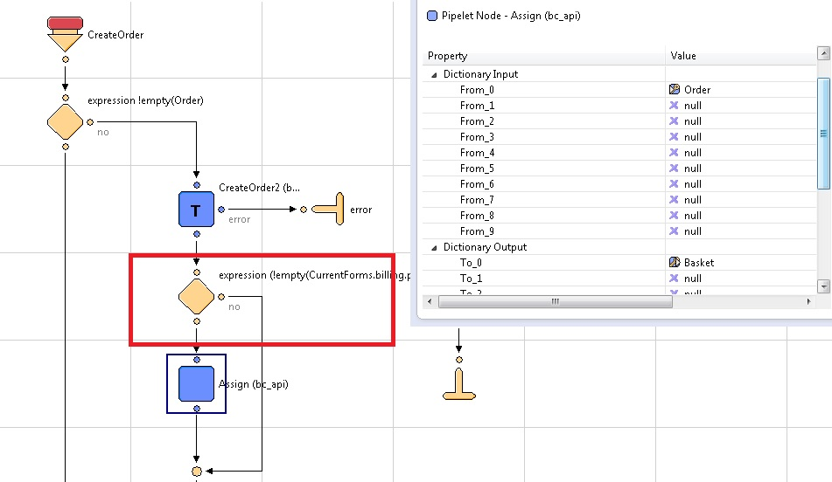

Add assign node just before FailOrder pipelet and null the Basket instance created at the time of createOrder2 pipelet.

NOTE: Refer to the screen below for changes:

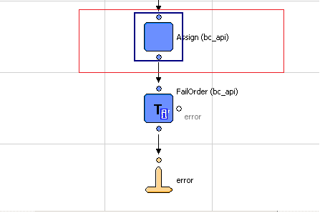

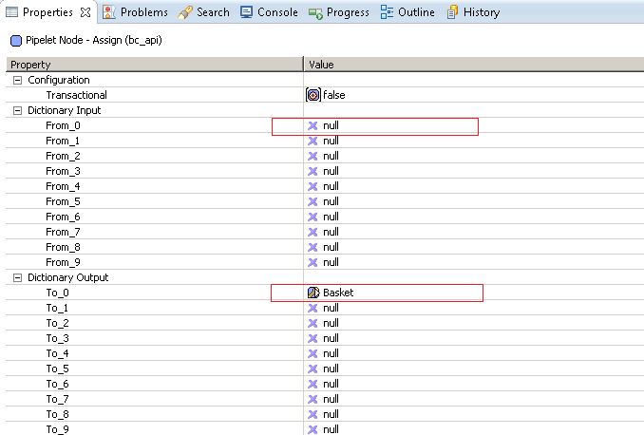

Also, update HandlePayments pipeline to handleresponse code returned by Cybersource

Authorized, Error, Declined and Review

Note: Refer to screen below for changes:

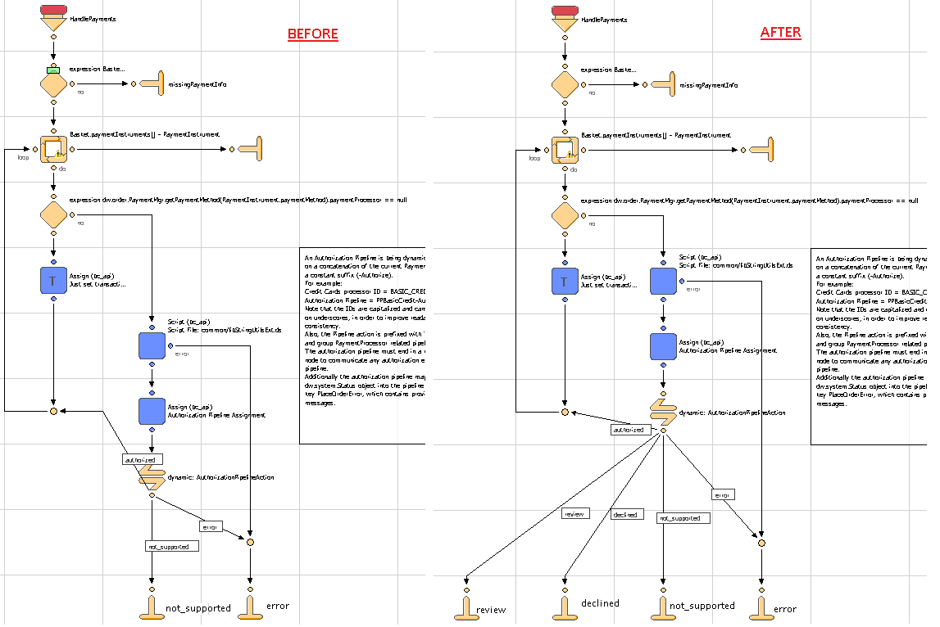

Add a condition in COBilling-SaveCreditCard pipeline node if merchant is using Credit card as payment method with other payment methods such as Paypal(Express or Billing), Alipay and BML for payment. By adding this, payment through BML, Paypal, Alipay payment methods will successfully processed.

Put below mentioned condition in the decision node.

CurrentForms.billing.paymentMethods.selectedPaymentMethodID.value.equals(dw.order.PaymentInstrument.METHOD_BML) || CurrentForms.billing.paymentMethods.selectedPaymentMethodID.value.equals("PayPal") || CurrentForms.billing.paymentMethods.selectedPaymentMethodID.value.equals("ALIPAY") || Basket.paymentInstrument.paymentMethod.equals("PayPal")

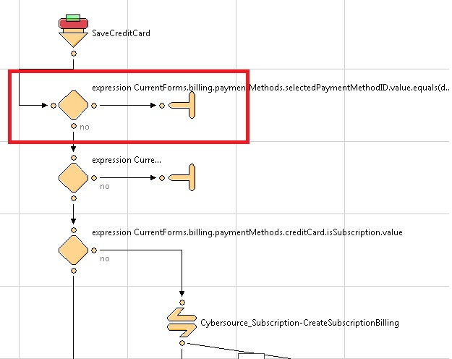

### Bill Me Later

Update COPlaceOrder-HandlePayments pipeline to include Cybersource-AuthorizeBML.

Add logic to handle following responses from the Cybersource-AuthorizeBML:

Authorized, Error, Declined

Note: Refer to screenshot below for changes:

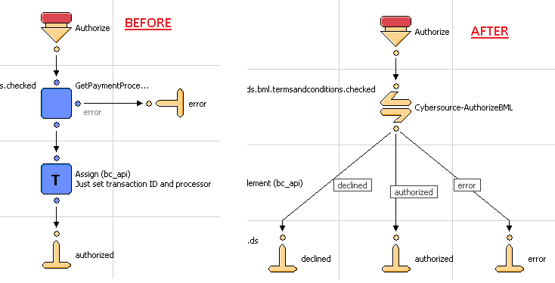

### Tax Service

Update Cart-Calculate pipeline to run the Cybersource-CalculateTaxes call node after running the cart/calculateCart.ds script.  
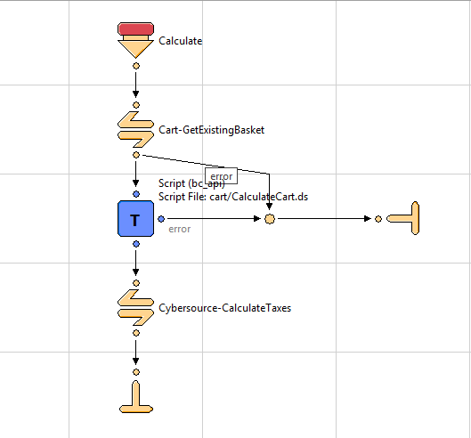

Comment out the built in tax calculation function call in cart/calculateCart.ds

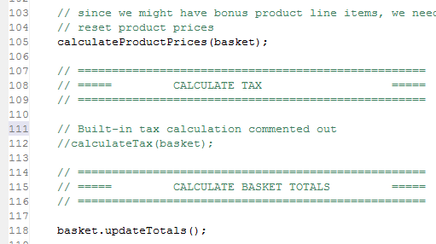

In order to avoid tax calculation call multiple times, set parameter SkipTaxCalculation to true in current session scope in the COShipping-UpdateShippingMethodList pipeline. Refer to the following screenshot:

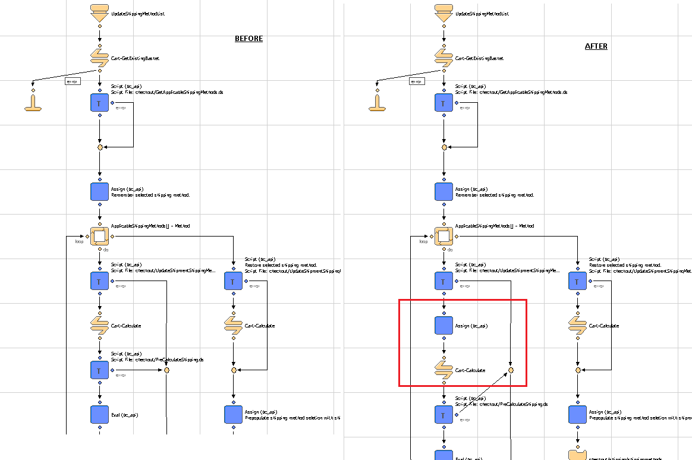

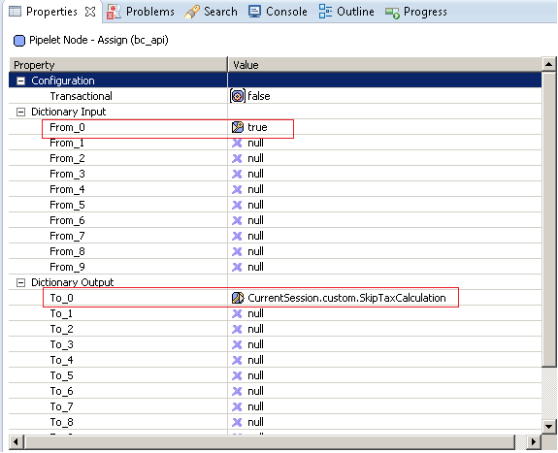

Set cartStateString parameter in current session to null after order has been placed, just before order_createdend node in the COPlaceOrder-Start pipeline. Refer to the following screenshots:

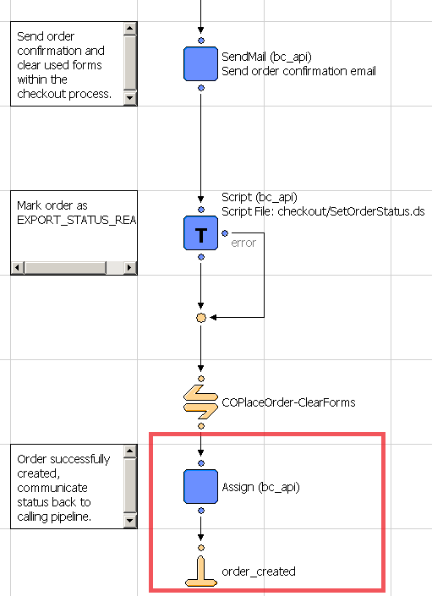

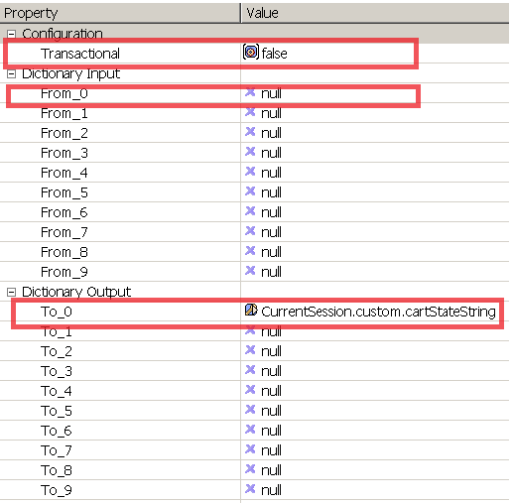

**Note:** Tax service changes specific to storefront cartridge version 15.3.

* package.json

Copy this file from app_storefront_core -> cartridge path and place the same file one folder above in app_storefront_core cartridge itself.

* Calculate.js

Check if your cartridge have latest sitegenesis version 15.3 code and updated Calculate.js file. Comment out the built in tax calculation function call in the same file as shown below.

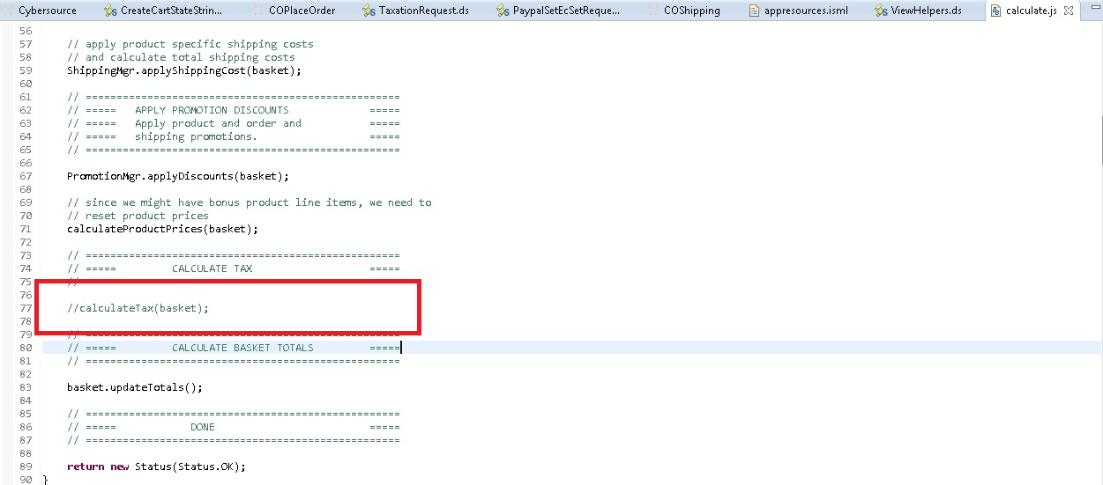

Above mentioned changes are must for calculating tax through Cybersource service calls.

### Address Verification Service

Provide Site Preference values for 2 AVS-related business rules:

CsAvsIgnoreResult – Determines whether AVS failures will force an auth failure

CsAvsDeclineFlags –Determines how “correct” an address must be to produce a failure result

Augment UI interaction nodes to deal with AVS failure or correction confirmation dialogs, wherever Payment Authorization takes place, typically within the COPlaceOrder-Start and COSummary-Submit pipelines.

### Delivery Address Validation Service

Provide Site Preference values for 2 DAV-related business rules:

CsDavEnable – Determines whether DAV features are enabled for payment auth requests

CsDavOnAddressVerificationFailure –Determines whether a DAV failure will result in a payment auth failure

Augment UI interaction nodes to deal with AVS failure or correction confirmation dialogs, wherever Payment Authorization takes place, typically within the COPlaceOrder-Start and COSummary-Submit pipelines.

### Full Authorization Reversal

Full Authorization reversal is created and working in stand-alone mode in Cybersource_Services.xml pipeline. It has to customized and integrated as per the merchant specific needs.

### Payer Authentication Service

Provide Site Preference values for 5 Payment Authorization related business rules:

CyberSource Merchant ID (PA):– Determines which Cybersource merchant id to be used for payer authentication. It can be same as default merchant id as well.

CyberSource Merchant Password (PA): –Password corresponding to the merchant account.

CyberSource Merchant Name (PA): –Merchant Name to be used for service.

CyberSource Save Proof.xml (PA): –Determines whether to save proof.xml (received from Cybersource response) as part of order object.

CyberSource Save ParesStatus(PA): –Determines whether to pass ParesStatus received as input parameter from Pa authorization request as input parameter to ccAuthorization request.

Update COPlaceOrder-HandlePayments pipeline to make custom loop to iterate through all the payment methods set in the basket.

NOTE: This is required as a result of a limitation of Loop Node due to which it does not work properly when an Interaction continue node is encountered in a loop.

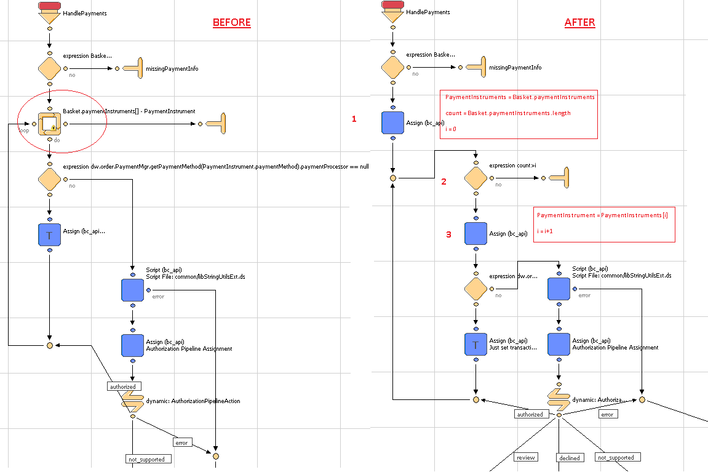

In the diagram above, the loop node in the left side image is now replaced by a custom loop code, created using two Assign nodes and one Decision node. The configuration of Assign node is same as mentioned in the right side image.

### Payment Tokenization Service

Update the form creditcard.xml

Include the following form field in the form:

<!-- field for credit card subscription -->

<field formid="isSubscription" type="boolean" mandatory="false" default-value="false"/>

<field formid="maskedFourDigit"label="creditcard.number" type="string" masked="4" max-length="16"/>

Update the template creditcardjson.isml

Replace the following code block

expirationYear:pdict.SelectedCreditCard.creditCardExpirationYear

With the following code block:

expirationYear:pdict.SelectedCreditCard.creditCardExpirationYear,

isSubscription:pdict.SelectedCreditCard.custom.isSubscription,

maskedFourDigit:pdict.SelectedCreditCard.custom.maskedFourDigit

Update the form customeraddress.xml

Include the following code just before adding the action events

<!-- email field is contained in separate form group to enable binding to customer profile -->

<group formid="email">

<field formid="emailAddress" label="profile.email" type="string" mandatory="true" regexp="^[\w.%+-]+@[\w.-]+\.[\w]{2,6}$" binding="email" max-length="50" missing-error="forms.address.email.invalid" range-error="forms.address.email.invalid" parse-error="forms.address.email.invalid" value-error="forms.address.email.invalid"/>

</group>

Update the form paymentinstruments.xml.

Replace the following code block to include the customeraddress.xml form:

<include formid="newcreditcard" name="creditcard"/>

With the following code block:

<include formid="newcreditcard" name="creditcard"/>

<include formid="address" name="customeraddress"/>

Update the template paymentinstrumentdetails.isml.

Include the following code block just after the <h1> tag to display the title message

<isif condition="${pdict.SubscriptionError != null}">

<div class="error-form">

${Resource.msg('account.subscription','account',null)}

</div>

</isif>

Update the template paymentinstrumentdetails.isml.

Include the following code right after the for field for card expiration year

<!-- code comments for adding new billing fields..-->

<isinputfield formfield="${pdict.CurrentForms.paymentinstruments.creditcards.address.firstname}" type="input"/>

<isinputfield formfield="${pdict.CurrentForms.paymentinstruments.creditcards.address.lastname}" type="input"/>

<isinputfield formfield="${pdict.CurrentForms.paymentinstruments.creditcards.address.address1}" type="input"/>

<isinputfield formfield="${pdict.CurrentForms.paymentinstruments.creditcards.address.address2}" type="input"/>

<isinputfield formfield="${pdict.CurrentForms.paymentinstruments.creditcards.address.country}" type="select"/>

<isinputfield formfield="${pdict.CurrentForms.paymentinstruments.creditcards.address.states.state}" type="select"/>

<isinputfield formfield="${pdict.CurrentForms.paymentinstruments.creditcards.address.city}" type="input"/>

<isinputfield formfield="${pdict.CurrentForms.paymentinstruments.creditcards.address.zip}" type="input"/>

<isinputfield formfield="${pdict.CurrentForms.paymentinstruments.creditcards.address.phone}" type="input"/>

<isinputfield formfield="${pdict.CurrentForms.paymentinstruments.creditcards.address.email.emailAddress}" xhtmlclass="email" type="input"/>

<!-- end code changes for billing fields. -->

Update the template paymentinstrumentlist.isml.

Include the following code just before

<div class="section-header"> to display the error message for delete subscription

<isif condition="${pdict.SubscriptionError != null}">

<div class="error-form">

${Resource.msg(paymentinstrumentlist.deletesubscription','account',null)}

</div>

</isif>

Update the account.properties.

Include the following code just at end of the account.properties file to display error messages

paymentinstrumentlist.deletesubscription=An error occurred while deleting subscription.

account.subscription = Subscription is not created. Please check your card details.

Update template minicreditcard.isml.

To display masked four digits instead of credit card number.

Add a variable within isscript block:

varmaskedFourDigit : String;

Assign the value into maskedFourDigit within if(pdict.p_card != null )

maskedFourDigit = pdict.p_card.custom.maskedFourDigit;

Replace the block of code:

<isif condition="${!empty(ccOwner) && !empty(ccType) && !empty(ccNumber)}">

<isprint value="${ccOwner}"/><br />

<isprint value="${ccType}"/><br />

<isprint value="${ccNumber}"/><br />

With following code block:

<isif condition="${!empty(ccOwner) && !empty(ccType) && !empty(maskedFourDigit)}">

<isprint value="${ccOwner}"/><br />

<isprint value="${ccType}"/><br />

<isprint value="${maskedFourDigit}"/><br />

Update the template paymentmethods.isml.

Include the following code before the credit card number field

<isinputfield formfield="${pdict.CurrentForms.billing.paymentMethods.creditCard.maskedFourDigit}" type="input"/>

Update the template paymentmethods.isml.

Include the following code right after the credit card expiration year field

<isinputfield formfield="${pdict.CurrentForms.billing.paymentMethods.creditCard.isSubscription}" type="hidden" />

Update the template paymentmethods.isml.

Replace the following code within select input type (Select a Credit Card)

<isprint value="${creditCardInstr.maskedCreditCardNumber}"/>

With

<isprint value="${creditCardInstr.custom.maskedFourDigit}"/>

Update the pipeline COBilling-Start.

Add Assign node just before interaction continue node to set isSubscrition form field “false”

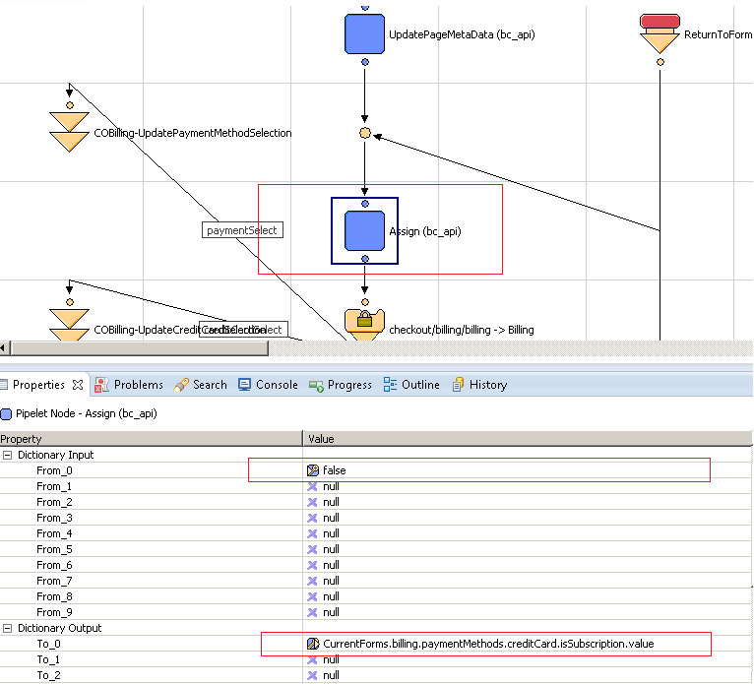

Update the pipeline COBilling-SelectCreditCard.

Update the assign node just after GetCustomerCreditCard.ds.

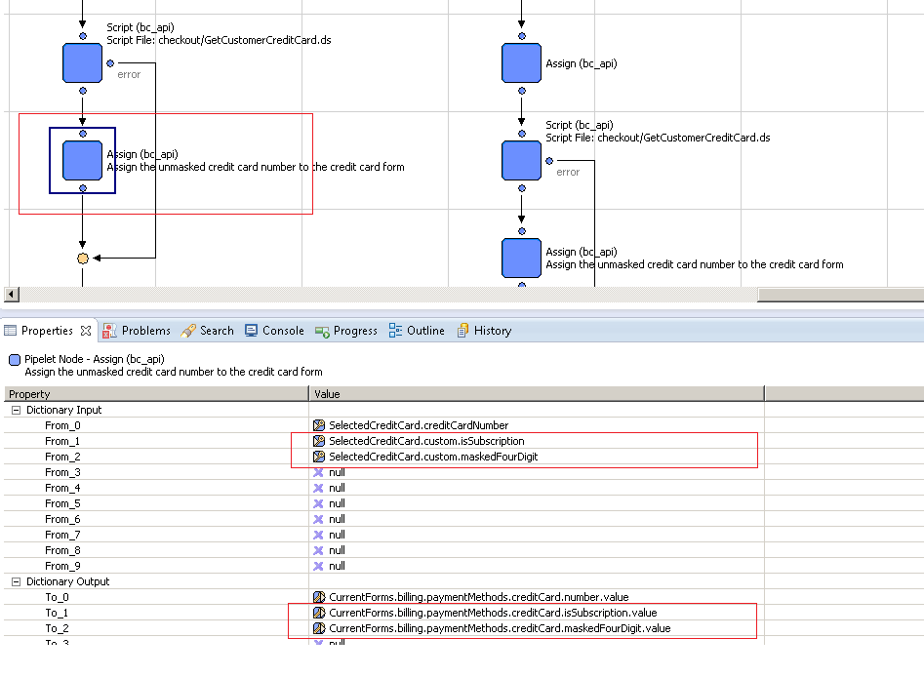

Update the pipeline COBilling-SaveCreditCard.

Add Conditional Node to check if the current payment card is a saved subscription or not. If not make a call to Cybersource pipeline to Create Subscription.

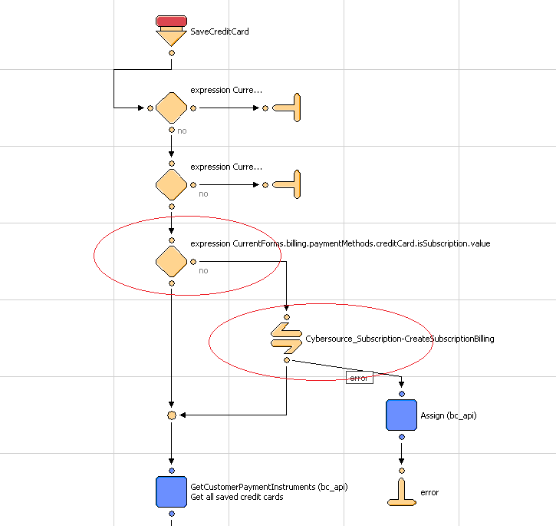

Update the pipeline COBilling-SaveCreditCard .

Add logic to save generated subscription id to customerpaymentinstrument&orderpaymentinstruments object.

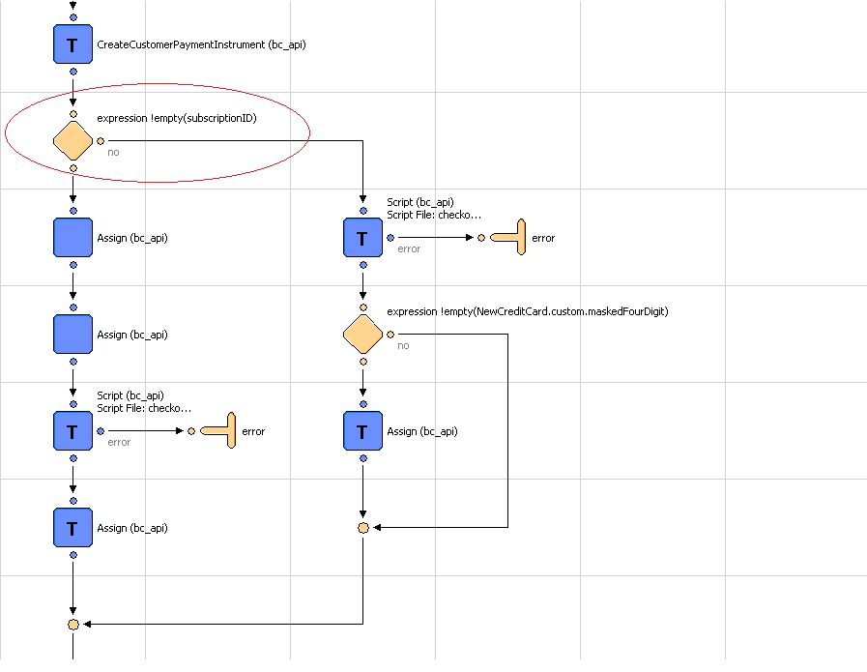

Update the pipeline COBilling-SaveCreditCard.

Add assign node after conditional block of subscriptionID to assign credit card number to masked four digit form field.

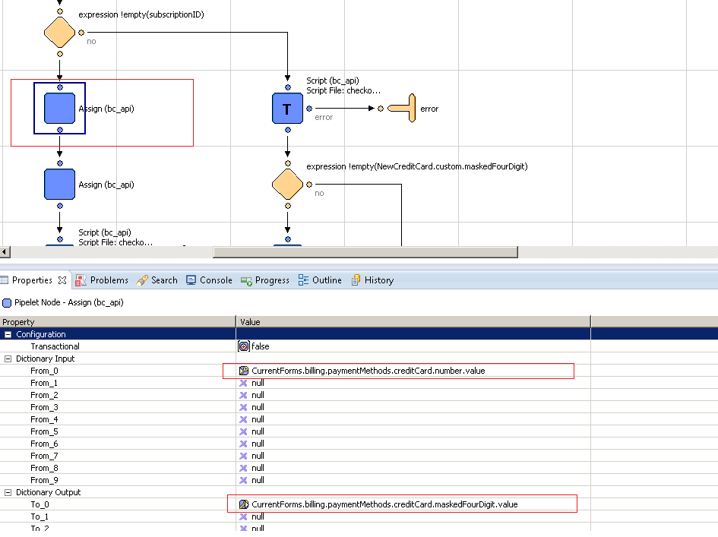

Add assign node just before SaveCustomerCreditCard.ds to update credit card number with subscriptionID.

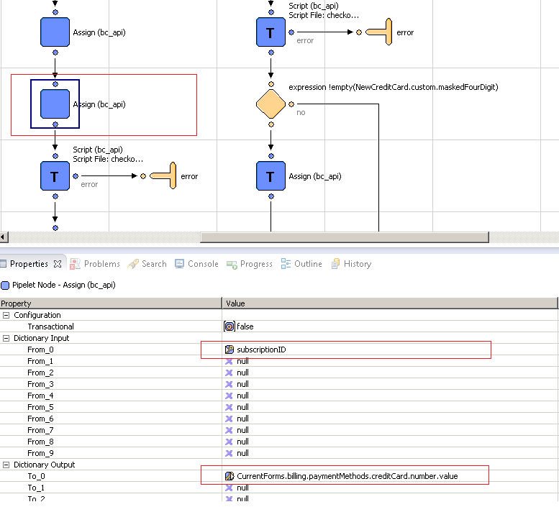

Add another assign node just after SaveCustomerCreditCard.ds to update customerpaymentinstruments&orderpaymentinsturments with subscription.

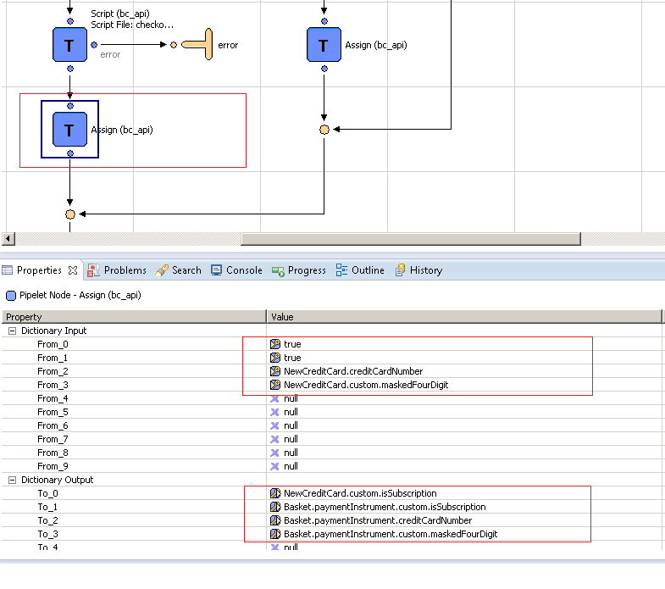

Update the script SaveCustomerCreditCard.ds to update customerpaymentinstruments with credit card form fields. Add the following code block after paymentInstr.setCreditCardType( creditCardFields.type.value ):

if(!empty(creditCardFields.isSubscription.value))

paymentInstr.custom.isSubscription = creditCardFields.isSubscription.value;

if(!empty(creditCardFields.maskedFourDigit.value))

paymentInstr.custom.maskedFourDigit = "************"+creditCardFields.maskedFourDigit.value.slice(creditCardFields.maskedFourDigit.value.length-4,creditCardFields.maskedFourDigit.value.length);

Update the pipeline COBilling-SaveCreditCard. If subscriptionID is empty.

Add the following expression node & assign node:

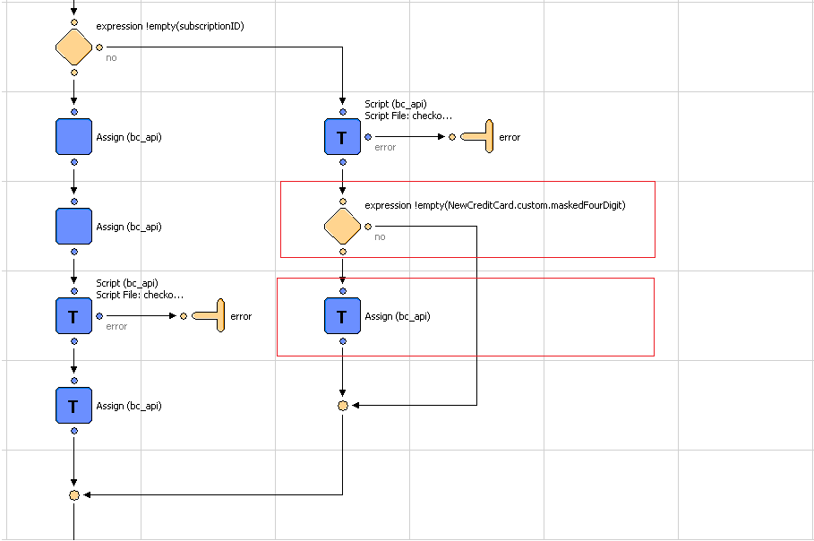

In assign node in above figure. Update the paymentinsturments custom attributessubscriptionID&isSubscription.

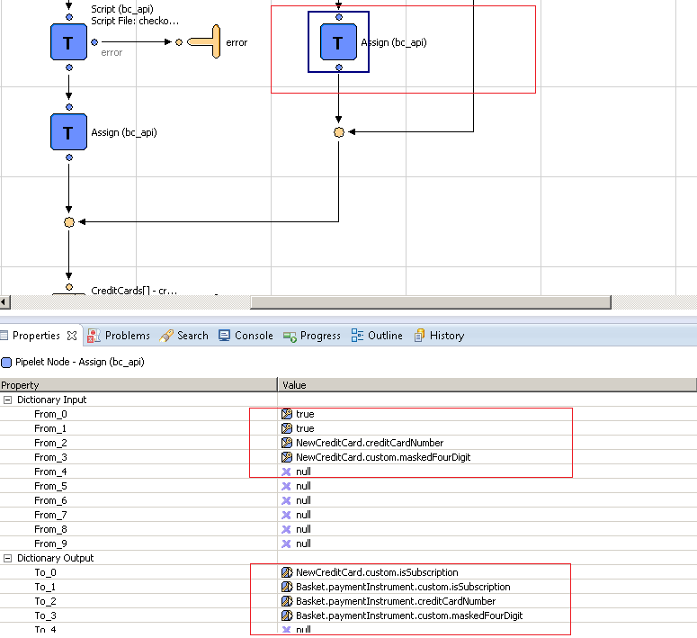

Update app.js. Update exports.init = function () function.

Add following code block after var selectedPaymentMethod = $selectPaymentMethod.find(':checked').val(); code line in above mentioned function

**var** $ccContainer = $($checkoutForm).find(".payment-method").filter(**function**(){

**return** $(**this**).data("method")=="CREDIT_CARD";

});

**var** $ccNum = $ccContainer.find("input[name$='_number']");

**var** $ccSubscription = $ccContainer.find("input[name$='creditCard_isSubscription']");

$ccSubscription.val(**false**);

**var** $ccMaskedFourDigit = $ccContainer.find("input[name$='creditCard_maskedFourDigit']");

$ccMaskedFourDigit.parent().hide();

**if**($ccMaskedFourDigit.val()== **undefined** || $ccMaskedFourDigit.val()=="")

{

$ccMaskedFourDigit.parent().hide();

}

**else**

{

$ccMaskedFourDigit.parent().show();

$ccNum.parent().hide();

$ccSubscription.val(**true**);

}

Update app.js. Update setCCFields function.

Add the following code block after

$creditCard.find('input[name$="_cvn"]').val('').trigger('change');

$creditCard.find('[name$="creditCard_isSubscription"]').val(data.isSubscription).trigger('change');

$creditCard.find('[name$="creditCard_maskedFourDigit"]').val(data.maskedFourDigit).trigger('change');

$creditCard.find("input[name$='creditCard_maskedFourDigit']").parent().show();

$creditCard.find("input[name$='_number']").hide();

$creditCard.find("input[name$='_cvn']").val('');

Update the pipeline BASIC_CREDIT-Handle to skip the subscription id for card validation.

Add Script node CreatePaymentInstrument.ds to create PaymentInstrument for subscription.

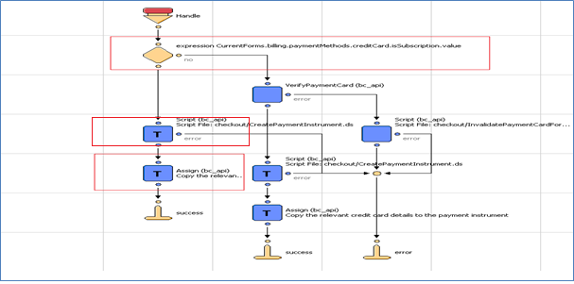

Assign the Input/output parameter as shown in figure below:

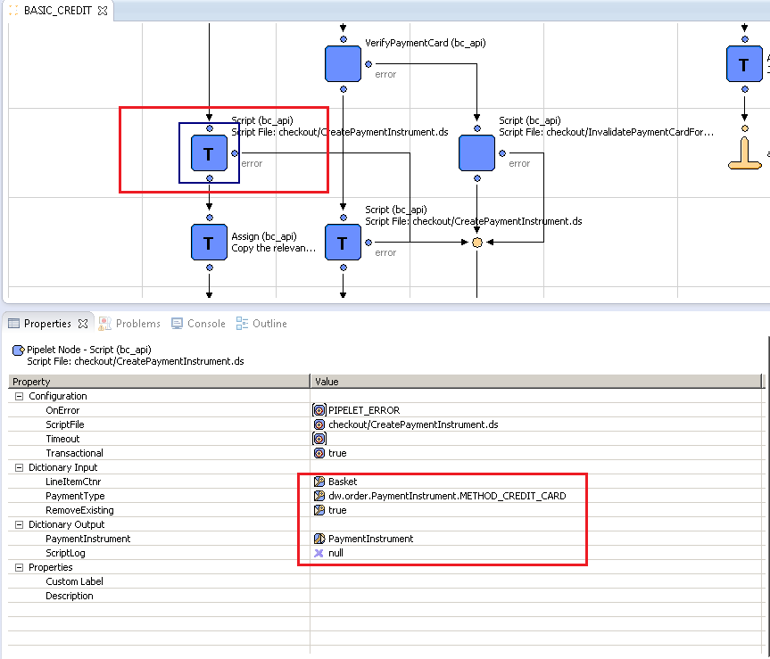

And assign current forms values to PaymentInstrument.

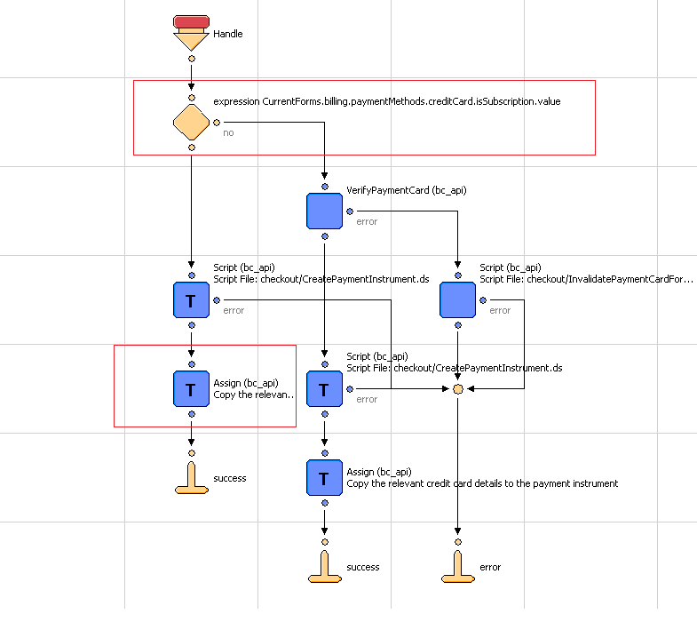

Assign the current credit card form field’s values to Payment Instruments as shown in screen below:

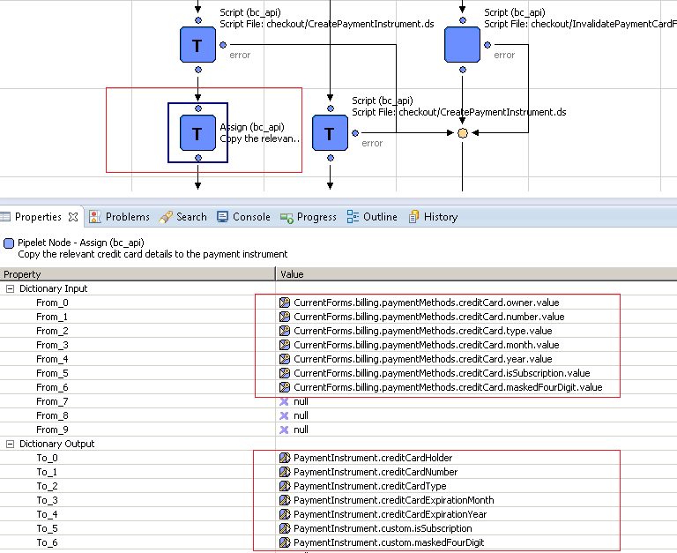

Update the pipeline PaymentInstruments-Add to make a call to Cybersource pipeline to Create Subscription.

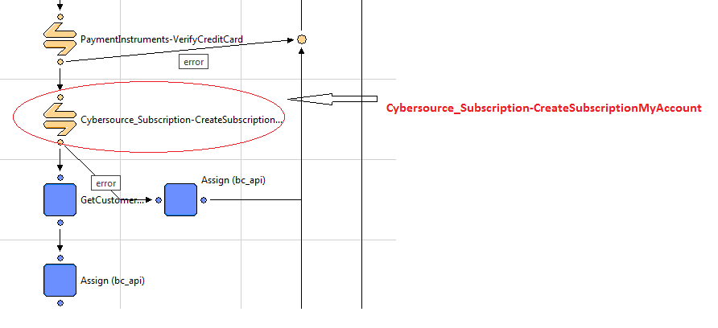

Add assign node just after call node at error connector. And assign the value as shown in screen below:

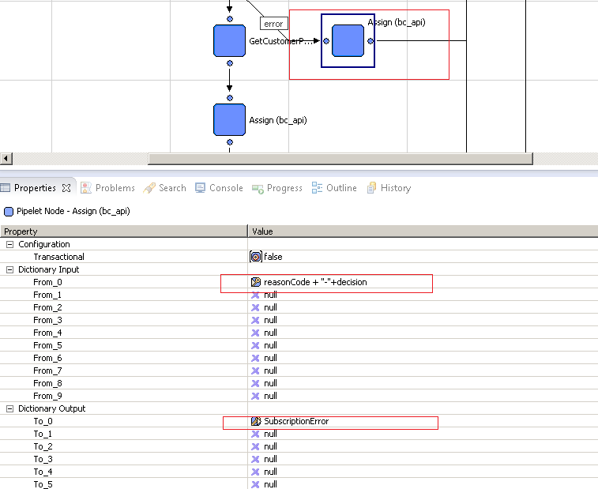

Add assign node just after GetCustomerPaymentInsturments.

Assign the credit card number to masked four digit (newly created field in creditcard.xml)

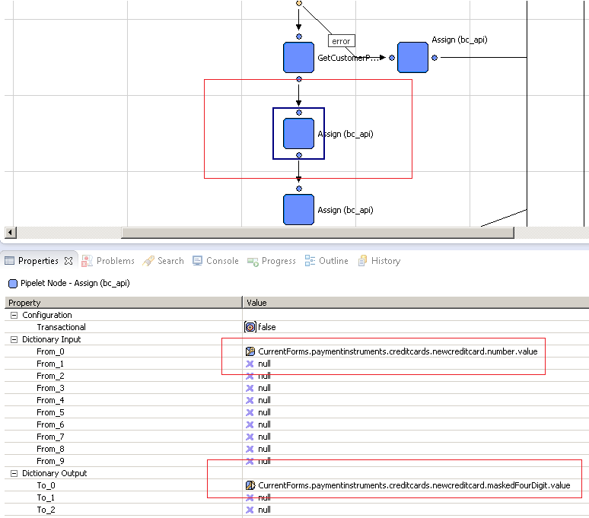

Add assign node just after UpdateObjectWithForm within same pipeline flow.

Update the customer payment instrument with isSubscription&maskedFourDigit (Make sure pipelet should be transactional).

Assign the following value:

************"+CurrentForms.paymentinstruments.creditcards.newcreditcard.maskedFourDigit.value.slice(CurrentForms.paymentinstruments.creditcards.newcreditcard.maskedFourDigit.value.length-4,CurrentForms.paymentinstruments.creditcards.newcreditcard.maskedFourDigit.value.length)

To

PaymentInstrument.custom.maskedFourDigit

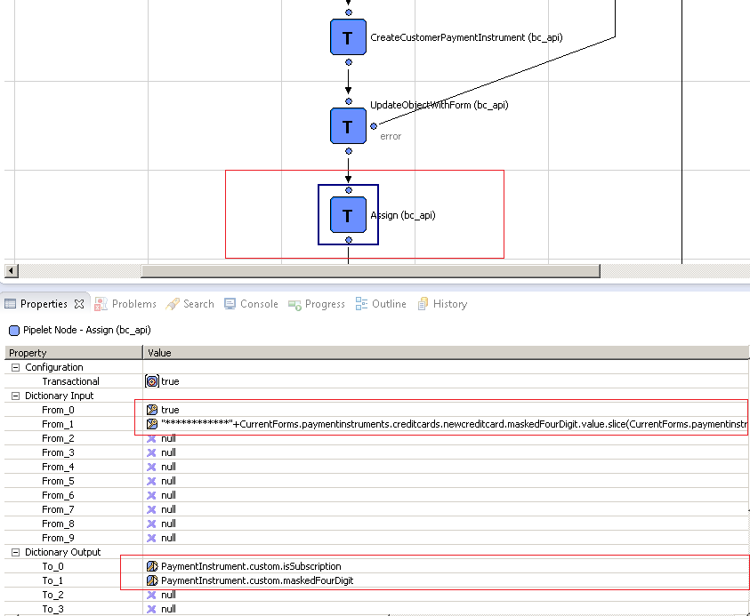

Update the pipeline PaymentInstruments-Delete to make a call to Cybersource pipeline to Delete Subscription. Add call node after expression.

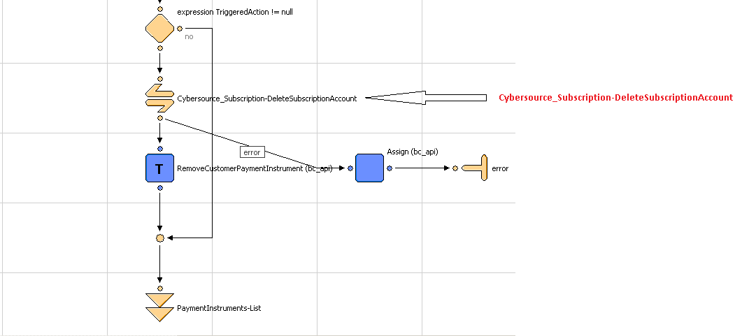

Add assign node just after call node at error connector. And assign the value as shown in screen below:



All functionalities related to Cybersource Payment Tokenization are created and working in stand-alone mode in Cybersource_Subscription.xml pipeline. They have to customized and integrated as per the merchant specific needs

### Alipay Authorization

Add CYBERSOURCE_ALIPAY pipeline to call Cybersource-AuthorizeAlipay pipeline.

**Note:** Refer the screen below for addition.

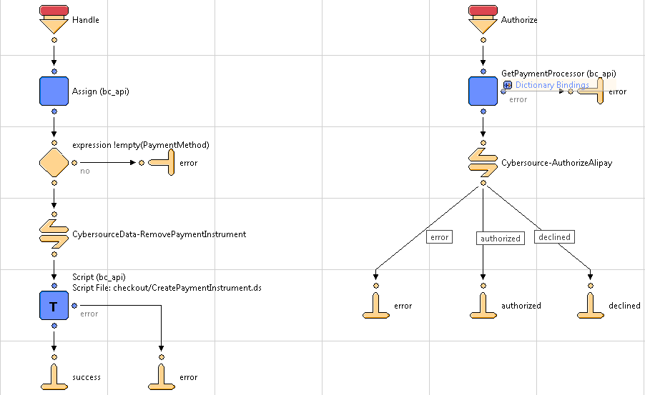

Update COPlaceOrder-Start pipeline for changing the Payment status from “Not Paid” to “Paid” in case of Alipay COMPLETED scenario. Refer the screen shot below for more details.

Put ((Order.paymentInstrument.paymentMethod == 'ALIPAY') && (!empty(Order.paymentTransaction.custom.apPaymentStatus) && Order.paymentTransaction.custom.apPaymentStatus == 'COMPLETED')) condition in the expression node.

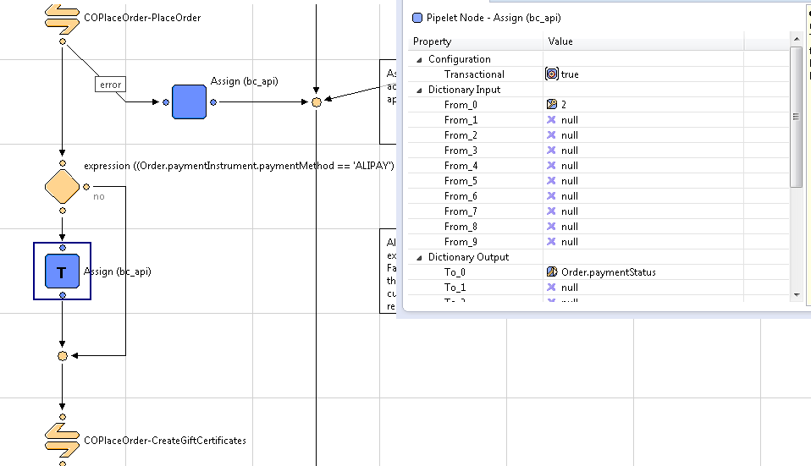

Also, update HandlePayments pipeline to handle response code returned by CyberSource

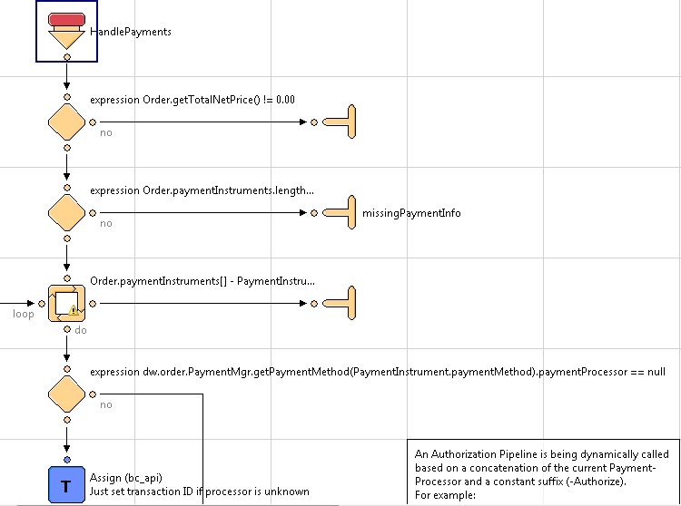

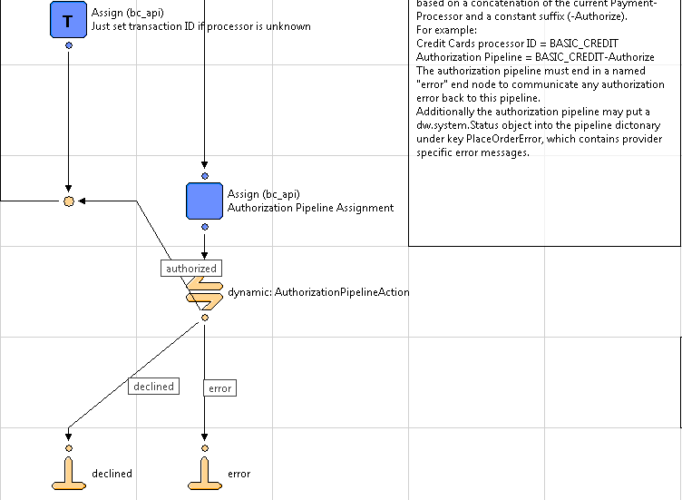

Add an assign node in COPlaceOrder-FailImpl to show the error message on screen in case of alipay error scenarios.

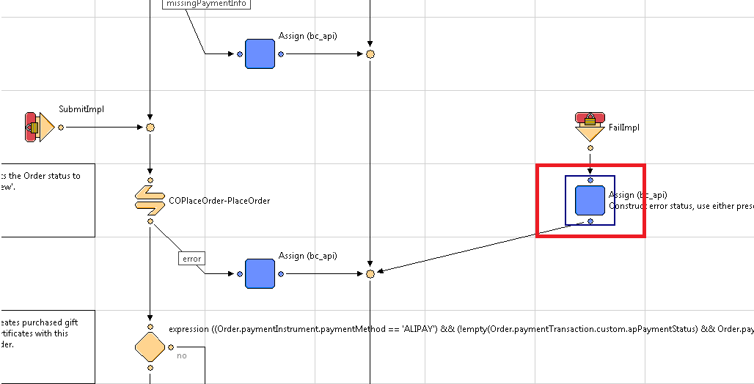

Assign PlaceOrderError != null ? PlaceOrderError : new dw.system.Status(dw.system.Status.ERROR, "confirm.error.declined") value in the pipeline Input Dictionary as shown below.

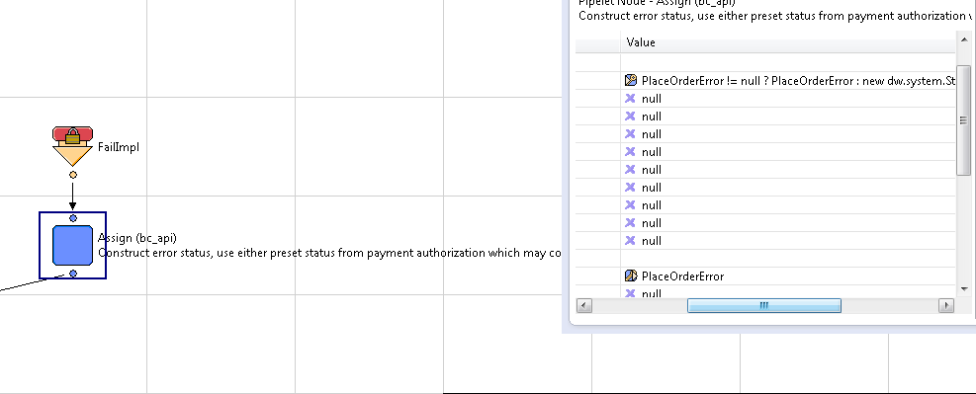

* checkout.properties

Add following values in checkout.properties file for alipay changes.

##############################################

# alipay Checkout

##############################################

alipaycheckout.domesticpaymenttype=APD

alipaycheckout.currency=CNY

alipaycheckout.internationalpaymenttype=APY

### Alipay Batch Job

Add a new start node Cybersource- AlipayCheckPaymentStatusWorkflow to process the orders in Demandware after getting response from Alipay Check Payment Status service. This pipeline will be called from job scheduler to change the status of Demandware orders. It will process all the orders which are in New, Open and Created state and will update the order status after getting response from service call.

**Note:** Please refer to the order status mapping and refer the screen shots below for code changes done in pipeline.

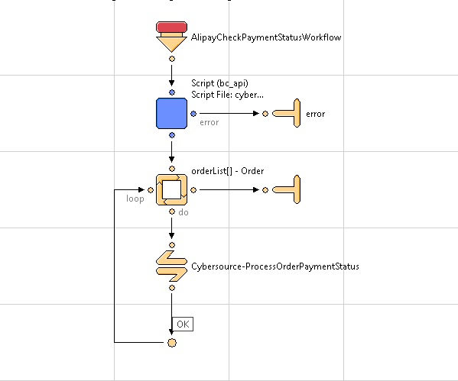

### PayPal Express Checkout [From Cart Page and Mini Cart]

Add a new transition in Cart-Show pipeline to support express checkout from cart as well as mini cart page and to further call Cybersource_Service-PaypalExpressCheckout. Refer the screen shots for more details.

Below screen shot recognize the express checkout from cart page.

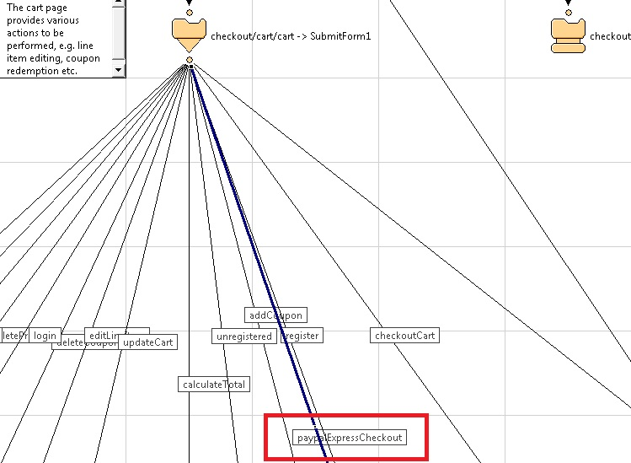

Below screen shot providing the details of start node for express checkout flow from mini cart.

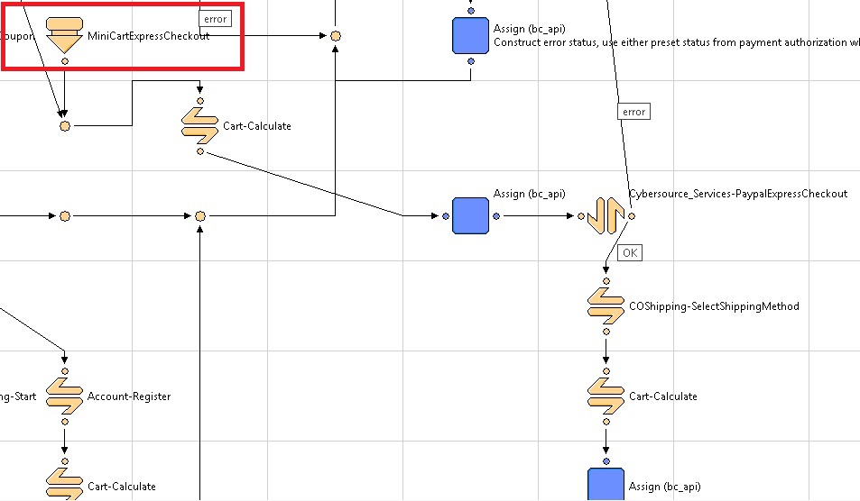

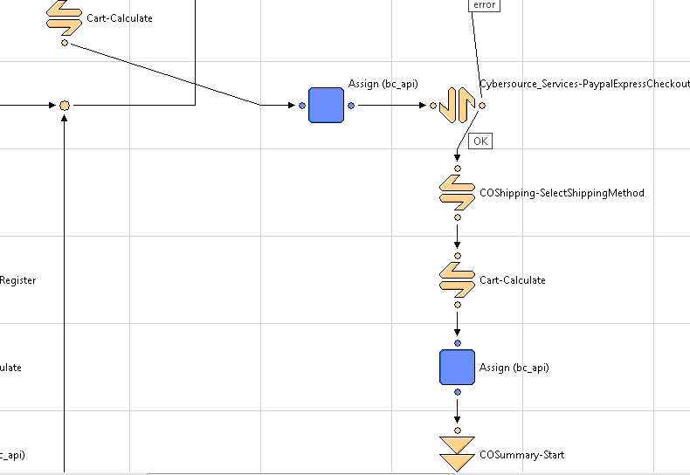

Assign the paypalOrigin to “cart” so as to recognize the flow.

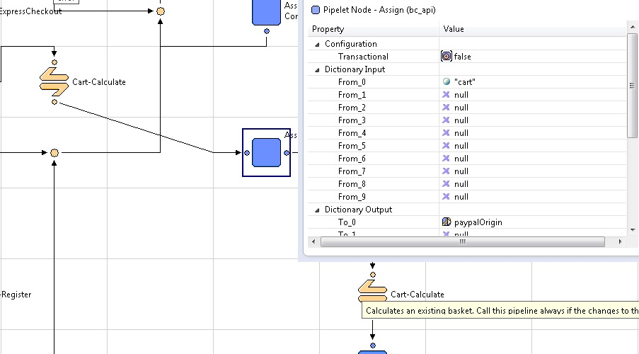

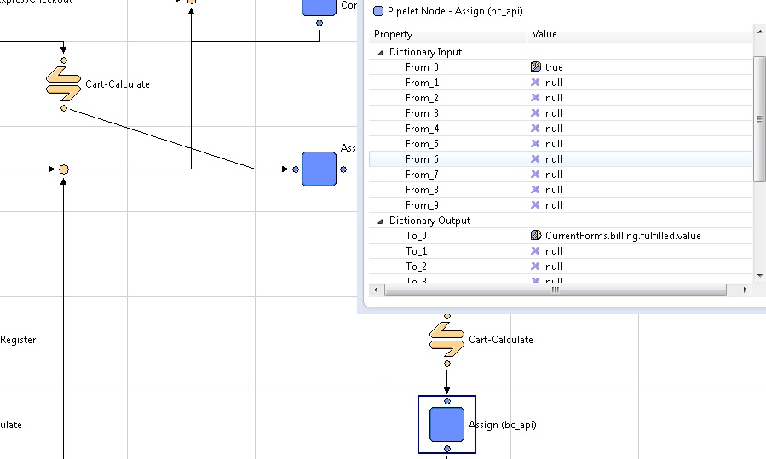

In Cart.xml pipeline also change the COShipping-SelectShippingMethod at the bottom and add a condition for PayPal to continue the checkout flow without using shipping method JSON object. Please refer the screen shot below for the changes in the pipeline.

Add below mentioned condition in the expression node.

PaymentInstrument != null && PaymentInstrument.paymentMethod == "PayPal"

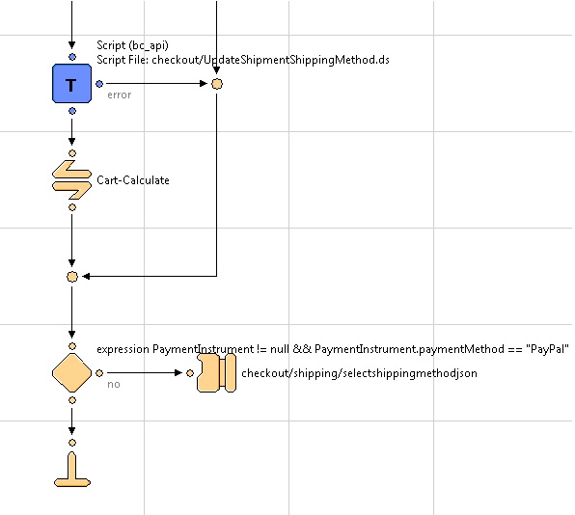

Note: Update HandlePayment pipeline node of COPlaceOrder same as mentioned above for Alipay to handle response from service call.

Also handle responses from COPlaceOrder-HandlePayments pipeline as mentioned below in the screen shot.

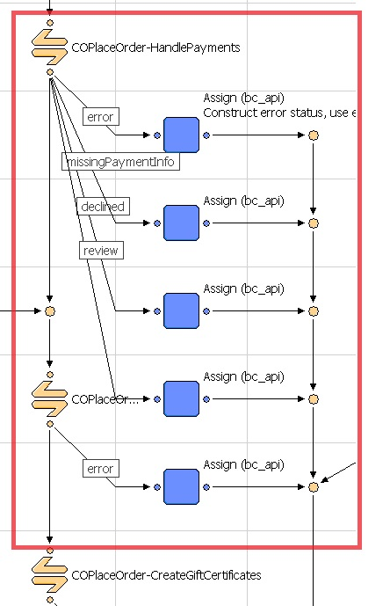

Also add CybersourceData-CreateItemForPaypal call node in COPlaceOrder-Start pipeline before creating an order as mentioned below. This change is required to avail item object in case of express checkout with decision manager enabled.

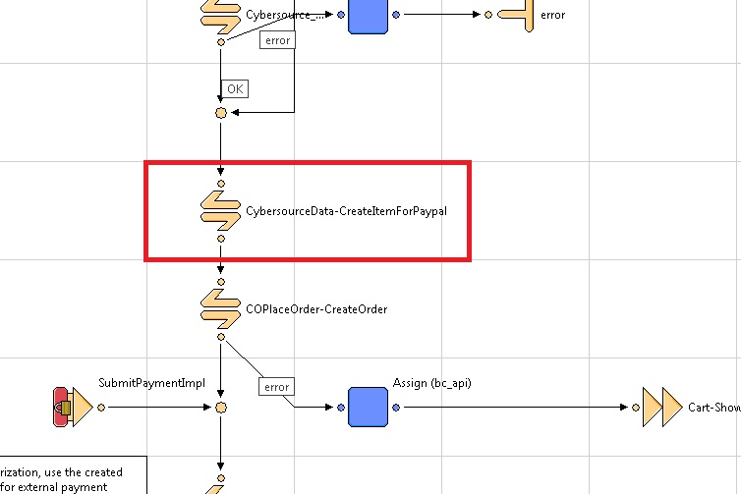

Update PAYPAL_EXPRESS-Handle and PAYPAL_EXPRESS-Authorize to call PayPal Order Setup, PayPal Authorize and capture PayPal. Please refer to the screen shot below:

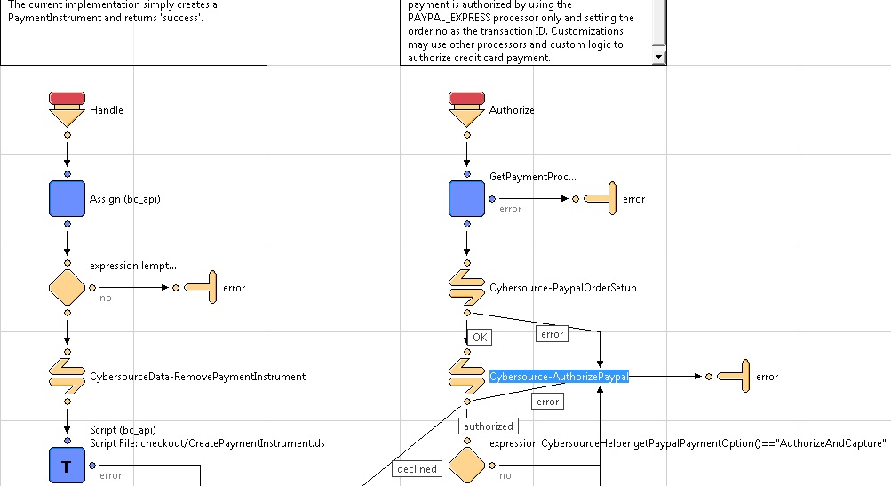

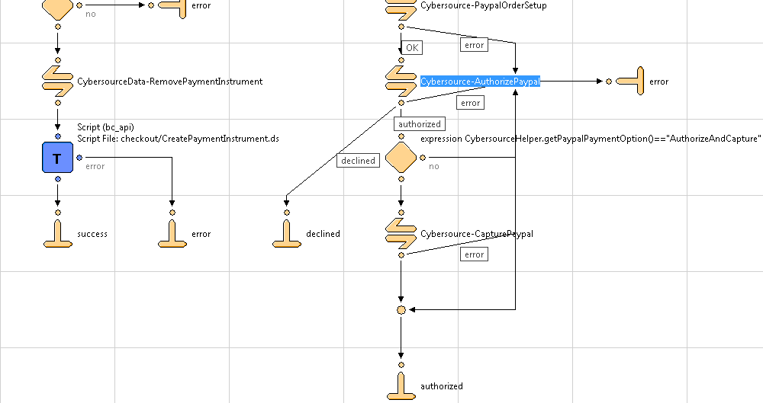

* cart.isml

Add below mentioned code to display the error on cart page while placing an order.

<isif condition=*"${pdict.PlaceOrderError != null}"*>

<div class=*"error-form"*>${Resource.msg(pdict.PlaceOrderError.code,'checkout',null)}</div>

</isif>

Please refer the screen shot below.

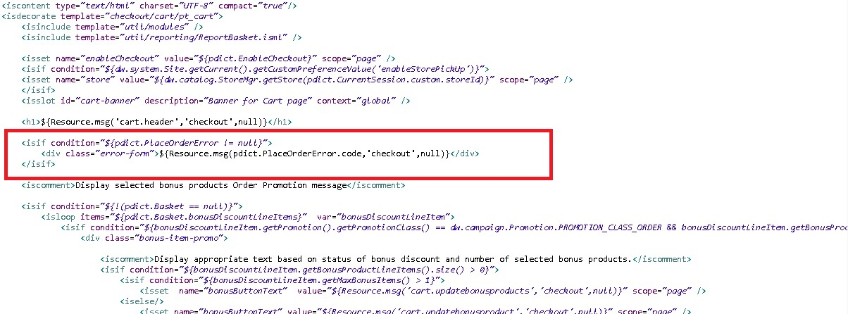

Add below mentioned code to display Paypal Express checkout button in cart page.

<isif condition=*"${dw.system.Site.current.getCustomPreferenceValue('CsEnableExpressPaypal')==true}"*>

<input type=*"image"* src=*"https://www.paypal.com/en_US/i/btn/btn_xpressCheckout.gif"* alt=*"Paypal Express"* name=*"${pdict.CurrentForms.cart.paypalExpressCheckout.htmlName}"* align=*"left"* style="margin-right:*7px*;"/>

</isif>

Please refer the screen shot below.

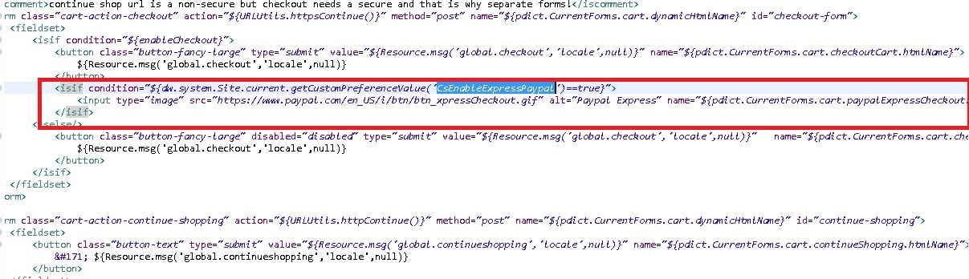

* minicart.isml

Add below mentioned code to display Paypal Express checkout button in minicart.

<form class=*"minicart-action-expresscheckout"* action=*"${URLUtils.url('Cart-MiniCartExpressCheckout')}"* method=*"post"* name=*"${pdict.CurrentForms.cart.dynamicHtmlName}"* id=*"checkout-form"*>

<fieldset>

<isif condition=*"${dw.system.Site.current.getCustomPreferenceValue('CsEnableExpressPaypal')==true}"*>

<input type=*"image"* src=*"https://www.paypal.com/en_US/i/btn/btn_xpressCheckout.gif"* alt=*"Paypal Express"* name=*"${pdict.CurrentForms.cart.paypalExpressCheckout.htmlName}"* align=*"left"* style="margin-right:*7px*;"/>

</isif>

</fieldset>

</form>

Please refer the screen shot below.

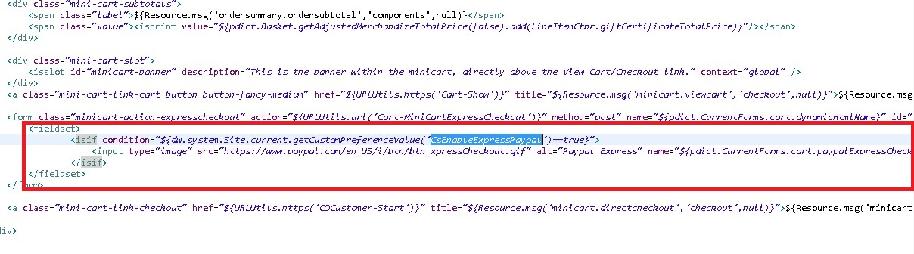

* style.css

Add below mentioned code to format the PayPal Express button in minicart.

*.minicart-action-expresscheckout*{

margin:*20px* *37px*;

}

**Note:** Below mention changes for PayPal Express is merchant specific. Merchant can refer to the changes mentioned below in case of below mentioned requirement.

Customization has been done for PayPal Express Checkout when user choose PayPal Express as Payment option and user redirected back to Demandware order summary page after PayPal, user has a provision to change only Shipping method. After user clicks on Edit button of shipping address as mentioned below, User will redirect to shipping page with all the fields disabled other than shipping method.

Refer to the screen shot below for Edit button on Order summary page.

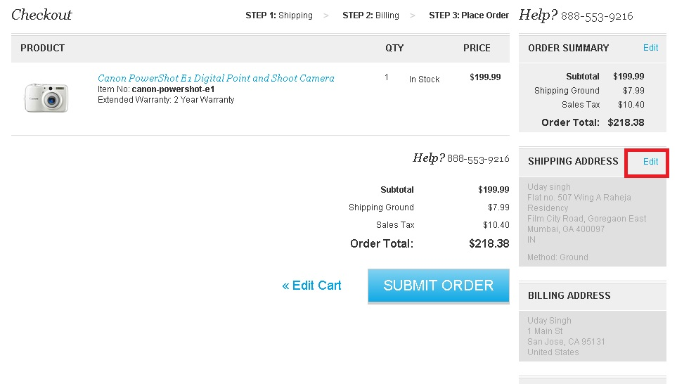

Refer to the screen shot below for disabled rest of the fields other than shipping method.

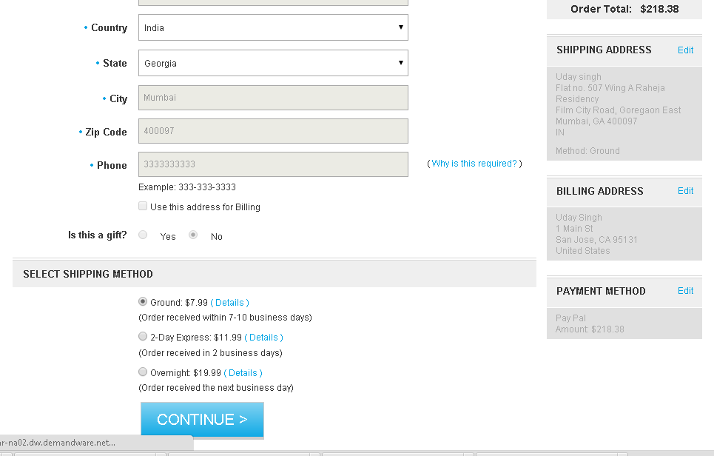

After selecting payment method user will be redirected back to order summary page and can place the order with updated shipping method.

Please refer the code changes for the above mentioned requirement.

* minishipments.isml

Add the code below to set the PayPal origin with the edit URL and refer the screen shot.

<isif condition=*"${!empty(pdict.paypalOrigin) && (pdict.paypalOrigin.equals('cart'))}">*

<isset name=*"editUrl"* value=*"${URLUtils.https('COShipping-Start', 'paypalOrigin', 'cart')}"* scope=*"page"*/>

<isif condition=*"${pdict.CurrentForms.multishipping.entered.value}"*>

<isset name=*"editUrl"* value=*"${URLUtils.https('COShippingMultiple-Start', 'paypalOrigin', 'cart')}"* scope=*"page"*/>

</isif>

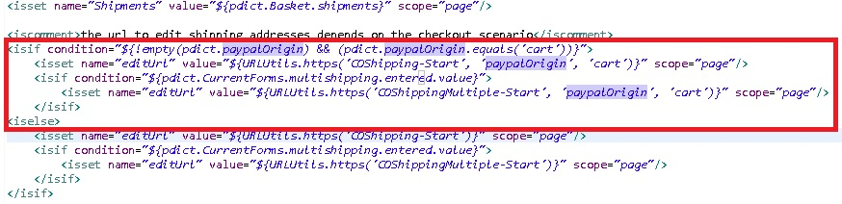

* minibillinginfo.isml

Add the code below to conditionally show the edit button for Billing Address and Payment Method on Order Summary Screen. Add the below mentioned code at two places as mentioned in the screen shot.

<isif condition=*"${( empty(pdict.CurrentHttpParameterMap.paypalOrigin.value) || pdict.CurrentHttpParameterMap.paypalOrigin.value.equals('cart')) && ( empty(pdict.paypalOrigin) || !(pdict.paypalOrigin.equals('cart')))}"*>

<a href=*"${URLUtils.https('COBilling-Start')}"* class=*"section-header-note"*>${Resource.msg('global.edit','locale',null)}</a>

</isif>

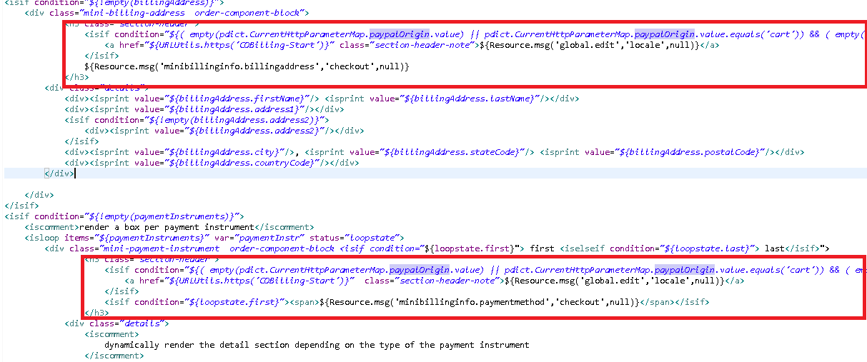

* singleshipping.isml

Add below if condition to conditionally display the added address dropdown for registered customers**.**

*<*isif *condition="${empty(pdict.CurrentHttpParameterMap.paypalOrigin.value) || !(pdict.CurrentHttpParameterMap.paypalOrigin.value.equals('cart'))}">*

*<iscomment> enter the code here </iscomment>*

</isif*>*

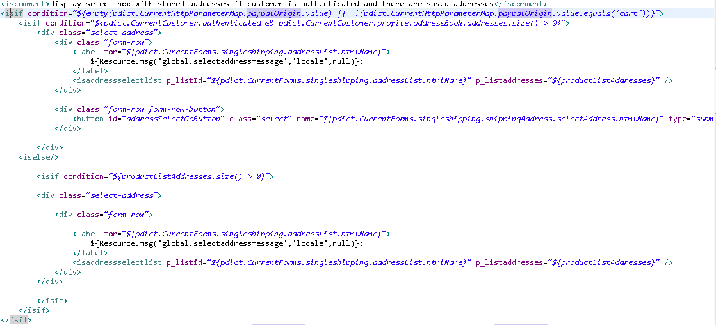

Add below mentioned code in the same file to conditionally hide the address fields and also set the attribute1="disabled" and value1="disabled" for fields as mentioned below in the screen shots.

*<*isif *condition="${!empty(pdict.CurrentHttpParameterMap.paypalOrigin.value) && (pdict.CurrentHttpParameterMap.paypalOrigin.value.equals('cart'))}">*

*<iscomment> enter the code here for disabled fields</iscomment>*

*<iselse>*

*<iscomment> enter the code here for enabled fields</iscomment>*

*</*isif*>*

Also set the value of isBillingRequiredForExpressCheckout variable in the same file as shown in the screen shot below to refer it in COShipping.xml file for redirecting the user from directly Shipping to Order Summary page.

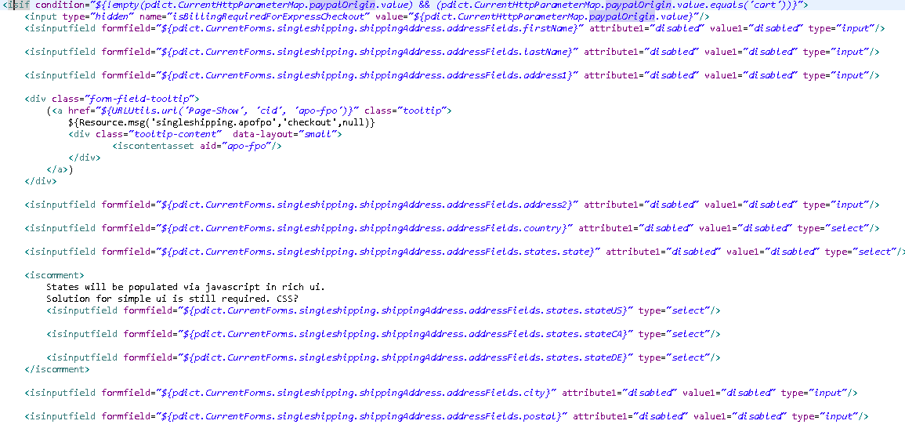

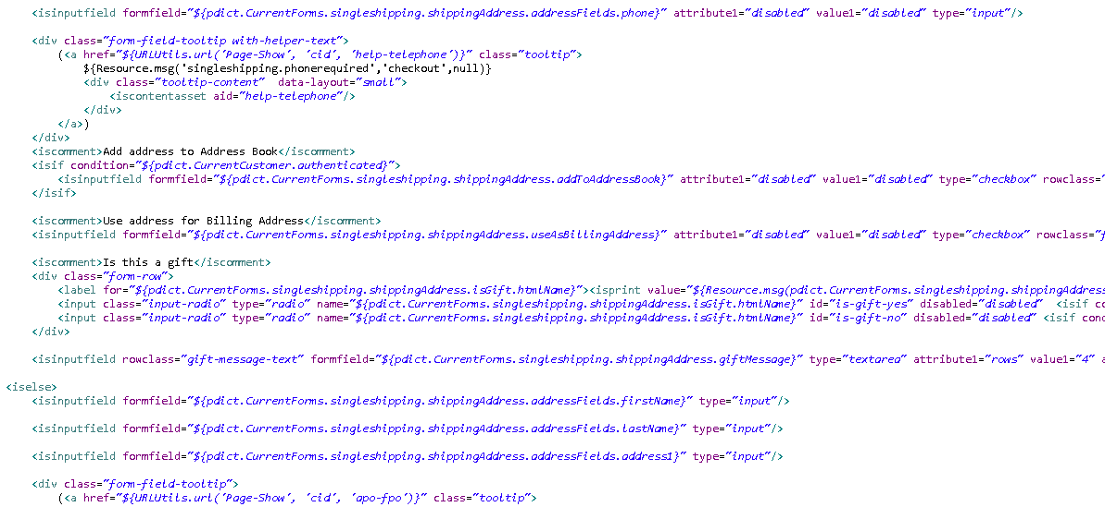

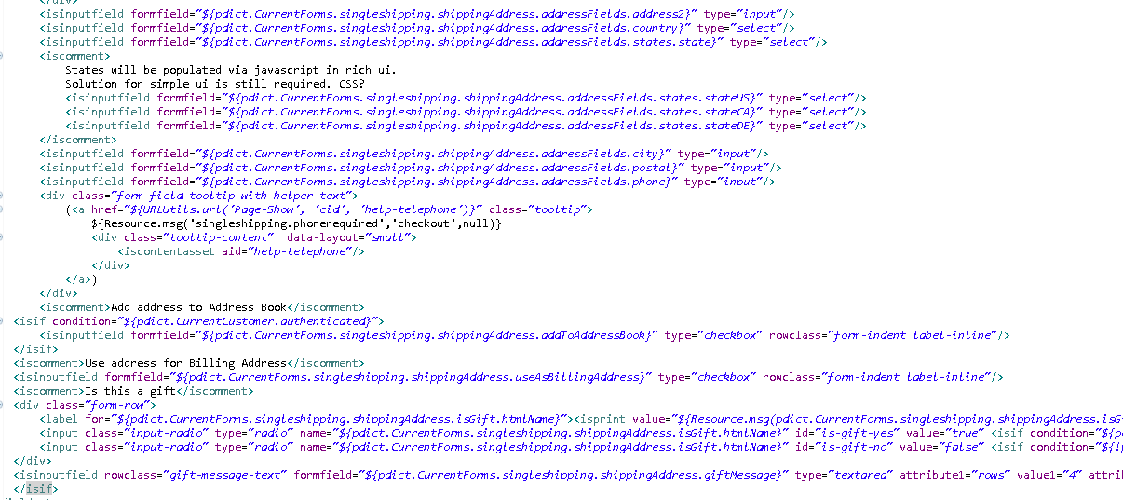

* COShipping.xml

Changes have been made in pipeline COShipping-Start node to redirect the user directly from shipping page to order summary page. Add a below condition in expression node and refer to the screen shot below.

empty(CurrentHttpParameterMap.isBillingRequiredForExpressCheckout.value) || !(CurrentHttpParameterMap.isBillingRequiredForExpressCheckout.value.equals('cart'))

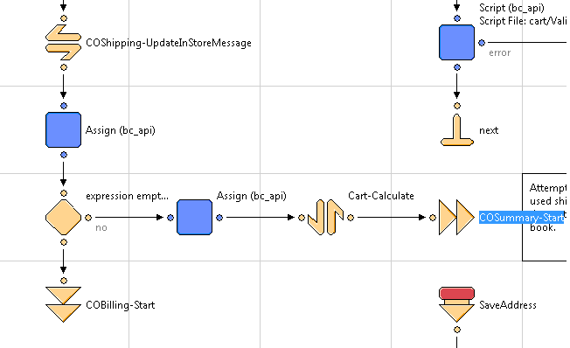

Set the value of paypalOrigin to cart again just to hide Edit button for Billing Address section and Payment Method section.

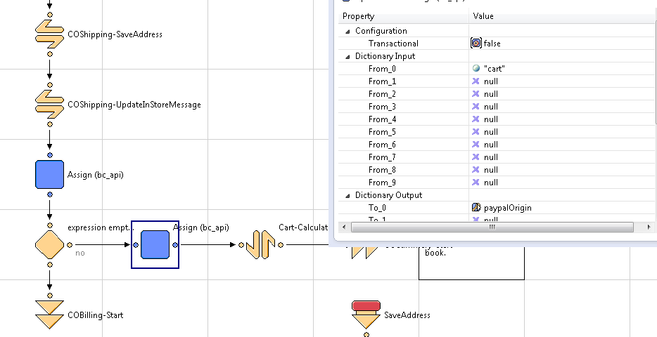

### PayPal Checkout [From Billing Page]

Add a new transition in COPlaceOrder-Start pipeline to support express checkout with normal checkout flow from billing page and to further call Cybersource_Service-PaypalExpressCheckout. Refer the screen shots for more details.

Below screen shot recognize the express checkout from billing page. Add below mentioned condition in the expression node.

Basket.paymentInstrument.paymentMethod.equals('PayPal') && empty(Basket.paymentInstrument.paymentTransaction.custom.payPalPayerId) && empty(Basket.paymentInstrument.paymentTransaction.custom.paypalToken) && empty(Basket.paymentInstrument.paymentTransaction.custom.paypalEcSetRequestToken) && empty(Basket.paymentInstrument.paymentTransaction.custom.paypalEcSetRequestID)

This condition has been added in the flow to bypass the set get service call in case both the calls have already been made and values of set get service response are already present. We can consider any error scenario of Order setup, Authorization and Capture service. In case of any error occurs in any of the mentioned service, there is no need to call set get service again.

Add transition node for Cybersource_Service-PaypalExpressCheckout and CybersourceData-CreateItemForPaypal before creating an order as shown below:

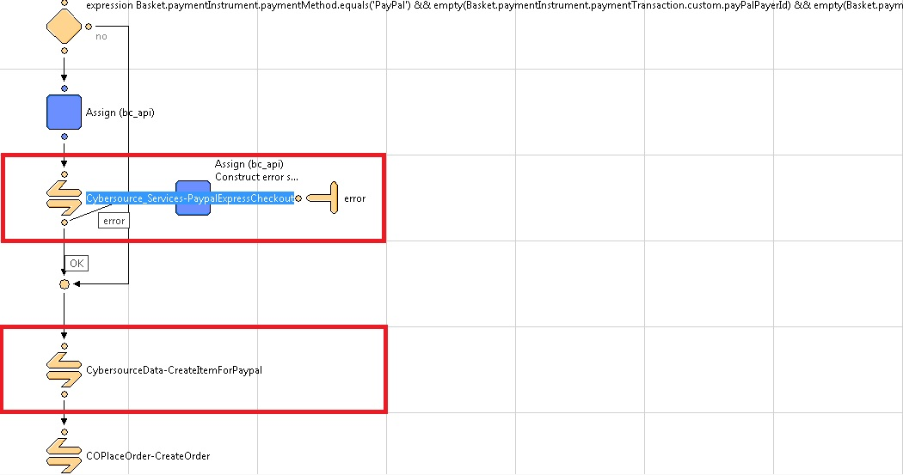

**Note:** Also handle responses from COPlaceOrder-HandlePayments pipeline as mentioned below in the screen shot.



* cart.xml

Add an action entry in cart.xml as mentioned below to run Paypal from cart page.

<action formid="paypalExpressCheckout" valid-form="false"/>

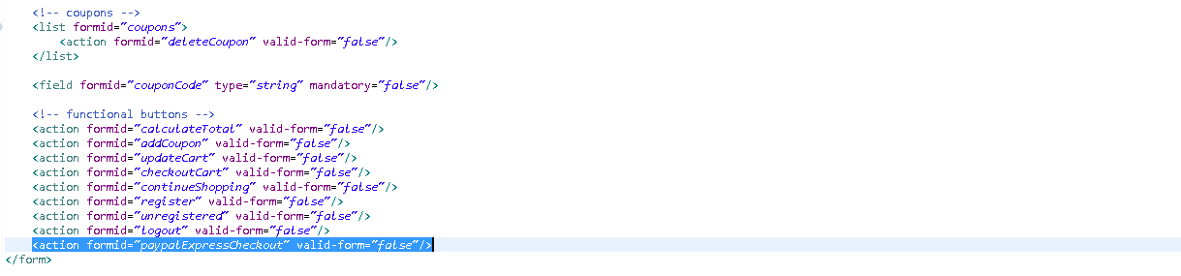

Note: Update HandlePayment pipeline node of COPlaceOrder same as mentioned above for Alipay to handle response from service call.

**Note:** Update PAYPAL_EXPRESS-Handle and PAYPAL_EXPRESS-Authorize node same as mentioned above for PayPal Express Checkout.

### Remove Duplicate Payment Methods while Checkout

Customization has been done to remove duplicate payment method while making the payment. This functionality is not provided by Site Genesis by default in the storefront cartridge. So merchant need to make the changes in the existing cartridge to remove duplication of payment methods.

For Alipay and Paypal, code has been written in the Cybersource cartridge to remove the duplication. This issue was coming when user change the payment method from summary page by clicking Edit button in Payment Method section. So after changing the payment method user was getting both the methods on order summary page instead of overwritten method. To resolve this issue CybersourceData-RemovePaymentInstrument has been added in both CYBERSOURCE_ALIPAY and PAYPAL_EXPRESS at Handle node. This change is already there in Cybersource cartridge.

One more issue was there in the storefront, when user select credit card as payment method and change the payment method to Alipay on summary page the same issue was coming. For Paypal as Payment method, this issue was already handled in Storefront cartridge but issue was still there with Alipay as Payment Method. Add a RemoveBasketPaymentInstrument pipelet in COBilling-ResetPaymentForms pipeline. Refer the following screen shot for the custom code.

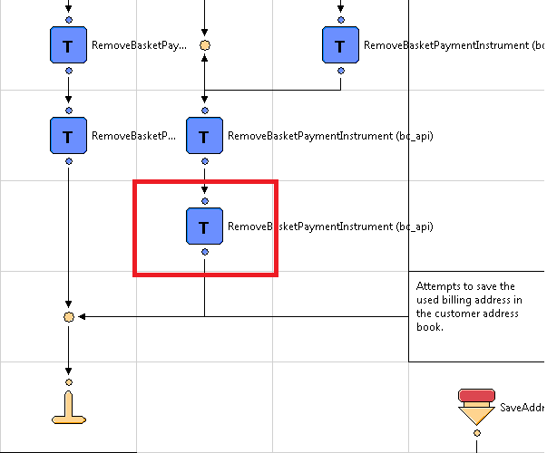

Set the Payment Instrument value to Basket.getPaymentInstruments( "ALIPAY")

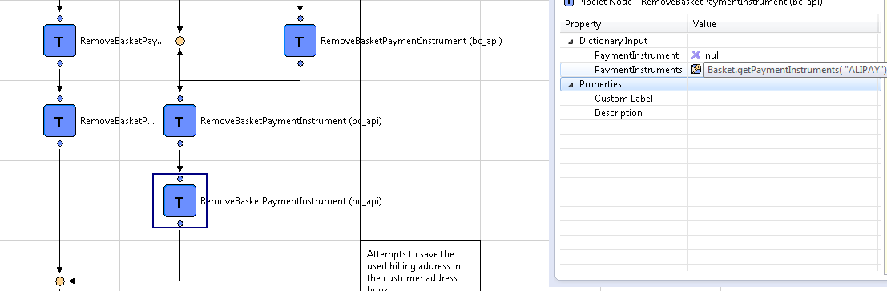

### Retail POS

This integration requires only one sub-pipeline to be integrated to your project. The pipeline screenshot is shown below which needs to be called in your project as required:

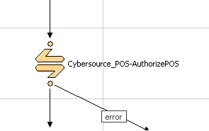

This required call node should be integrated at EACreditCard-Authorize pipeline of DSS app as show below. The track data, expiration date or account number should not be encrypted and may need to be decrypted prior to calling Cybersource_POS-AuthorizePOS depending on the payment terminal used.

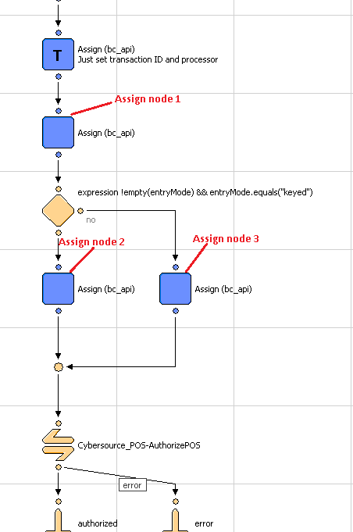

Three assign nodes must be used for required node Cybersource_POS-AuthorizePOS to work correctly as shown above. The assign node must set variables based on POS terminal entry mode. Below are the use and description for assignment of variables. Assuming that object.attribute variable used in Assign node will be replaced by actual object/variable to get the required values:

POS terminal entry mode can be set in int_ocapi_ext/cartridge/scripts/actions/CaptureCreditCardDetails.ds as shown below.

1. Use of Assign node labeled as “Assign node 1” above. This will set the common variables for the transaction irrespective of entry mode used. Below is the screenshot of variables used in this assign node:

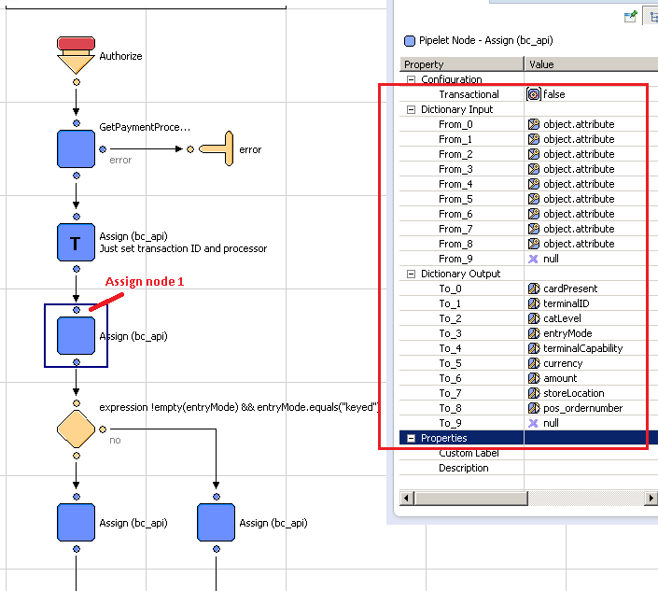

Example input variables from DSS:



2. Use of Assign node labeled as “Assign node 2” if keyed entry mode is used on the POS terminal device. See below screenshot for the list of variables to set:

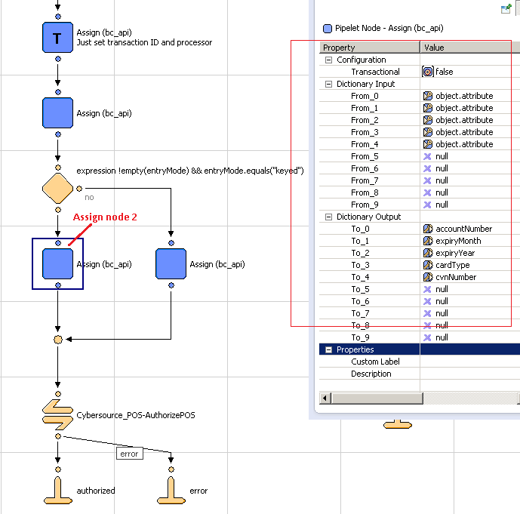

Example input variables from DSS:



1. Use of Assign node labeled as “Assign node 3” if swiped entry mode is used on the POS terminal device. See below screenshot for the variable to set:

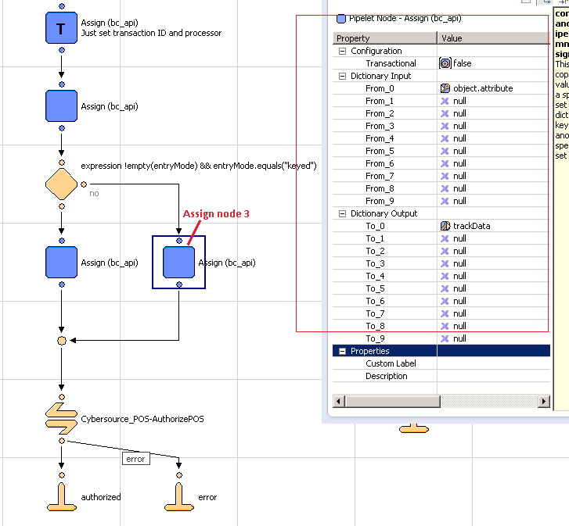

Example of input variables from DSS:

Below is the snapshot of required pipeline.

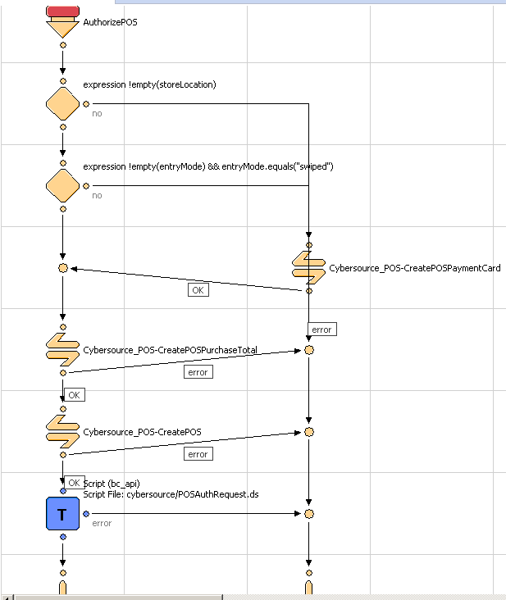

Below is the list of variables with description. One or two variables become mandatory depending upon other variables and few are optional:

|  |  |  |  |
| --- | --- | --- | --- |
| S. No. | Variable name | Description | Note |
| 1 | cardPresent | Indicates whether the card is present at the time of retail POS transaction. Possible values:  N – card not present  Y – card is present | Required. |
| 2 | catLevel | Type of cardholder activated terminal. Possible values:  1 – Automated dispensing machine  2 – Self-service terminal  3 – Limited amount terminal  4 – In-flight commerce (IFC) terminal  5 – Radio frequency device  6 – Mobile acceptance terminal | Optional. This variable becomes required if terminalID variable is set to a value. |
| 3 | entryMode | Method of entering credit card information into the POS terminal. Possible values:  keyed – Manually keyed into POS terminal.  swiped – Read from credit card magnetic stripe. | Required. |
| 4 | terminalCapability | POS terminal’s capability. Possible values:  1 – Terminal has a magnetic stripe reader only.  2 – Terminal has a magnetic stripe reader and manual entry capability.  3 – Terminal has manual entry capability only. | Required. |
| 5 | terminalID | Identifier for the terminal at your retail location. You can define this value yourself, but consult with the processor for requirements. Terminal ID(s) are configurable in a custom object named ‘POS_TerminalMapping’ (Refer custom object definition XML to be impoorted). Here terminal device’s serial number will be mapped to a Terminal ID. This variable should be assigned device’s serial number. Code will pick configured Terminal ID if found and passed to CyberSource API in request. | Optional. |
| 6 | trackData | Card’s track 1 and 2 data. Some processors require track 1 data, some processors require track 2 data, and some processors require both track 1 data and track 2 data. To make sure that you provide the required information regardless of the processor that you use now or may use in the future, CyberSource recommends that you send both track 1 and track 2 data in your retail POS requests.  The sentinels are required. The start sentinel (%) indicates the initial data position on the track. The end sentinel (?) follows the final character of data recorded on the track. Details of track 1 and track 2 data for the example %B4111111111111111^SMITH/JOHN^1612101976110000868000000?;4111111111111111=16121019761186800000?  Track 1 – the track 1 data precedes the semicolon (;)  Track 2 – the track 2 data follows the semicolon (;) | Required if entryMode=swiped. |
| 7 | currency | Currency used for order. For possible values refer [ISO Standard Currency Codes](http://apps.cybersource.com/library/documentation/sbc/quickref/currencies.pdf) | If this variable is not set with any currency code then default currency code is retrieved configured for web store in Business Manager. |
| 8 | amount | Grand total for the order. |  |
| 9 | accountNumber | Customer’s credit card number. | This variable becomes mandatory if entryMode=keyed. |
| 10 | cardType | Type of card to authorize. Possible values:  001 – Visa  002 – MasterCard  003 – American Express  004 – Discover  005 – Diners Club  006 – Carte Blanche  007 – JCB | CyberSource strongly recommends that you send the card type even when it is optional for your processor and card type. Omitting the card type can cause the transaction to be processed with the wrong card type. |
| 11 | cvnNumber | This number is never transferred during card swipes. | Optional. |
| 12 | expiryMonth | Two-digit month in which credit card expires. Format: MM. Possible values: 01 through 12. Leading 0 is required. | Required if entryMode=keyed. |
| 13 | expiryYear | Four-digit year in which credit card expires. Format: YYYY. | Required if entryMode=keyed. |
| 14 | storeLocation | Store’s physical location. This is use to configure merchant’s ID and security key in a custom object to call CyberSource API for the transaction. This is dependent upon merchant how they wanted to link store(s) to Merchant ID (MID). For e.g. if merchant has 3 separate CyberSource merchant ID and want to use one MID for store(s) in Massachusetts, 2nd MID for store(s) in New York City, etc. then assign this variable as MA or Massachusetts or any string representing the location AND configure the same value as POS Location field for POS_MerchantIDs custom object in Business Manager after import. | Location can be set as State code or Zip code or city etc. For e.g. MA (Massachusetts) or  01803 (Burlington, MA) or  Burlington |
| 15 | pos_ordernumber | Order number for the transaction needs to be set to this variable | Required |

In order to obtain messages in DSS based on failures from Cybersource changes will need to be made to int_cybersource/cartridge/scripts/cybersource/POSAuthRequest.ds in order to output a Status. Add a @output Status : dw.system.Status to the beginning comment of the file and then set the following Status values:

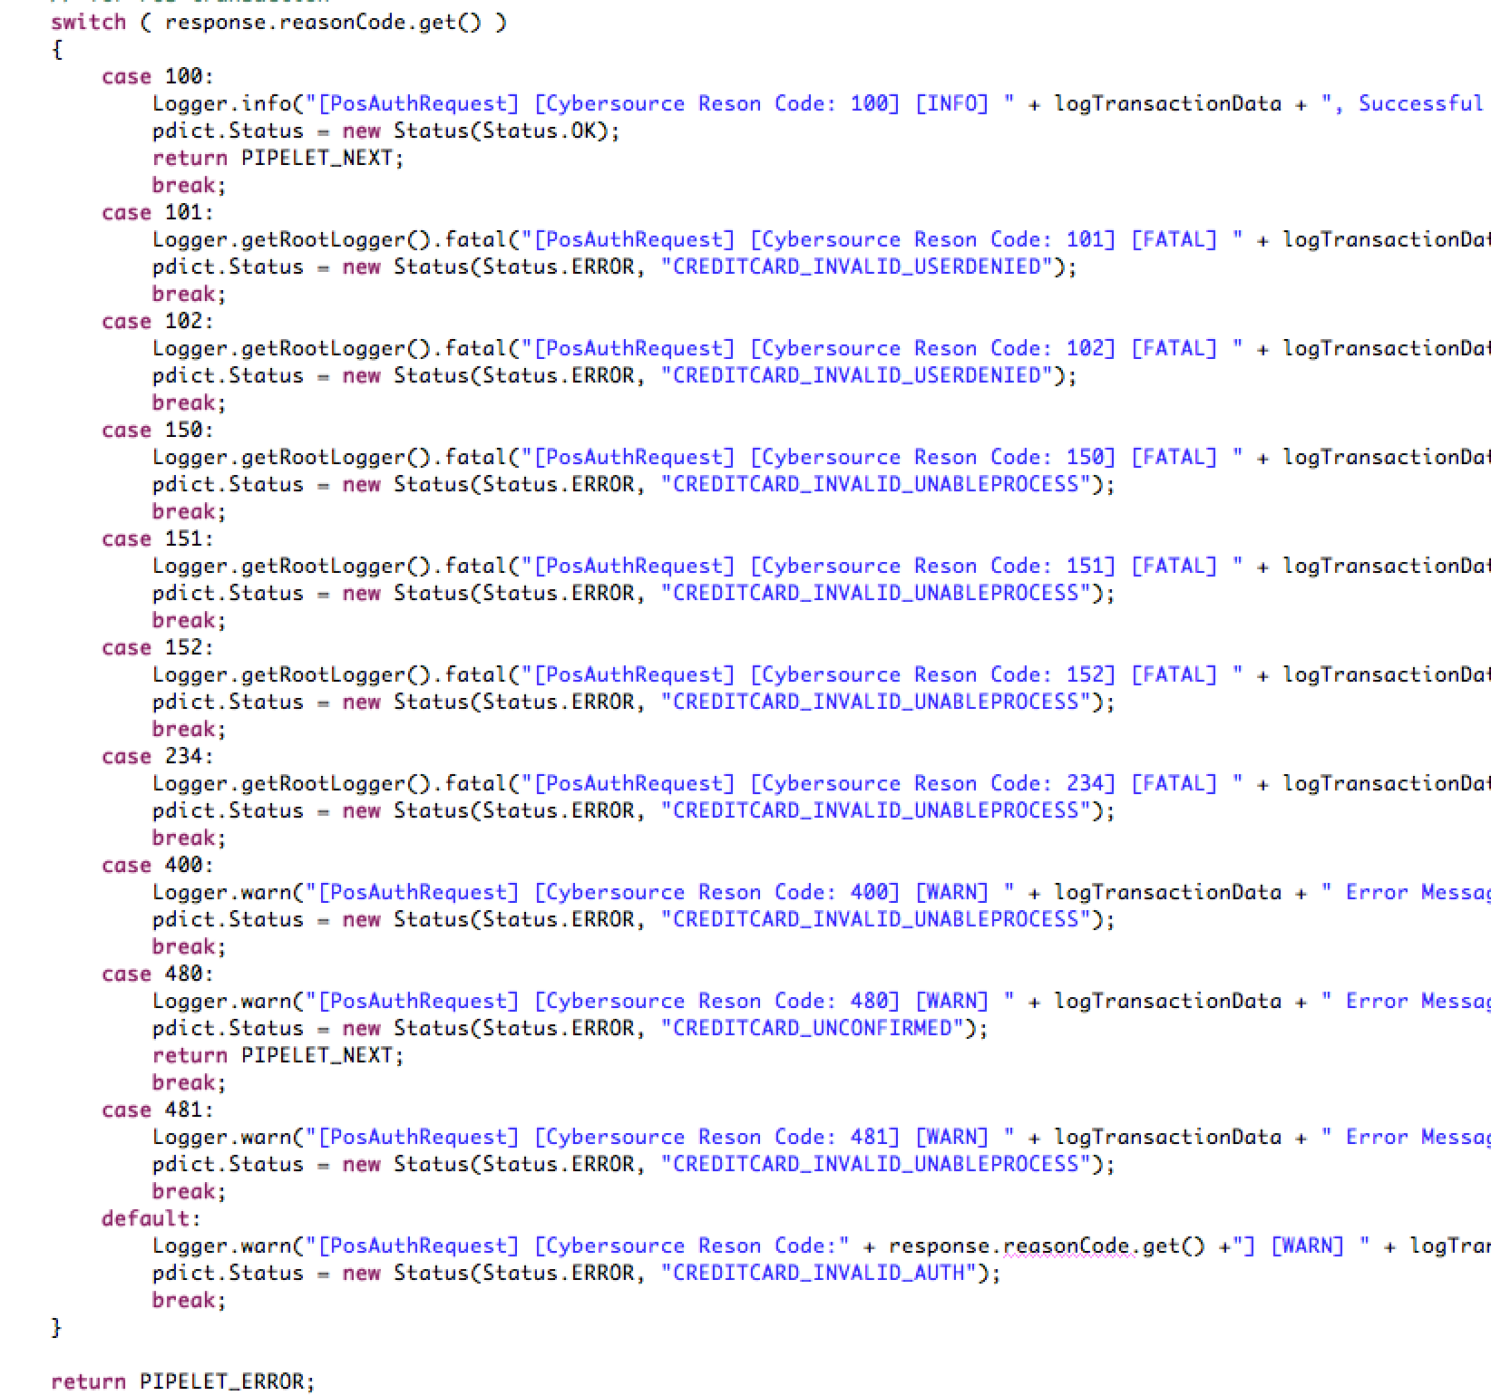

Then add these lines to the int_ocapi_ext/cartridge/templates/resources/eastatus.properties file

CREDITCARD_INVALID_USERDENIED=400|InvalidCreditCardExpception|User Denied|User has been denied.

CREDITCARD_INVALID_AUTH=400|InvalidCreditCardException|Credit Card Declined|Authorization Denied.

CREDITCARD_INVALID_UNABLEPROCESS=400|InvalidCreditCardException|Unable to Process|Call Customer Service.

CREDITCARD_UNCONFIRMED=400|InvalidCreditCardException|Unconfirmed|Unconfirmed

In the Cybersource_POS cartridge set the Status to the CreditCardStatus

## Site Configuration

### Import Meta Data

Import following site configuration meta-data through Business Manager:

* /int_cybersource/configuration/metadata/Cybersource-metadata.xml – sets all the site preferences
* /int_cybersource/configuration/metadata/Cybersource_PaymementTransaction_updates.xml – add custom attributes to the Payment transaction object.
* /int_cybersource/configuration/metadata/Cybersource_subscription_metadata.xml – add custome attributes to the CustomerPaymentInstrument and OrderPaymentInstrument object
* /int_cybersource/configuration/CyberSource_POS_CustomObjectDefinitions.xml – add 2 custom objects for mapping of device’s serial number to Terminal ID and set of Merchant ID and key pair(s).
* /int_cybersource/configuration/Cybersource_Alipay_PayPal_Payment_Method.xml- add new payment method as Alipay and Paypal
* /int_cybersource/configuration/Cybersource_Alipay_CheckStatusService_BatchJob.xml – add new batch job for Alipay check status service

The following Business Manager Screenshot depicts the import / Export functionality:

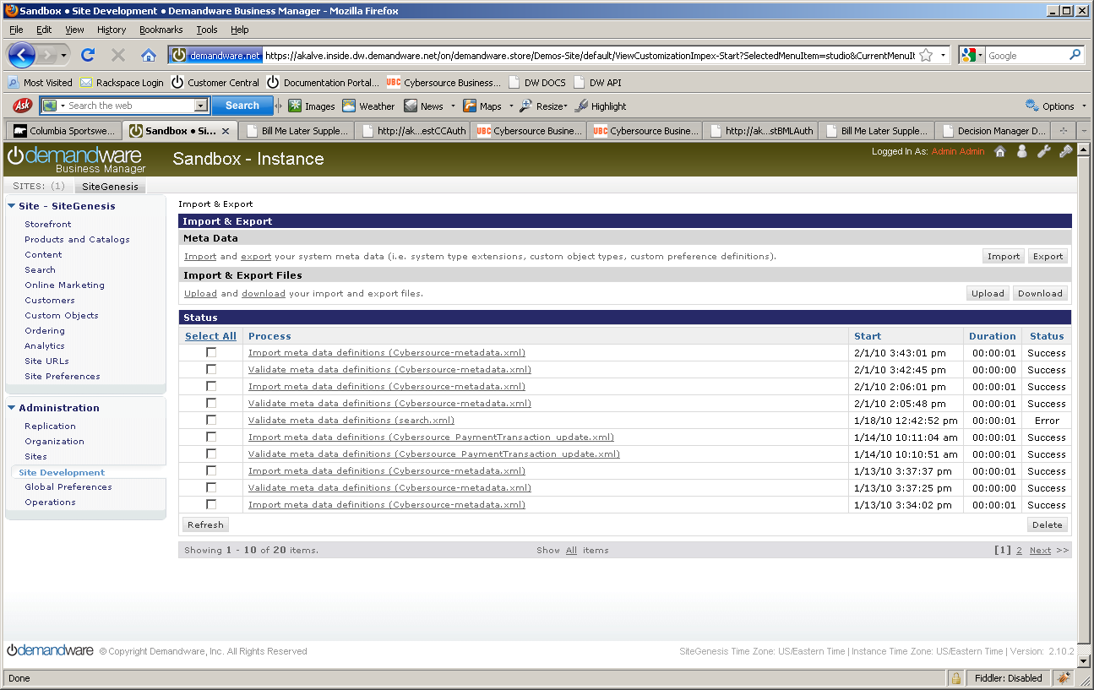

### Configure Payment Processor for Alipay

Go to Site -> Ordering -> Payment Processor, add a new payment processor name CYBERSOURCE_ALIPAY to handle Alipay related requests while order processing through Alipay as payment method. Please refer to the screen shot below:

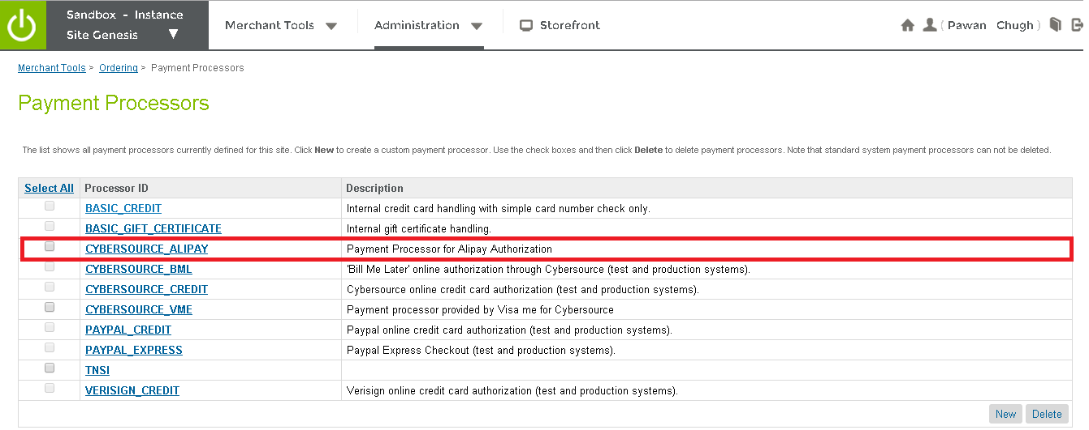

### Configure Site Preferences

Update CyberSource site preference through Business Manager >StoreFront Site> Site Preferences.

The screen shot below depicts the site preferences configuration:

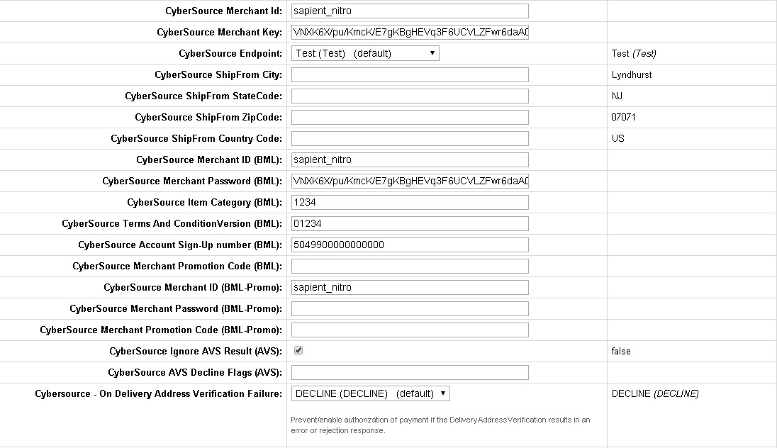

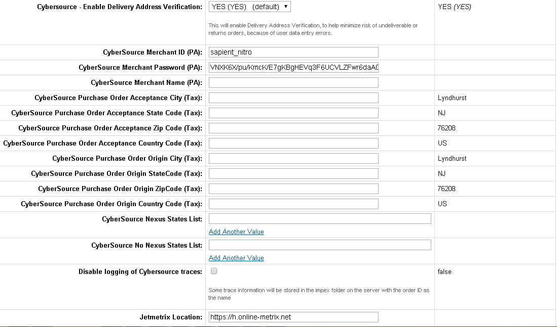

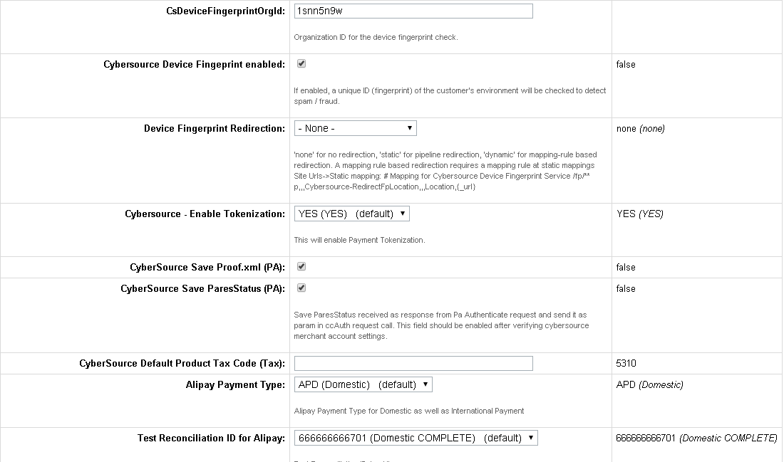

Update credit card preference through Business Manager >StoreFront Site> Ordering> Payment Methods> Credit Card/Debit Cards > Enable Payer Authentication

The screen shot below depicts the site preferences configuration:



Update shipping method preference through Business Manager >StoreFront Site> Ordering> Shipping Methods > Name > CyberSource Shipping ID

The screen shot below depicts the site preferences configuration:



### Configure Site Preferences for Alipay

Verify Alipay Site Preferences in already existing custom preferences group.

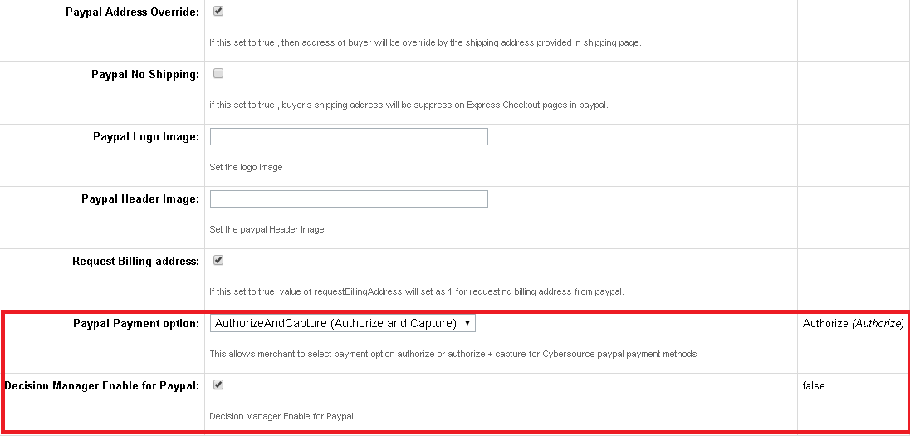

### Business Manager changes for Alipay Batch Job

Verify the newly added batch job for Alipay Check Status Service.

Go to Administration - > Operations -> Job Schedules

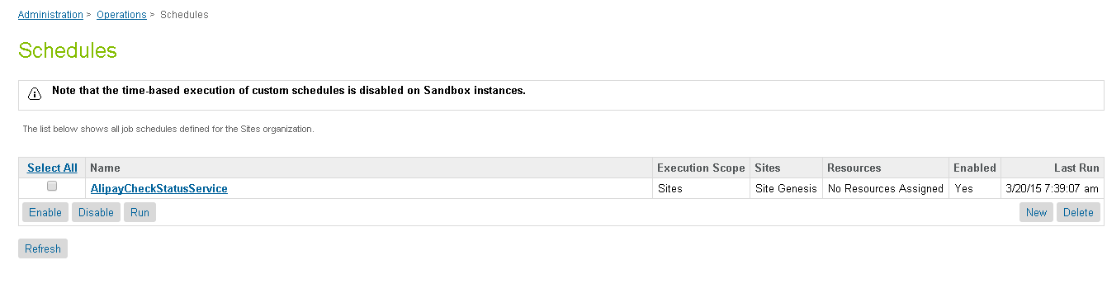

### Configure Site Preferences for PayPal and PayPal Express Checkout

Verify Cybersource_paypal as newly added Custom Preferences Group

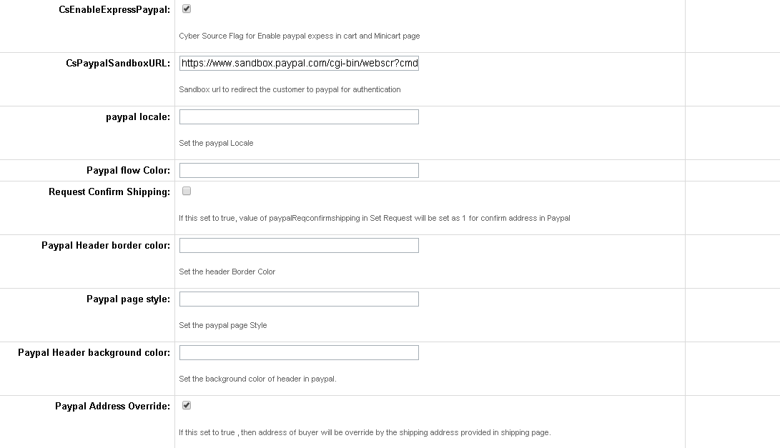

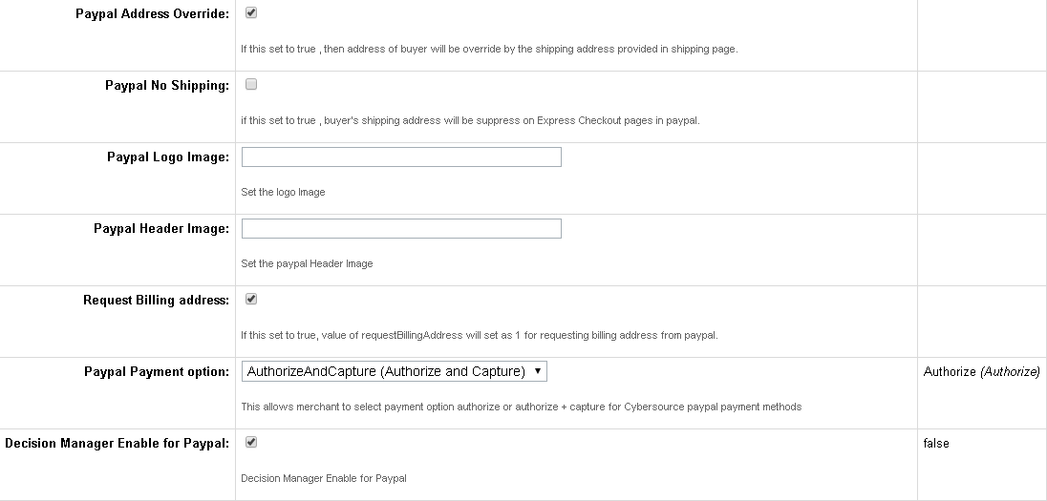

### Applying CyberSource Cartridge to the Site

Go to the “Administration” in the left hand list to expand the menu and select Sites > Manage Sites link. This will open a list of the active sites on the Demandware platform in your account. Click on the site for which you wish to add the CyberSource cartridge. This will open the General Settings page for that site.

Add int_cybersource cartridge to the cartridge path as depicted in the following screen:

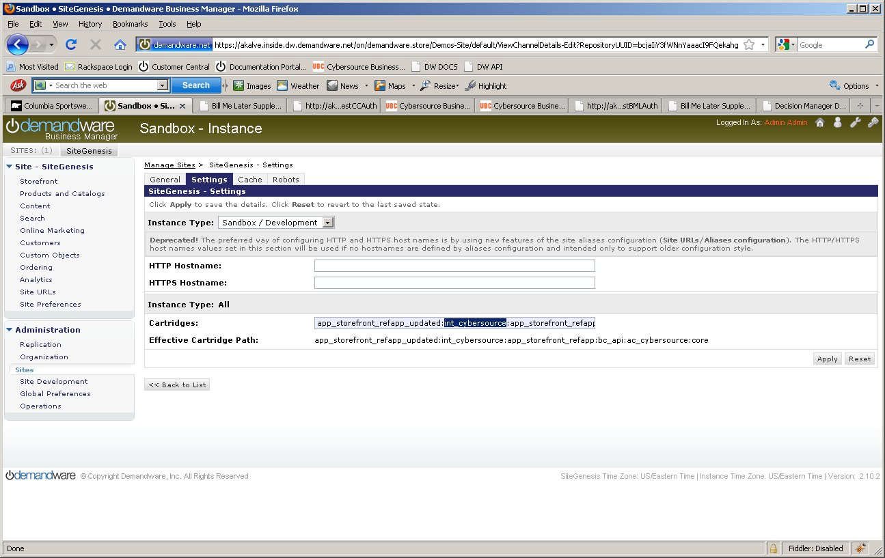

### Configure Custom Objects for Retail POS

Two custom objects have been added for POS transactions. Below are screenshots of sample custom object entry for both custom objects:

* 1. POS_MerchantIDs





* 1. POS_TerminalMapping





## Testing

Use CybersourceUnitTest pipeline to test all the services as follows:

### Authorize Credit Card

Use and modify the CybersourceUnitTest-TestCCAuth pipeline and associated scripts and sub-pipelines. The end node of the unit test pipeline is a template which displays all relevant request/response information in an easy to digest manner. User can change static credit card and address data to observe various responses.

Note: Mark the start node as “PUBLIC” before executing the test case

### Tax Service

Use and modify the CybersourceUnitTest-TestTax pipeline and associated scripts and sub-pipelines. The script nodes for creating CreateCybersourceShipTo and CreateCybersourceBillTo objects have bindings to produce valid results, but otherwise can be manually modified to test against any domestic or international address.

The end node of the unit test pipeline for taxes is a template which displays all relevant request/response information in an easy to digest manner, to aid the debugging the various response codes and corrected address response.

Note: Mark the start node as “PUBLIC” before executing the test case

### Address Verification Service (AVS)

Use and modify the CybersourceUnitTest-TestCCAuth pipeline and associated scripts and sub-pipelines. By running simplified payment authorizations with different site preferences set, you can see how the AVS process works and how that result affects the overall payment authorization process.

Note: Mark the start node as “PUBLIC” before executing the test case

### Delivery Address Verification Service (DAV)

To test the stand-alone DAV service, use and/or modify the CybersourceUnitTest-TestDAVCheck pipeline and associated scripts and sub-pipelines. Like other test pipelines,test data can be customize to simulate various situations that need to be handled.

Note: Mark the start node as “PUBLIC” before executing the test case

The end node of the unit test pipeline for the stand-alone DAV Service is a template which displays all relevant request/response information in an easy to digest manner, to aid the debugging the various response codes and corrected address response.

Note: Mark the start node as “PUBLIC” before executing the test case

### Payment Tokenization

Use the Cybersource_Subscription-Start pipeline to start Subscription creation test suite. By entering test data you can use the various Payment Tokenization related services like Create Subscription, View Subscription, Update Subscription, Delete Subscription, Use Subscription for One Time Payment.

Note: Mark the start node as “PUBLIC” before executing the test case

### Full Authorization reversal

Use the Cybersource_Services-Start pipeline to start Authorization reversal test suite. By entering test data merchant can use the Cybersource Full Authorization Reversal service.

Note: Mark the start node as “PUBLIC” before executing the test case

### Device Fingerprint

Call the pipelineCybersourceUnitTest-TestFingerprintto test the device Fingerprint Service. ACreditCard Authorization is done and a device fingerprint will be additionally submitted.

Note: Mark the start node as “PUBLIC” before executing the test case

### Payer Authentication

Call the pipeline CybersourceUnitTest-TestPA to test the Payer Authentication Service.

Note: Mark the start node as “PUBLIC” before executing the test case

### Retail POS Authorization Request

Call the pipeline CybersourceUnitTesting-StartPOS to test the retail POS Service. This renders a template with a form containing various request fields to enter/select values. The service response is shown after the submit button is clicked. The field’s label turns to red colored font if the field was mandatory.

Note: Mark the start node as “PUBLIC” before executing the test case

### Alipay Initiate Request

Call the pipeline CybersourceUnitTesting-TestAlipayInitiateService to test Alipay Initiate request. Use and modify the mentioned pipeline and associated scripts to test initiate request. The end node of the unit test pipeline is a template which displays all relevant request/response information in an easy to digest manner. User can change static purchase object data and payment type to observe various responses.

Note: Mark the start node as “PUBLIC” before executing the test case

https:// <Sandbox Name>/on/demandware.store/Sites-SiteGenesis-Site/default/CybersourceUnitTesting-TestAlipayInitiatesService

### Alipay Check Status Request

Call the pipeline CybersourceUnitTesting-TestAlipayCheckStatusService to test Alipay Check Status request. Use and modify the mentioned pipeline and associated scripts to test initiate request. The end node of the unit test pipeline is a template which displays all relevant request/response information in an easy to digest manner. User can change value of requestID either in pipeline assign node or can pass the value in the URL along with pipeline URL to observe various responses. Pass requestId generated by Alipay Initiate service in the URL as mentioned below to test this service.

Note: Mark the start node as “PUBLIC” before executing the test case

https:// <Sandbox Name>/on/demandware.store/Sites-SiteGenesis-Site/default/CybersourceUnitTesting-TestAlipayCheckStatusService?requestId=”Initiate Request Id”

### Paypal Capture Request

Call the pipeline CybersourceUnitTesting-TestPaypalCaptureService to test Paypal Capture request. Use and modify the mentioned pipeline and associated scripts to test initiate request. The end node of the unit test pipeline is a template which displays all relevant request/response information in an easy to digest manner. User can change value of orderNo either in pipeline GetOrder pipelet node or can pass the value in the URL along with the pipeline URL to observe various responses. Pass orderNo for order with Demandware Order Status as New and Order Payment Status as Not Paid in the URL as mentioned below to test this service.

Note: Mark the start node as “PUBLIC” before executing the test case

https:// <Sandbox Name>/on/demandware.store/Sites-SiteGenesis-Site/default/CybersourceUnitTesting-TestPaypalCaptureService?orderNo=”Order Number”

## Cartridges Structure and Reference

### Pipelines

##### Cybersource

This contains the nodes that make the actual call to CyberSource based on what is needed, cc auth, bml, tax or address verification.

##### CybersourceData

This contains the node that creates the objects needed for the CyberSource pipeline. Each node in the pipeline creates a needed object for each request. This is the pipeline that will be modified by customers, as each customer may need to pass different information based on their needs

##### CybersourceUnitTesting

Used for testing.

##### Cybersource_Subscription

This contains the nodes that makes call to different Subscription related services. This is the pipeline that will be referred and modified by the merchants, as each merchant may need to pass different information based on their needs.

##### Cybersource_POS

This contains the main node to be integrated and related sub node for integration of retail POS transaction. This pipeline also contains other node for testing purpose.

##### Cybersource_Services

This contains the main node to be integrated for PayPal express and PayPal authorization. This also contains node for full authorization reversal.

### Scripts

There is a JS object for each request data elements. List of DS objects used:

* Cybersource_BillTo_Object.ds
* Cybersource_BML_Object.ds
* Cybersource_Card_Object.ds
* Cybersource_Item_Object.ds
* Cybersource_PurchaseTotals_Object.ds
* Cybersource_ShipFrom_Object.ds
* Cybersource_ShipTo_Object.ds
* Cybersource_TaxRequest_Object.ds
* CreateCyberSourceBillToObject_UserData.ds
* CreateCyberSourcePaymentCardObject_UserData.ds
* CreateCyberSourcePurchaseTotalsObject_UserData.ds

The following scripts are used in CyberSource pipeline to make the CyberSource web service calls.

* TaxationRequest.ds
* BMLAuthRequest.ds
* CCAuthRequest.ds
* DAVRequest.ds
* PayerAuthEnrollCheck.ds
* PayerAuthValidation.ds
* AlipayInitiatePaymentRequest.ds
* AlipayCheckPaymentStatusRequest.ds
* PaypalSetEcSetRequest.ds
* PaypalGetEcRequest.ds
* PaypalOrderSetupEcRequest.ds
* PaypalAuthorizationRequest.ds
* PaypalCaptureRequest.ds

The following scripts are used in Cybersource_Subscription pipeline to make the Payment Tokenization web service calls.

* CreateSubscription.ds
* DeleteSubscription.ds
* OnDemandSubscription.ds
* UpdateSubscription.ds
* ViewSubscription.ds

The following scripts are used to create the objects needed. These are the scripts that customers would change to fit their needs

* CreateCybersourceBillToObject.ds
* CreateCybersourceBMLObject.ds
* CreateCybersourceBMLPaymentCardObject.ds
* CreateCybersourcePaymentCardObject.ds
* CreateCybersourcePurchaseTotalsObject.ds
* CreateCybersourceShipFromObject.ds
* CreateCybersourceShipToObject.ds
* CreateCybersourceTaxationItemsObject.ds
* CreateCybersourceTaxationPurchaseTotalsObject.ds
* CreateCyberSourceTaxRequestObject.ds
* AlipaySetProductParameters.ds
* CreateCSPurchaseTotalForAlipay.ds
* CreateCybersourceBillToObjectForExpressCheckout.ds
* CreateCybersourceItemForPaypal.ds
* AddAddressToBasket.ds
* AlipayGetOrderForCheckStatusWorkflow.ds

These are the pipelines that use the scripts from above and may have need storefront specific integration:

* CybersourceData:CreateBillTo
* CybersourceData:CreateShipTo
* CybersourceData:CreatePaymentCard
* CybersourceData:CreatePurchaseTotals
* CybersourceData: CreateShipFrom
* CybersourceData: CreateTaxItems
* CybersourceData: CreateTaxService

The following is a library script that is used by the Request scripts to build the XML request that is passed to CyberSource. This lib script contains integration independent code and it doesn’t need any storefront specific changes.

* libCybersource.ds

### Templates

* payerauthentication.isml
* payerauthenticationredirect.isml
* pt_payerauthentication.isml
* alipayintermediate.isml
* Contains templates used by unit test pipeline

### Configuration Files

Contains two configuration file as follows:

* Cybersource_PaymentTransaction_update.xml

Contains custom attributes added to the “PaymentTransaction” object.

* Cybersource-metadata.xml

Contains CyberSource specific site preferences.

### Retail POS Cartridge Components

|  |  |
| --- | --- |
| **Component** | **Files** |
| **Pipelines** | *Cybersource_POS.xml*  *CybersourceUnitTesting.xml* |
| **Forms** | *pos.xml* |
| **Scripts** | *cybersource/Cybersource_POS_Object.ds*  *cybersource /libCybersource.ds*  *cybersource/POSAuthRequest.ds*  *POS/CreateCyberSourcePaymentCardObject_UserData.ds*  *POS/CreateCyberSourcePOSObject_UserData.ds*  *POS/CreateCyberSourcePurchaseTotalsObject_UserData.ds*  *Cybersource_UnitTesting/TestPOSAuth.ds* |
| **Templates** | *custom/pos_scripterror.isml*  *pos/createpos.isml*  *pos/postransactionresult.isml* |
| **Metadata** | *CyberSource_POS_CustomObjectDefinitions.xml* |

# Typical Project Plan

## Roles, Responsibilities

Typically most of the integration works is done by the backend developer. We expect that the person doing this integration is familiar with the web service, xml processing and has hands on experience with the Demandware platform.

## Typical Efforts and Timelines

The level of effort is mostly detected by the services merchant may choose from the CyberSource cartridge. The

|  |  |  |
| --- | --- | --- |
| **CyberSource Service** | **Level of Effort (LOE)** | **Dependencies** |
| Initial Cartridge Setup | **0.5**– Person Day  List of tasks involved:   * Add CyberSource Cartridge to the project * Import Cybersource-metadata.xml * Import Cybersource_PaymentTransaction_update.xml | * Cartridge is available |
| Authorize Credit Card | **0.5**– Person Day  List of tasks involved:   * Integrate CyberSource-AuthorizeCreditCard pipeline with COPlaceOrder. | * Merchant ID and Key is established for the client. * Site Preferences for authorization configured with above ID and Key. |
| Device Fingerprint (as addition to Authorize Credit Card) | **0.5** Person Day | * Enable Device Fingerprint, set Organization ID * Add include at billing page. |
| Address Verification Service (AVS)* | **0.5**– Person Day | * Initial Cartridge Setup |
| Delivery Address Verification (DAV)* | **0.5**– Person Day | * Initial Cartridge Setup |
| Bill Me Later (BML) | **0.5**– Person Day | * Setup Account with Bill Me Later. |
| Decision Manager | **0.5**– Person Day | * Access to Decision Manager. * Business rules are defined. * Order status notification URL pointing to Cybersource-NewDecision pipeline is defined. |
| Payment Tokenization* | **0.5**– Person Day  +  Depends on customization needs | * Initial Cartridge Setup |
| Payer Authentication | **1.5**– Person Day | * Initial Cartridge setup * Update CoPlaceOrder-HandlePayments pipeline * Handle error scenarios in merchant specific ways |
| Alipay Integration on Payment Page | **1.0**– Person Day | * Initial Cartridge setup * Update CoPlaceOrder-HandlePayments pipeline * Handle error scenarios in merchant specific ways |
| Paypal Express Checkout on Cart page and Mini Cart Page | **1.0**– Person Day | * Initial Cartridge setup * Update CoPlaceOrder-HandlePayments pipeline * Handle error scenarios in merchant specific ways |
| Paypal Integration on Payment Page | **1.0**– Person Day | * Initial Cartridge setup * Update CoPlaceOrder-HandlePayments pipeline * Handle error scenarios in merchant specific ways |

*Note that because customized user interface elements are completely dependent on merchant specification, the time required to interact with the customer to correct address information or confirm standardized address format corrections, is not included; only the time required to integrate with the web services is included, with minimal testing and simplified validation handling, ie. Automatically make correction to a customer address, as per validation response.

## Pre-Production Steps

In order to avoid misuse of unit testing pipelines on production instances it is advised to make following pipelines private before pushing code to production instances.

CybersourceUnitTesting-TestBMLAuth

CybersourceUnitTesting-TestCCAuth

CybersourceUnitTesting- TestAlipayInitiateService

CybersourceUnitTesting- TestAlipayCheckStatusService

CybersourceUnitTesting- TestPaypalCaptureService

CybersourceUnitTesting-TestTax

CybersourceUnitTesting-TestDAVCheck

CybersourceUnitTesting-TestPA

CybersourceUnitTesting-TestFingerprint

Cybersource_Subscription-Start

Cybersource_Subscription-CreateSubscription

Cybersource_Subscription-ViewSubscription

Cybersource_Subscription-UpdateSubscription

Cybersource_Subscription-DeleteSubscription

Cybersource_Subscription-OnDemandPayment

Cybersource_Services-Start

Cybersource_Services-Reversal

CybersourceUnitTesting-StartPOS

# CyberSource Site Preferences

##### Site preference and description

|  |  |
| --- | --- |
| Site Preferences | Description |
| CyberSource Merchant Id(CsMerchantId) | CyberSource Merchant ID |
| CyberSource Merchant Key(CsSecurityKey) | CyberSource Security Key |
| CyberSourceEndpoint(CsEndpoint) | CyberSource Web service End points:  Test <https://ics2wstest.ic3.com/commerce/1.x/transactionProcessor>  Prod<https://ics2ws.ic3.com/commerce/1.x/transactionProcessor> |
| CyberSourceShipFromCity(CsShipFromCity) | Ship to data if fixed for the site |
| CyberSourceShipFromStateCode(CsShipFromStateC)ode | Ship to data if fixed for the site |
| CyberSourceShipFromZipCode(CsShipFromZipCode) | Ship to data if fixed for the site |
| CyberSourceShipFrom Country Code(CsShipFromCountryCode) | Ship to data if fixed for the site |
| CyberSource Merchant ID(CsBmlMerchantId) | BML Merchant ID |
| CyberSource Merchant Password(CsBmlPassword | BML Merchant Key |
| CyberSource Item Category(CsBmlItemCategory) | BML Item Category |
| CyberSource Terms AndConditionVersionCsBmlTCVersion | BML Terms and Condition Version |
| CyberSource Account Sign-Up numberCsBmlNewAcctNo) | BML CyberSource account sign-up number |
| CyberSource Merchant Promotion Code(CsBmlPromoCode) | BML promo code |
| CyberSource Merchant ID(CsBmlPromoMerchantId) | BML promo merchant ID |
| CyberSource Merchant Password(CsBmlPromoMerchantPassword) | BML promo merchant key |
| CyberSource Merchant Promotion Code(CsBmlPromoPromoCode) | BML promo promo code |
| CyberSource Ignore AVS Result(CsAvsIgnoreResult) | AVS ignore results |
| CyberSource AVS Decline Flags(CsAvsDeclineFlags) |  |
| Cybersource – On Delivery Address Verification Failure(CsDavOnAddressVerificationFailure) |  |
| Cybersource – Enable Delivery Address Verification(CsDavEnable) | This will enable Delivery Address Verification, to help minimize risk of undeliverable or returns orders, because of user data entry errors. |
| CyberSource Merchant ID(CsPaMerchantId) | Payer Auth merchant ID |
| CyberSource Merchant Password(CsPaMerchantPassword) | Payer Auth Merchant Key |
| CyberSource Merchant Name(CsPaMerchantName) | Name |
| CyberSource Purchase Order Acceptance City(CsPoaCity) | CyberSource purchase order acceptance data – used by Tax |
| CyberSource Purchase Order Acceptance State Code(CsPoaStateCode) | CyberSource purchase order acceptance data – used by Tax |
| CyberSource Purchase Order Acceptance Zip Code(CsPoaZipCode) | CyberSource purchase order acceptance data – used by Tax |
| CyberSource Purchase Order Acceptance Country Code(CsPoaCountryCode) | CyberSource purchase order acceptance data – used by Tax |
| CyberSource Purchase Order Origin City(CsPooCity) | CyberSource purchase order origin data – used by Tax |
| CyberSource Purchase Order Origin StateCode(CsPooStateCode) | CyberSource purchase order origin data – used by Tax |
| CyberSource Purchase Order Origin ZipCode(CsPooZipCode) | CyberSource purchase order origin data – used by Tax |
| CyberSource Purchase Order Origin Country Code(CsPooCountryCode) | CyberSource purchase order origin data – used by Tax |
| CyberSource Nexus States List(CsNexus) | CyberSource nexus state list |
| CyberSource No Nexus States List(CsNoNexus) | CyberSource no nexus state list |
| Disable logging of Cybersource traces(CsDebugCybersource) | To enable/disable debugging |
| Cybersource Device Fingeprintenabled(CsDeviceFingerprintEnabled) | To enable / disable the device fingerprint for advanced fraud detection |
| JetmetrixLocation(CsJetmetrixLocation) | Location of device fingerprint service |
| CsDeviceFingerprintOrgId(CsDeviceFingerprintOrgId) | Id of DeviceFingerprintOrgId |
| Device Fingerprint Redirection(CsDeviceFingerprintRedirectionType) | None,static or dynamic for type of redirection. |
| Cybersource – Enable Tokenization(CsTokenizationEnable) | To enable/disable tokenization call in CC Authorization |
| CyberSource Save Proof.xml(CsPaEnableProofXML) | To enable/disable saving of proof.xml in order object |
| Alipay Payment Type(apPaymentType) | Alipay Payment Type for Domestic as well as International Payment |
| Test Reconciliation ID for Alipay(apTestReconciliationID) | Test Reconciliation ID for Alipay to test initiate and check status services. |

# Cybersource_paypal Site Preferences

##### Site preference and description

|  |  |  |
| --- | --- | --- |
| **Site Preference** | **Description** | **Default Value** |
| CsEnableExpressPaypal | Cyber Source Flag for Enable paypal expess in cart and Minicart page | NA |
| CsPaypalSandboxURL | Sandbox url to redirect the customer to paypal for authentication | NA |
| CsPaypalLc | Set the paypal Locale | NA |
| CsPaypalPayflowcolor | Set Paypal Flow Color | NA |
| CsPaypalReqconfirmshipping | If this set to true, value of paypalReqconfirmshipping in Set Request will be set as 1 for confirm address in Paypal | NA |
| CsPaypalHdrbordercolor | Set the header Border Color | NA |
| CsPaypalPagestyle | Set the paypal page Style | NA |
| CsPaypalHdrbackcolor | Set the background color of header in paypal. | NA |
| CsPaypalAddressOverride | If this set to true, then address of buyer will be override by the shipping address provided in shipping page. | NA |
| CsPaypalNoshipping | if this set to true , buyer's shipping address will be suppress on Express Checkout pages in paypal. | NA |
| CsPaypalLogoimg | Set the logo Image | NA |
| CsPaypalHdrimg | Set the paypal Header Image | NA |
| CsRequestBillingAddress | If this set to true, value of requestBillingAddress will set as 1 for requesting billing address from paypal. | NA |
| CsPaypalPaymentOption | This allows merchant to select payment option authorize or authorize + capture for Cybersource paypal payment methods | Authorize |
| isDecisionManagerEnable | Decision Manager Enable for Paypal | False |

# Device Fingerprint

The device fingerprint enables CyberSource to detect fraud/spam more efficient.  
The device fingerprint can be used as an addition of the Credit Card Payment, it is not an independent service.

## How does it work?

During/before checkout three (invisible) ‘beacons’ at the checkout page (a JavaScript, an image and a flash object) would collect and transmit several client-specific parameters to CyberSource partner.

Those beacons contain the session Id.

With the Credit Card Payment, this session Id is transmitted again and CyberSource is able to combine the data for advanced fraud detection.

## Setup:

(Prerequisites: CyberSource cartridge is already installed).

1. Enable the device fingerprint at the Site Preferences of CyberSource and set the Organization ID (provided by CyberSource). The Merchant ID should be set already, anyway.
2. Include following snippet i.e. at the billing.isml page (Recommended: at bottom of page to have no visual impacts)

<isifcondition=*”${dw.system.Site.getCurrent().getCustomPreferenceValue(‘CsDeviceFingerprintEnabled’)}”*>

<isincludeurl=*”${URLUtils.url(‘Cybersource-IncludeDigitalFingerprint’)}”*/>

</isif>

Do a checkout with Credit Card payment. After this checkout, at the CyberSource Business Manager you will see (at the Transaction Manager):

*Device Fingerprint: submitted*

### Hints for the CsDeviceFingerprintRedirectionType:

To get improved deviceFingerprint results, Cybersource recommends redirecting the included code (loading a image, a flash and a javascript) pointing to the CsJetmetrixLocation, to a local domain.

There are three possible settings for this redirection: ‘none’, static’ and dynamic.

No redirection, the beacons will be loaded direct from the CsJetmetrixLocation (i.e. https://h.online-metrix.net)

*Static* The beacons are included with aemandware pipeline call. The pipelinecall will redirect to the CsJetmetrixLocation.

Dynamic If set to dynamic, you have to specify a mapping rule at SiteUrls->Static Mappings.

All URLs matching the pattern will be redirected by the Demandware Server.



Example for a matching mapping rule for the device fingerprint redirection

### Modified Scripts and pipelines for the device fingerprint

Scripts:

libCybersource .ds->addCCAuthRequestInfo modified.

CCAuthRequest.ds (updated WSDL reference)

TestCCAuth (Testcases plus added ‘response object’ dumping for developers)

Pipelines:

CybersourceUnitTesting (new test case)

# Known Issues

1. Incase of setting Ignore AVS Result custom preference to true, there can be a known issue as described below:

If the AVS response code received as N, the cartridge ignores the ccAuthReply reason code and processes the transaction under “review” status. This can lead to an ambiguous situation when the Credit Card was rejected, but due to the AVS code as “N”, the cartridge continued with order processing and successful order placement.

1. Testing of Alipay is possible only with Test data provided by CyberSource such as Reconciliation ID that is getting passed to Alipay Initiate Service to get the response back. We don’t have Alipay simulator and access to Alipay live environment.

# CyberSource document links

1. <http://www.cybersource.com/support_center/implementation/testing_info/simple_order_api/General_testing_info/soapi_general_test.html>
2. <http://www.cybersource.com/support_center/support_documentation/quick_references/view.php?page_id=422>
3. <http://apps.cybersource.com/library/documentation/dev_guides/CC_Svcs_SO_API/Credit_Cards_SO_API.pdf> - Page 163 - Appendix C.
4. <http://apps.cybersource.com/library/documentation/dev_guides/Getting_Started/Getting_Started_Advanced.pdf>
5. <http://www.cybersource.com/support_center/support_documentation/quick_references/>
6. <http://apps.cybersource.com/library/documentation/dev_guides/Payer_Authentication_IG/20090928_Payauth_IG.pdf>
7. <http://apps.cybersource.com/library/documentation/dev_guides/Payer_Authentication_IG/html/>
8. <http://apps.cybersource.com/library/documentation/dev_guides/CC_Svcs_IG_BML_Supplement/html/>
9. <http://apps.cybersource.com/library/documentation/dev_guides/Verification_Svcs_IG/20091012_Verification_IG.pdf>
10. <http://www.cybersource.com/support_center/support_documentation/services_documentation/tax.php>
11. <http://apps.cybersource.com/library/documentation/dev_guides/Tax_IG/Tax_Guide.pdf>
12. <http://apps.cybersource.com/library/documentation/dev_guides/Retail_SO_API/Retail_SO_API.pdf>
13. <http://apps.cybersource.com/library/documentation/dev_guides/PayPal_Express_SO/PayPal_Express_SO_API.pdf>
14. <http://apps.cybersource.com/library/documentation/dev_guides/AliPayDom/AliPay_Dom_SO_API.pdf>
15. <http://apps.cybersource.com/library/documentation/dev_guides/AliPayInt/AliPay_Int_SO_API.pdf>

# Release History

|  |  |  |
| --- | --- | --- |
| Version | Date | Changes |
| 1.0.0.1 | 02/02/2010 | Initial release |
| 1.0.0.2 | 02/08/2010 | Device Fingerprint Feature added |
| 1.0.0.3 | 03/01/2012 | Updated Tax pipeline to remove unnecessary / redundant tax requests to reduce tax service charges. |
| 1.0.0.4 | 12/18/2012 | Updated Tax pipeline to remove redundant tax requests by using SkipTaxCalculation parameter |
| 1.1.0 | 01/16/2013 | Incorporated review comments from Demandware team |
| 1.1.0 | 02/06/2013 | Incorporated New changes as per new Site Genesis code |
| 2.0.0 | 09/23/2013 | V.me support changes added. Removed deprecated method setGrossPrice for taxation |
| 2.1.0 | 10/04/2013 | V.me Clickjacking changes added |
| 2.1.1 | 11/04/2013 | Removed unsued code from pipeline |
| 2.1.2 | 04/25/2014 | RSA key removed from the cartridge. Bug fixed related to promotional discount. |
| 2.1.3 | 05/29/2014 | Retail Point of Sale (POS) API added |
| 14.2.1 | 08/04/2014 | Document version updated |
| 15.0 | 03/25/2015 | Alipay, Paypal Express and Paypal implementation |
| 15.1.0 | 04/15/2015 | Changes done for Taxation service call and other Changes related to Credit Card and BML. V.me support changes and V.me Clickjacking changes removed. |